# 

# Oxford City Council’s Homelessness Review and Housing, Homelessness and Rough Sleeping Strategy Evidence Base 2021

Contents

**1.0 - Introduction** 4

**2.0 - About Oxford and its housing market** 5

2.1 - Population 6

2.2 - The economy and its impacts on housing demand 7

2.3 - Deprivation 10

2.4 - The Oxford Housing Market 12

2.5 - Supply of affordable housing 13

2.6 - Affordability of housing 14

2.7 - Empty dwellings 17

2.8 - HMOs, the condition of the Private Rented Sector, and licensing 17

2.9 - The housing market for students 18

**3.0 - What have we achieved so far? The current Housing & Homelessness Strategy** 18

3.1 - Summary of achievements 19

3.2 - Challenges for the current strategy 22

3.3 - Strategy delivery and monitoring 23

**4.0 - Local and National Policy Context** 23

4.1 - The Homelessness Reduction Act 2017 23

4.2 - National Rough Sleeping Strategy 24

4.3 - Oxfordshire’s Homelessness and Rough Sleeping Strategy 2021-26 25

4.4 - Crisis Housing-led Feasibility Study for Oxfordshire 26

4.5 - Abolition of Section 21 notices (Renters Reform Bill) 26

4.6 - Housing Revenue Account Changes 26

4.7 - Use of receipts from Right to Buy sales 27

4.8 - Social Housing White Paper 27

4.9 - Planning Policy changes 28

4.10 - The Covid-19 Pandemic 29

4.11 - Domestic Abuse Act 2021 30

**5.0 - What is the extent of the homelessness problem in Oxford?** 30

5.1 - Households at risk of becoming homeless and homeless households that we owe a duty to support 32

5.2 - Prevention and Relief Duties 33

5.3 - Main Homelessness Duty 35

5.4 - Temporary Accommodation 37

5.5 - Households included on the register for social housing 39

5.6 - Rough Sleeping 40

5.7 - Hidden Homelessness 44

5.8 - Covid-19 impact on the extent of homelessness in the City 46

5.9 - In summary – The overall picture of homelessness levels in Oxford 47

**6.0 - Who are becoming homeless in Oxford?** 48

6.1 - Household Type and Gender 49

6.2 - Ethnicity 51

6.3 - Age 53

6.4 - Economic status 54

6.5 - Support Needs 56

**7.0 – What is causing homelessness in Oxford?** 59

7.1 - What is causing statutory homelessness? 60

7.2 - What is causing rough sleeping? 66

7.3 - What is driving demand for Discretionary Housing Payments? 66

7.4 - Summary of the causes of homelessness 68

**8.0 - What are the Council and other organisations doing to tackle homelessness?** 69

8.1 - Statutory support and assistance to prevent and relieve homelessness available in Oxford 70

8.2 - Homelessness prevention in Oxford 75

8.3 - The provision of Temporary Accommodation 78

8.4 - Support to access accommodation in the Private Rented Sector 79

8.5 - The allocation of social housing 83

8.6 - Supported accommodation for homeless people and those vulnerably housed 87

8.7 - Adult Homeless Pathway 87

8.8 - Mental Health Pathway 90

8.9 - Young people's supported accommodation service (YPSAS) 90

8.10 - Other supported accommodation 92

8.11 - Other support available in the City 92

**9.0 - What are we doing to build more new homes?** 93

9.1 - New builds and acquisitions 94

9.2 - Oxford City Housing Ltd. 95

9.3 - Oxford City Council’s Housing Revenue Account 96

9.4 - Registered Providers 96

9.5 - Oxfordshire Growth Board 97

9.6 - Oxford Local Plan 2036 98

9.7 - Oxford’s unmet housing need 98

9.8 - Community-led housing 99

9.9 - Employer-linked affordable housing 100

9.10 - Regeneration 100

9.11 - Housing for the elderly 100

9.12 - Accessible and adaptable homes 101

9.13 - Property sizes 101

9.14 - Living rent 102

**10.0 - Oxford City Council as a social landlord** 103

10.1 - What the Social Housing White paper means for Oxford City Council 106

10.2 - The council as a social landlord through the pandemic 107

**11.0 - Reducing carbon emissions and improving energy efficiency in the housing stock** 107

11.1 - Decarbonisation of the council housing stock 109

11.2 - Decarbonisation of the council’s housing development 110

11.3 - Decarbonisation of the wider Oxford housing market 111

**12.0 - How are housing and homelessness services funded?** 112

12.1 - Overview of resources for housing, homelessness and rough sleeping in the city 112

12.2 - Funding for homelessness and rough sleeping 113

12.3 - Funding for housing and affordable development 114

**13.0 - Conclusion and draft priorities** 116

## **1.0 - Introduction**

Oxford City Council has long prioritised the challenge of delivering good quality, affordable housing for its residents, and combating homelessness, and over recent years has delivered significant progress. As we enter a new period of recovery from the pandemic and its economic consequences we need to update and refresh our strategic approach, refocusing what needs to happen to tackle the housing and homelessness issues in the city, which is crucial to delivering the City Council’s wider ambition for the city.

Local authorities are required under the Homelessness Act 2002 to carry out a review of homelessness in their area every 5 years, to develop and publish a homelessness strategy based on the review, and to consult with other local statutory and voluntary organisations.

The National Rough Sleeping Strategy launched in August 2018 also requires all local authorities to rename and incorporate the prevention and tackling of rough sleeping into their homelessness strategies.

This document marks the first steps in our development of a new strategy for Oxford which will cover the 5 year period of 2022-2027. It encompasses the homelessness review for Oxford City Council, and an evidence base for the wider housing and homelessness strategy. The review has been carried out in accordance with the relevant Act, accompanying Code of Guidance and Rough Sleeping Strategy. Whilst there is no legal obligation on local authorities to have a Housing Strategy or to carry out a review of housing, we have incorporated key elements of data and other information in relation to housing in this document. This is because our strategy incorporates housing, as well as homelessness and rough sleeping and the relationship between ‘housing’ and homelessness and rough sleeping is inseparable.

Together this combined document provides the full findings that will underpin and inform the development of the Council’s strategic response to prevent all forms of homelessness and tackle the housing challenges the city faces. The next step after publication of this document will be to conduct a consultation, covering the document, and the vision and priorities we have for the new strategy.

This strategic development process and the strategy it will produce, sits alongside a number of interconnected strategies and policies. This wider picture is crucial as our ambition for housing and homelessness with be impossible to meet without this wider work, and only together can the united vision the City Council has for Oxford be met.

## **2.0 - About Oxford and its housing market**

|  |
| --- |
| Key Findings – Oxford and its housing market.   * Oxford’s population profile differs significantly from the English average, both being younger and more diverse. Its population is difficult to project for future years, but a further increase seems likely, with core modelling forecasts suggesting anything from -3.5% to +10.4% over the coming years. * Oxford has a large private rented sector, 28% at the 2011 census, and as much as 49.3% on current modelling, making it proportionally one of the biggest in the country. * The median house price in Oxford increased by 132% from 2002 to 2019. Median earnings for full-time employees in Oxford increased by 59% in the same period. * The combination of wealth disparity, a strong labour market, and an undersupply of housing (in particular affordable housing) has resulted in a decade of increasing unaffordability in the housing market. |

The Oxford context is key to understanding what drives the key features of housing and homelessness in the city. Only by understanding what is happening with the city’s population, economy, labour market, housing market, etc. can we really understand the challenges we face, and possible solutions we have.

### 2.1 - Population

According to the Census 2011 Oxford’s population was 151,906. The recent Census took place on 21 March 2021, with population figures expected to be published in March 2022. Population, and forward projections of population change, provide useful context and indication of patterns of likely housing demand in future years. However there is far from a clear consensus on population projections for Oxford in the next 10 years.

**Office of National Statistics (ONS)**

ONS uses past trends to estimate future population. Population estimates from the latest census are updated each year to produce mid-year population estimates, taking into account births, deaths, and internal and international migration. Oxford is estimated to have a population of 152,450 (ONS 2019 mid-year estimate) and 53,500 households (2018-based Household projections for England, ONS). Oxford’s population is expected to decline by 3.5% during the period 2018 to 2028, with the population in 2028 expected to be 149,000.  (ONS Subnational household projections). In 2018 the ONS published revised population estimates for the period 2012-2016, where the population for Oxford in 2016 was revised from 161,291 to 155,292. It should be noted that the quality of population estimates declines as we move further away from the census year.

**Oxfordshire housing-led population forecasts (interim) 2018 to 2028**

Oxfordshire County Council carries out an annual update to population forecasts to support planning for school places, social care and other services.  These differ significantly from the population projections provided by ONS in that they take into account the predicted increase in housing across Oxfordshire, alongside data from wider sources. The forecast is based on known sites and likely windfall in adopted local plans as at March 2020. The housing-led forecast (interim) show the population of Oxford increasing from 158,100 in 2018 to 170,200 by 2028. (+12,100, +8%).

**SHMA Update to 2036**

The Strategic Housing Market Assessment (SHMA) Update to 2036 uses the 2014-based ONS Sub-national Population Projection as a starting point for the core scenario, with adjustments for the 2016 mid-year estimate, migration age structure, national fertility/mortality projections and removing the ONS consolidation factor. This gives a projected population change from 161,291 in 2016 to 178,025 in 2036 (10.4%). It goes on to examine different scenarios adjusting for some of the underlying assumptions for population growth. These scenarios show estimated population growth varying from 1% up to 20% between 2016 and 2036.

This wide range of forecasts demonstrate how difficult it is to project population change in Oxford, and provides a challenge for strategic planning and policy making. However we anticipate an increase in population in the city over the next decade, supported by the County Council and SHMA forecasting, due to these models taking in more local factors.

Moving beyond the headline population figures, we can consider the breakdown in Oxford population. Oxford has a very young population compared to national figures, with the number of 15-34 year olds significantly higher than the national average, linked to it being a major university city. 36% of the population belong to ethnic groups other than White British, compared to the average for England of 20%. (Census 2011).

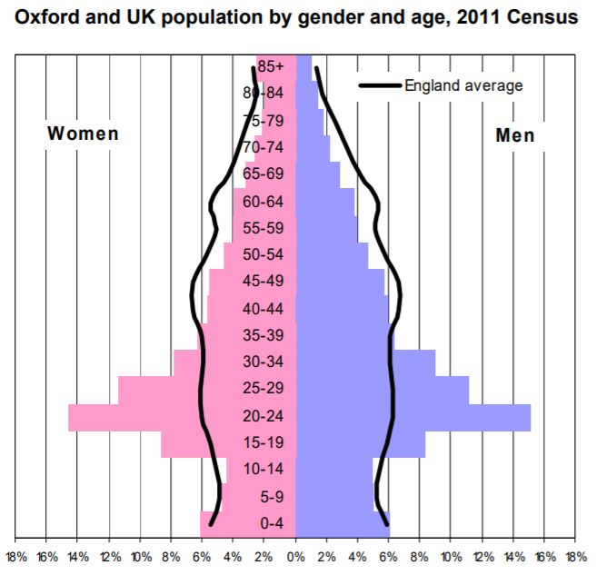

### 2.2 - The economy and its impacts on housing demand

Oxford has enjoyed a long period of good economic growth and high demand for labour over the last decade, putting pressure on the housing market across the county to house workers.

Oxford has a very high job density level of 1.33 (ONS jobs density 2018) with more than one job for every resident of working age. This demonstrates the importance of Oxford as a centre for employment, its role in serving the wider area economically, and reflects high levels of commuting into the city.

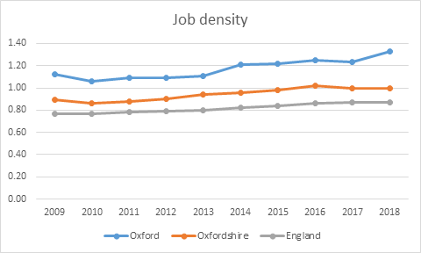

<https://www.nomisweb.co.uk/datasets/jd>

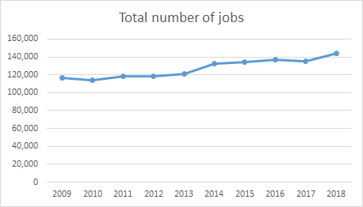

<https://www.nomisweb.co.uk/datasets/jd>

The strength of the city's economy has attracted significant inward migration into the county over the last decade, from both the wider UK and the world, and has been a major success story. It has however also contributed to an increasingly competitive housing market, with strong rental and house price inflation observed over the last decade.

The population in Oxfordshire increased by 7.6% in the ten-year period 2009 to 2019 according to ONS. In the same period the population of Oxford increased only by 4.8%, with growth likely constrained in the city by limited new housing supply and prices. There is a net outflow of people moving from Oxford to the surrounding districts in Oxfordshire, doubling from around 1,300 in 2012 to around 2,600 in 2019. It is very likely that people are having difficulty finding affordable housing in Oxford and are therefore making the decision to look outside of Oxford for accommodation. A consequence of this has been a large number of people commuting into Oxford from neighbouring districts. According to the Census 2011 46% of Oxford’s workforce commuted into the area in 2011.

The housing challenge in Oxford has impacted upon local employers who need to retain staff to provide essential local services such as care and health workers on lower incomes who cannot afford to live in Oxford. Increasingly this issue is affecting a wider group of employees beyond the traditional definition of “key workers” and includes academic, teaching and professional roles essential to Oxford’s knowledge economy, as well as health and social care professionals contributing to the wider health agenda. Local employers have highlighted the lack of suitable and affordable housing to meet the needs of employees, as a major barrier to recruitment and retention of staff.[1]

While the economy and jobs market has been very strong over the last decade, unemployment in Oxford has increased considerably since the start of the Covid-19 pandemic, after a long period of historically low unemployment. The rate of people claiming unemployment benefits increased from 2.0 in March 2020 to 4.8 in March 2021, though this is lower than the England figure of 6.6.

ONS Claimant count, March 2021 (Nomis)

The number of young people (16-24 years old) claiming unemployment-related benefits in Oxford increased by almost 200% between March 2020 and March 2021 from 305 claimants to 905, whereas the increase for those aged 25 and over was 133%.[2] Young people have been particularly hard hit by unemployment during the pandemic as they are more likely to work in industries most affected by the coronavirus such as hospitality[3], and fill jobs with fewer employee protections.

It is unclear what long term impact the pandemic will have on the unemployment rate and wider labour market, and whether the current high unemployment will continue and reverse the trend of the last decade, or if the city will return to pre-pandemic unemployment levels with strong inward migration. Either scenario poses significant challenges for affordability in the local housing market.

**Claimants per lower super output area (LSOA) in Oxford January 2021**

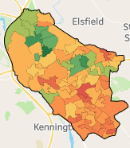 Lowest rate of claimants  Highest rate of claimants



From Oxfordshire Insight

### 2.3 - Deprivation

The economic success of the city has not reached all communities in Oxford. According to the Index of Multiple Deprivation 2019 Oxford is the 136th least deprived of the 317 local authorities in England, making it the most deprived of the five Oxfordshire districts. However this masks the fact that the city has some extremes of wealth and deprivation. One area in Oxford is within the 10 per cent most deprived areas nationally (Northfield Brook) and 9 areas in total among the 20 per cent most deprived nationally, which are located in The Leys, Barton, Littlemore, Rose Hill and Carfax. At the other end of the socio-economic scale, 12 areas in total in North Oxford, Marston, Headington, Quarry and Risinghurst, Jericho and Wolvercote are among the 10 per cent least deprived areas in the country.

Despite having most of its neighbourhood areas in the least deprived half of the Index of Multiple Deprivation ranking, Oxford has a significant proportion (17 out of 83) of its areas in the most deprived 30% in England. Key aspects of relative deprivation in Oxford are low income (especially child poverty), poor educational attainment and higher levels of health deprivation.

DWP statistics show that the percentage of children (aged under 16) in Oxford living in relative low income families (before housing costs) is 14%, lower than the UK average of 19%, but higher than the other Oxfordshire districts. According to *End Child Poverty* estimates (2018-19) after removing housing costs, 1 in 4 children in Oxford are estimated to be living in poverty.

According to the Income Deprivation Affecting Children Index (IDACI) 2019, 11 of Oxford’s Lower Super Output Areas (LSOAs) fall in the 20 per cent most deprived nationally and 3 LSOAs in the 10 per cent most deprived nationally. These numbers have improved since 2015 when they were 16 and 6 respectively. The most deprived areas on the IDACI 2019 were in parts of Blackbird Leys, Littlemore and Rose Hill & Iffley wards. These 3 LSOAs have between 34-39% of children living below the poverty line. Amongst the LSOAs in the top 20 per cent most deprived areas it’s more than a quarter of children. In contrast, less than 4% of children are living in poverty in each of the 9 least deprived LSOAs in North Oxford, Wolvercote, Marston and Headington.

As of December 2020, 3.7% of young people aged 16-18 (school year 12-13) in Oxford were classified as Not in Education, Employment or Training (NEET). This is higher than all the other districts in Oxfordshire and the highest it’s been since December 2013.

48.6% of pupils in Oxford achieved grades 5 or above in English and Mathematics GCSE in 2019/20, lower than both the national average (50.2%) and Oxfordshire average (52%).[4] Education is one of the main routes out of poverty and deprivation, so improving educational attainment is an important part of reducing homelessness.

The gap in life expectancy at birth for females in Oxford between the areas with lowest and highest life expectancies is 12.4 years. For males it is 10.9 years.

The two maps below shows where the concentrations of deprivation in the city are, and how housing need in the city predominantly comes from these most deprived areas (in this case the demand for social housing). It can also be observed that the areas with highest deprivation are also the areas of highest concentration of social housing, such as Barton, Wood Farm, Blackbird Leys, Rose Hill and Littlemore.

*Map of Oxford showing LSOA boundaries and Index of Multiple Deprivation*

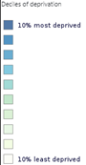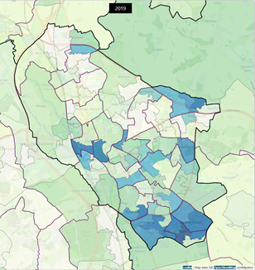

*Distribution of general register applications by postcode*

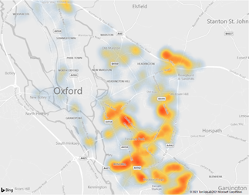

Housing need and homelessness are inextricably linked with poverty and deprivation. Households on lower incomes, people who are unemployed, or economically inactive, are all more likely to face homelessness or be forced to live in poor standard housing; but also those living in poor quality housing or who become homeless are more likely to suffer poverty and deprivation due to the destabilising nature of these events and circumstances, which make sustaining employment or undertaking training and education much more difficult. Therefore deprivation, homelessness and poor standards of housing are a self-reinforcing cycle, creating a poverty trap; so to tackle deprivation we must combat homelessness and increase the standard of accommodation.

### 2.4 - The Oxford Housing Market

Oxford is a dense urban area, surrounded by green belt and rural countryside. The housing stock varies with age, with some of the oldest homes concentrated around the centre and other historic sites, with Victorian housing in areas such as Jericho, Headington and the Cowley Road, through to post war development in areas such as Blackbird Leys and Barton. Land for new development is significantly constrained by the tight and dense profile of the city, with recent new development in areas around the train station and on the edge at Barton Park. The constraint on the height of buildings is a significant feature of development in the city due to the historic and cultural assets, but does provide additional constraint to new supply.

The 2011 census found the percentage of households who own their home in Oxford was relatively low in Oxford – 47% compared to 63% in England. While the percentage of households who rent their home in the private sector is high – 28% in Oxford compared with 17% in England.

|  |  |  |  |  |
| --- | --- | --- | --- | --- |
|  | **Oxford** | **Oxfordshire** | **South East** | **England** |
| Owned | 47% | 66% | 68% | 63% |
| Shared ownership | 2% | 1% | 1% | 1% |
| Social rented | 21% | 14% | 14% | 18% |
| Private rented | 28% | 18% | 16% | 17% |
| Living rent free | 2% | 2% | 1% | 1% |

Census 2011

Between 2001 and 2011 the percentage of households who own their home decreased from 54% to 47% and the percentage renting in the private rented sector increased from 21% to 28%.

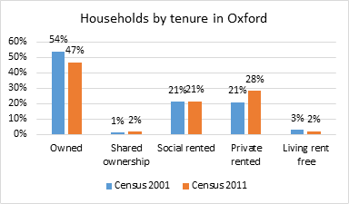

The housing market has continued to change since the 2011 census, continuing the trends observed between 2001 and 2011. The most recent information available is from a 2020 City Council commissioned report into the Private Rented Sector. This gave a new figure based on modelling from a number of data sources, and placed the size of the private sector now at 49.3%, a huge increase from 28% over the last 9 years. This would mean Oxford having one of the largest private rented sectors in the country, in terms of proportion of stock.

The city also has a sizable social rented sector, where homes are rented to tenants at below market rents. Oxford City Council owns 7,669 dwellings (including 205 in neighbouring districts), making it the biggest social landlord in the city. In addition, housing associations in Oxford have around 4,000 dwellings. There are around 62,400 dwellings in total in the city.

2.5 - Supply of affordable housing

Housing Associations, the Council and the Council’s housing company Oxford City Housing Ltd (OCHL) have built on average 73 affordable homes per year in the last ten years. This is not enough to meet demand, especially when taking into account that the Council has lost a total of 248 properties through the Right to Buy over the same decade.

The Oxfordshire Strategic Housing Market Assessment (SHMA) Update 2018 indicates a need to deliver 678 affordable homes a year in Oxford if all households who are not able to meet their needs in the housing market were to be allocated an affordable home. This assumes that households will spend up to 35% of their gross income on housing costs.

We let on average 370 council and housing association properties per year in the last ten years to general register applicants (including homeless applicants, but excluding social housing transfer applicants), which is far short of the need indicated in the SHMA Update 2018.

We explore the development of affordable housing in greater detail in chapter 9

### 2.6 - Affordability of housing

The extremes of wealth and poverty in Oxford, the strong labour market over the past decade, and the long term under supply of housing (in particular affordable housing), have combined to significantly impact on housing affordability in the city.

Many Oxford residents are unable to afford to buy or rent a home at market prices, driving poverty and displacement of established communities, alongside homelessness. According to the Office for National Statistics[5], in 2020 the median house price in Oxford was £400,000 – 11.72 times median gross earnings (£34,124) in the city. For England as a whole, the median house price is 7.84 times median earnings. According to Centre for Cities, Oxford is the least affordable city (of 62 cities) in the UK.[6]

House prices have been increasing at a much higher rate than earnings. The median house price in Oxford increased by 132% from 2002 to 2019. Median earnings for full-time employees in Oxford increased by 59% in the same period.

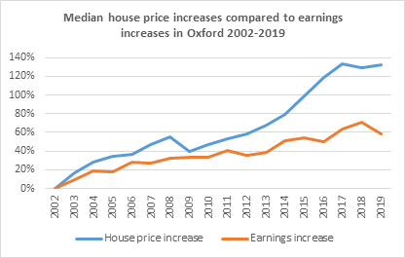

House price and earnings data taken from <https://www.ons.gov.uk/peoplepopulationandcommunity/housing/datasets/housepriceexistingdwellingstoresidencebasedearningsratio>

[ONS reports a median private rent](https://www.ons.gov.uk/peoplepopulationandcommunity/housing/datasets/privaterentalmarketsummarystatisticsinengland) of £1,500 a month for a three-bedroom home in Oxford. The equivalent amount for England as a whole is £795. A household would need an income of £51,429 if they were to spend 35% of their income on rent for an average three-bed property in Oxford, however median full-time pay for people living in Oxford is £34,124. Looking at the less expensive end of the market, the lower quartile rent for a three-bed is £1,300 a month and household would need an income of £44,571 if they were to spend 35% of their income renting a lower quartile rent three-bed property, however lower quartile full-time pay for people living in Oxford is £24,947. Market rents therefore are unaffordable for a wide sway of the city’s population, from median earners to the lower quartiles.

|  |  |
| --- | --- |
| **Area** | **Median rent for 3 bedrooms (Per Month)** |
| England | £795 |
| South East | £1,100 |
| Oxfordshire | £1,250 |
| Oxford | £1,500 |

ONS Private rental market summary statistics in England, Apr 2019 Mar 2020

The Local Housing Allowance (LHA) in the Oxford broad rental market area is £1,100 a month for a three-bedroom property as from April 2020. The LHA is used to set the amount of housing support a household can claim in Housing Benefit, or Universal Credit, so is important for access to the private rented sector for lower income households. The Broad Rental Market Area (BRMA) for Oxford covers most of Oxfordshire. However, the rents in Oxford are higher than in most other parts of Oxfordshire, so by including parts of the wider county this has the effect of lowering the average rents considered in the calculation of the LHA, so even those in the lower quartile of rents in Oxford are not covered by the LHA – the lower quartile private rent in Oxford for a three-bedroom home is £1,300 (2019/20 data). This has led to many lower income households who require support with housing costs increasingly unable to find and stay in a private rented home in the city.

The LHA was frozen for four years between April 2016 and March 2020, during which time the gap between the LHA rate and rents increased considerably. The LHA rate did increase in April 2020 providing some much needed support for private renters through the pandemic, but was frozen again from April 2021, adding further pressure in the future.

ONS Private rental market summary statistics in England, Apr 2019 Mar 2020, VOA Private rental market summary statistics for previous years

### 2.7 - Empty dwellings

As at February 2021 there were 570 long-term empty dwellings in Oxford (0.91% of total dwelling stock), of which 459 had been empty between 6 months and 2 years and 111 for over 2 years. There were also 646 dwellings classed as second homes.

The number of long-term empty dwellings have been increasing over the past 6 years.

### 

### 2.8 - HMOs, the condition of the Private Rented Sector, and licensing

The Council estimates that there are 5,240 Houses in Multiple Occupation (HMOs) in Oxford. There are estimated to be 1,794 mandatory licensable HMOs, of which 1,741 have a licence issued (as at 1 April 2020). In 2019/20 144 private rented sector dwellings were found to have one or more category 1 hazards (HHSRS), of which 92 were made free from those hazards as a result of action by the Council.

In Oxford, the Council has operated “additional licensing” since 2011, i.e. all HMOs in Oxford are subject to licensing. The additional licensing was brought in to address problems associated with poor management of HMOs. The scheme expired on 24 January 2021. However, the Council has undertaken a consultation exercise, the results of which went to the Cabinet in March 2021, who decided to renew the scheme in order to improve housing conditions and the management of HMOs. The additional HMO licensing scheme will resume for five years on the 10th of June after a statutory three month notice period.

In March 2021, the Cabinet also approved a city wide selective licensing scheme going beyond the existing licencing structure, to ensure all Oxford landlords are fit and proper and that properties let to residents meet minimum standards and are a safe place to live. The objective of selective licensing is to improve living conditions within the private rented sector and, through ensuring an improvement in management practices of the poorer performing landlords, an improvement in the surrounding community. The scheme must be confirmed by central government before it can be introduced.

There is evidence of poor housing conditions across the city in the private rented sector, with a review undertaken in 2020, which estimated there were 6242 privately rented homes containing a serious home hazard, the most common hazards found relate to fire safety and excess cold in privately rented homes. Currently the Council operates a reactive service to tackle issues of poor conditions, however if the decision to introduce city wide selective licensing is confirmed by government, a planned programme of inspections and improvements will be implemented. At this stage it is estimated that 12,000 homes will require a selective licence.

Over the recent years, short-term lettings in England has increased significantly and this growth is causing concern that it may have a negative impact on the housing market in some areas of the country. A House of Commons briefing paper on the issue from May 2020, states that the short-term let market may result in a reduction of accommodation available for long-term lets, and that if this is the case, it can exacerbates the shortage of housing and increase rents in some areas.[7] In September 2019, an internet search showed that more than 300 homes in Oxford were rented on a short-term basis.[8] This indicates that there is a potential loss of properties to the short-term let market in Oxford that would otherwise have been available to households that need access to longer term accommodation.

Due to the Covid-19 pandemic and subsequent restrictions put in place on holiday accommodation (which includes short-term lets), the short-term let market in Oxford and the rest of the country has been disrupted somewhat however.[9] We will continue to monitor the growth of short-term lettings and the potential impact this may have on the loss of domestic dwellings available for households, and in particular families, in Oxford.

### 2.9 - The housing market for students

Oxford hosts two leading Universities, and students make up a significant proportion of the city’s population. In 2018/19 there were a total of 32,930 full-time students and 9,125 part-time students at the University of Oxford and Oxford Brookes University. At the 2011 Census, 24% of the city's adult population was a full-time student (30,000 people) – the highest proportion in England and Wales. As there is not enough purpose built student accommodation a significant proportion of students live in the private rented sector.At December 2019 the two universities in Oxford had in total 22,213 accommodation places for students. That left 8,028 students with accommodation requirements living outside of university provided accommodation in Oxford. This puts a significant pressure on the private rented market in Oxford and contributes to higher rents and difficulty finding accommodation for the whole population. Recent years have seen the Universities increasing the supply of purpose built student accommodation, with one of its aims being that this accommodation will help release other residential housing in the city for other groups, and the City Council through the Oxford local plan now requires the Universities to meet certain conditions on numbers of students outside of student accommodation in order to get planning permissions on any university buildings, but the need to house large numbers of students in the PRS continues.

## **3.0 - What have we achieved so far? The current Housing & Homelessness Strategy**

|  |
| --- |
| Key Findings – The current Housing and Homelessness Strategy   * The council has made considerable progress over recent years in meeting its strategic housing and homelessness goals, such as establishing its own housing company to deliver new affordable homes (OCHL), increased the rate of affordable housing supply, opened the accommodation and assessment hub at Floyds Row, successfully implemented the Homelessness Reduction Act, and delivered considerable investment into the council’s housing stock and estates. * However, there is still a way to go in solving many of the problems the city faces. The supply of new affordable housing being delivered is still not sufficient to meet need, households are still struggling to find and keep tenancies in the city due to cost, and we still have a significant number of people rough sleeping. * A lot has been learnt regarding our approach to strategy development and implementation, and this learning should inform the new strategy. |

When developing the new strategy it is crucial to first consider and evaluate the successes and failures of the current one, and consider any learning to inform our new approach.

The purpose of this evaluation, is to determine what we have achieved over the strategy period that we set out to do, and if there are certain aspects that we set out to do, but have been unable to achieve. We have also looked at the strategy itself, how it has driven work, the process for how objectives and milestones have been updated and how work has been scrutinised throughout in order to take on any learning for the development, implementation and delivery of the new strategy.

Many of the themes picked up in this evaluation are later explored further in the wider review.

The current Housing & Homelessness Strategy (2018-21) was approved by Cabinet and adopted by Oxford City Council in January 2018.

The 5 main objectives of the strategy are:

* Increase housing supply and improving access to affordable housing
* Preventing homelessness and meeting the needs of vulnerable people
* Making best use of Private Sector accommodation
* Investing to create sustainable communities that are safe and healthy
* Being an effective landlord and delivering quality services

### 3.1 - Summary of achievements

It is evident that the Council and partners have achieved a great deal in fulfilling its aims and objectives as laid out in the strategy. We have also worked with partners to deliver aspects of work that are in line with the strategy, but not necessarily laid out as objectives. This has been necessary when the landscape has changes (for example handling the emergency that the Covid-19 emergency presented) and shows that we are able to react and adjust our service provision as needed to meet demand and change in priorities.

Key achievements under the 5 priorities are detailed below.

Priority 1: Increase the supply and improve access to affordable housing

* We have worked with partners to secure funding through the Oxfordshire Growth Board for the Housing and Growth Deal to the value of £60 million for affordable housing. The schemes planned within Oxford have started on site and future schemes are on track to start on time.
* Established Oxford City Housing Limited, the Council owned company developing social housing in the City. OCHL has to date started development on 10 sites, with public consultation about to begin in relation to other sites, and an ambitious business plan to deliver significantly more homes over coming years.
* At the end of January 2021, the Barton Park development has delivered 223 units of accommodation, with 95 let to households on the Council’s housing register. When completed, Barton Park will have delivered 885 new homes, with 354 of these let at social rent by OCHL.
* Across all developments in the City since the April 2018 and until the end of March 2021, over 300 new affordable homes have been delivered.
* Affordable housing development rates during this period have increased compared to the previous strategic cycle, from an average of 77 units a year under the last strategy (2015-2018) to 147 a year units now (2018-2020). These rates are projected to increase further in coming years through identified sites.
* Our Local Plan has been accepted and signed off and includes opportunities to develop affordable housing across many sites in the city.
* We have worked with our neighbouring Districts to start to formulate agreements on how they can help meet Oxford’s unmet housing need. The additional requirements to meet Oxford’s unmet housing need have been incorporated in each district council’s local plan. The next step for agreements are the nominations for properties in Districts for households who are on the City Council’s housing register.

Priority 2: Prevent homelessness and meet the needs of vulnerable people:

* Successfully implemented the Homelessness Reduction Act, introduced in April 2018. During the first two years operating under the HRA, we have prevented 322 number of households from becoming homeless through the new Prevention Duty and we relieved 143 households from homelessness under the new Relief Duty by assisting them to secure new accommodation.
* We have embedded a corporate commitment to homelessness prevention across the organisation.
* Delivered the MHCLG funded Oxfordshire Trailblazer Programme focussing on early or upstream prevention of homelessness, with learning now informing ongoing transformation.
* Enabled the use of the private rented sector for households in housing need by continuing the Real Lettings Scheme and starting a Rent Guarantee Scheme. We saw 126 households assisted to move on to homes in the private rented sector in 2018/19 and 104 in 2019/20.
* Worked with our partners in the County and District Councils to re-commission the Young Person’s Pathway, increasing our financial contribution to providing accommodation and support for young persons in housing need.
* Reduced the number of households that need to be in temporary accommodation to under 120 at any one time, ranging between 78 and 99 households during 2019/20, lower per capita than many comparator urban authorities.
* Since spring 2018, we have successfully bid for just over £5m funding from the government’s Rapid Rehousing Pathway, Rough Sleeping Initiatives Schemes and Next Steps Accommodation Programme to prevent and tackle rough sleeping. Funding has been awarded for (not exhaustive) a multi-agency service hub - the new Engagement and Assessment Centre at Floyds Row - , additional capacity for the city’s outreach team, navigator posts to support long-term rough sleepers, and most recently funding for the short term accommodation provided for rough sleepers in YHA and Canterbury House due to the Covid-19 Crisis, as well as longer term funding to provide permanent homes through the expansion of Housing First (including the purchase of properties) and funds to help assist move-on to the private rented sector. Some of the funding received has been made in partnership with other Districts in the County.
* We have also increased our own funding for supported accommodation.
* We have worked in partnership with Districts and County Council and Crisis to enhance our homeless prevention work.
* In a multi-agency bid, we have secured funding from the Department of Health and Social Care from the Shared Outcomes Fund to deliver a pilot project focussing on achieving better outcomes for persons in hospital who are homeless or at risk of becoming homeless on discharge. The funds is part of DHSC’s drive to ‘improve health and wellbeing and reduce health inequalities, through action to end rough sleeping’.
* In addition to this we, successfully delivered the ‘Everyone In’ initiative, that involved providing accommodation and support services for those rough sleeping and people who were housed in communal areas, during the first wave of the Covid-19 crisis. Just over 110 units of accommodation were provided through the pandemic.

Priority 3: Make best use of Private Sector accommodation

* We expanded our use of the private rented sector to prevent homelessness through the creation of the Rent Guarantee Scheme.
* Delivered campaigns to increase the number of private landlords that are working with our Home Choice Scheme.
* Teams across the Council continue to work together in order to ensure that private rented sector accommodation in the city is of good standard. We have advanced plans for a selective licencing scheme for private landlords, with a consultation held over winter 20/21, that seeks to improve the standards of private rented sector accommodation in the City.
* Since April 2018 and up until the end of November 2020, we have brought back 79 empty properties for domestic use.
* Progressed plans for renewing our additional licensing scheme, building on the success of the previous schemes in improving standards in the HMO stock.

Priority 4: Invest to create sustainable communities that are safe and healthy

* We have continued to support households in Oxford that face financial hardship due to welfare reform. In 2019/20, we administered £440,762.19 in Discretionary Housing Payments to help households afford their rent. Recently, we have integrated the Welfare Reform Team into our housing team to improve customer journeys and allow for better sharing of best practice.
* The regeneration of Blackbird Leys has progressed and the Council’s development partners, Catalyst, held public consultation events in November 2020. A planning application for the scheme is now expected in spring 2021.
* A significant investment programme has been carried out across Council owned homes, and properties have been improved in line with Energy Efficiently targets.
* We have continued to provide energy efficiency advice to our tenants through our Energy Advice Officers.
* We have promoted energy efficiency across all tenures and agreed an enforcement approach, with a pilot which ended in March 2020, which saw a 100% compliance rate for domestic properties. Enforcement power in relation to EPCs has been delegated from County, following approval from City and County Cabinets, with just agency agreement to be finalised.
* The Barton Healthy Town project completed with good practise shared with partners.
* During the Covid-19 crisis, the Council set up community hubs to be able to respond to the needs of the community. Putting staff into the community to support during the crisis, better able to respond to issues such a food and fuel poverty, and isolation. Learning from this approach is now being used to inform future service transformation.

Priority 5: Be an effective landlord and deliver quality services

* We have continued to roll out our resident ambassador programme to help deliver a tenant-led approach of our landlord services. A Tenant Involvement Portal went live in March 2020 and we achieved TPAS reaccreditation.
* We have continued to deliver our Removal Expenses and Mobility Scheme for Council tenants who wants to move and downsize. This service has been provided for 53 households from April 2018 to the end of January 2021.
* We developed a new Tenancy Strategy that is in place until 2023 that sets out the Council’s requirements and expectations of social housing providers operating within the City, helping ensure social landlords in the city operate in a way that meets housing needs, and provide secure, affordable homes.
* We revised our Allocations Scheme to take into account changes due to the Homelessness Reduction Act, the development of OCHL and the recommendations following the review of older persons’ housing.
* All schemes identified within the Great Estates programme were delivered by the end of March 2021.
* Progressed the refurbishment of the tower blocks in the city, and ensure full health and safety compliance, which is now near completion.

Since the Rough Sleeping Action Plan was incorporated to the Housing and Homelessness Strategy as an addendum in autumn 2019, we have moved ahead with the opening of the new accommodation and assessment hub at Floyds Row early in 2020. We had a promising start, but the centre had to close at the end of March due to the pandemic in order to comply with social distancing regulations. It has since reopened in a Covid compliant way, but with reduced function.

Much of the work in relation to rough sleeping since April 2020 has been focussed on providing accommodation for rough sleepers and those who were previously in communal settings (such as Floyd’s Row). A total of 319 rough sleepers and people who have been at imminent risk of rough sleeping had been accommodated in interim accommodation through the Everyone In scheme between end of March 2020 and end of January 2021; 138 of these have moved on successfully to other accommodation.

We have also worked with the Oxfordshire Districts and County Council, and health partners, alongside Crisis to establish a joint strategy for preventing and reducing rough sleeping and are working to deliver housing led services across Oxfordshire from April 2022. This was informed by a Crisis-led feasibility study carried out through 2020, and its findings informed the drafting of the new strategy. The draft strategy was consulted upon in early 2021 and will be finalised by summer 2021. Future governance and commissioning arrangements are current being considered to enable this approach. This is explored further in chapter 4.

3.2 - Challenges for the current strategy

Despite the many achievements under the current strategy, some key and significant challenges remain which need to be taken into consideration in the development of the new strategy, and underlines the need for a renewal of the council’s strategy. These challenges have to be tackled in an increasingly difficult financial climate due to the effects of the Covid-19 crisis.

* We still need to deliver more affordable homes in the city to meet housing need. While we have been successful in increasing supply of affordable homes during the latest strategic period, and the current pipeline of future supply is set to further increase delivery, supply is not yet at a level to make a significant impact on affordability in the city.
* There is still a small but entrenched number of people who sleep rough in the city. Even after the Everybody In directive from central government a small population has continued to sleep rough on the streets of Oxford.
* The profile of households that seek our help when homeless is changing and this is presenting new challenges. We are seeing greater demand from single homeless people, who have different support and accommodation needs from our historic profile of clients.
* Rents in the private rented sector remain expensive and unaffordable for households on lower incomes, leading to homelessness.

### 3.3 - Strategy delivery and monitoring

Reviewing the current strategy, and the role it has had in driving and delivering work and the monitoring processes associated with the strategy, the recommendations for the new strategy are as follows:

* A shorter and more focused strategy document is created, informed by this detailed review and evidence base.
* Annual reviews and updates of the Action Plan to ensure the strategy remains relevant and plays a key role in driving work across the organisation.
* A clearer governance and scrutiny process is established to ensure work is delivered.

## **4.0 - Local and National Policy Context**

|  |
| --- |
| Key Findings – Local and National Policy Context   * Recent years have seen significant national and local policy change, which will have significant impacts on the next strategy. * Locally, these changes include the development of a new county-wide homelessness and rough sleeping strategy, the publication of the Crisis Housing-led feasibility report, and the new Oxford local plan. * Nationally, a number of major policy changes have either happened recently or are underway, including significant national changes in approach to rough sleeping, planning and additional regulation on both the social and private rented housing sectors. * The Covid-19 pandemic has had a significant impact on the council and its services, and has had a major effect on homelessness in the city. |

A number of local and national policy changes and developments have happened in recent years that are important for the review and subsequent strategy to be informed by and address.

### 4.1 - The Homelessness Reduction Act 2017

The Homelessness Reduction Act 2017 came into effect on 3 April 2018. The Act widened the duties of local authorities to help people who are homeless or threatened with homelessness.

New provisions introduced by the act include:

* A new duty to prevent homelessness – Prevention Duty – which means that local authorities must take reasonable steps to prevent homelessness for a eligible applicant at risk of homelessness with 56 days, regardless of priority need. This can involve assisting the household to stay in their current accommodation, or helping them find a new place to live.
* A new duty to relieve homelessness – Relief Duty – which meant that local authorities must take reasonable steps to help the applicant to secure suitable accommodation, regardless of priority need, for example by funding a rent deposit or working with private landlords to make properties available.
* Requirement to carry out an assessment and personalised housing plan.
* Public bodies now have a duty to refer people whom they know are threatened with homelessness.
* Applicants have the right to ask for a review of any points of the new legislation.

The Homelessness Reduction Act 2017 brought about the biggest changes to homelessness legislation for 40 years, refocussing local authority statutory homelessness services on the prevention of homelessness, with a more person centred and collaborative approach, as well as providing a catalyst for broader culture change in the way people experiencing homelessness are treated. The requirements of the HRA led to the council re-organising how it works with homeless applicants. It has also led to a shift to the types of households we are now supporting. The act is still influencing the development of the council’s services several years since implementation, with many impacts still emerging and needing to be responded to, therefore the act will continue to be a key driver in the coming years.

A change in the data collected for homeless applicants was also introduced at the same time as the HRA. The Homelessness Case Level Information Collection, or H-CLIC, replaced the P1E forms. The new system collects more detailed data (anonymous) on the circumstances of households owed a duty under the HRA, as well as the activities undertaken by local authorities to prevent and relieve homelessness and the outcome of such activities. This means that we now have a lot more data available to us that we can use both to see developing trends and use as intelligence to change or develop the services we deliver.

The data collected by MHCLG from all local authorities through H-CLIC is published showing the activity in each local authority over a quarter. Data on temporary accommodation is however collected and published as a snap-shot at the end of each quarter.

The introduction of both the new data collection and also the changes to legislation that came about in April 2018, does mean that the data available pre-HRA and post-HRA is not directly comparable. MHCLG advises that only data on temporary accommodation and Main Duty decisions are comparable, but that any comparison made should still be made with caution as there are still lingering data quality issues with data collected nationally following the implementation of H-CLIC. We would also point out that as the context and the way in which we are now operating our homelessness services under the new legislation is very different, even these figures should not be directly compared. For example, the number of households owed a Main Duty is a lot lower since the introduction of the HRA, as more households are prevented or relieved from homelessness prior to a Main Duty decision has to be considered and made (for further details, see chapter 5).

### 4.2 - National Rough Sleeping Strategy

In 2018 the Ministry for Housing, Communities and Local Government (MHCLG) published a Rough Sleeping Strategy and a Delivery Plan[10]. The Rough Sleeping Strategy sets out the government’s plan to halve rough sleeping by 2022 and end it by 2027.

In the Delivery Plan the MHCLG sets out a commitment that all local authorities update their strategies and rebadge them as homelessness and rough sleeping strategies, that their strategies are made available online and submitted to MHCLG and that local authorities report progress in delivering these strategies and publish annual action plans.

In Oxford, the Rough Sleeping Action Plan was included as an addendum to the existing Housing & Homelessness Strategy as part of the mid-point review process of the strategy in autumn 2019.

The Government has since increased their stated ambition, and now said they want to end rough sleeping by the end of the current parliament, so December 2024 or earlier.

### 4.3 - Oxfordshire’s Homelessness and Rough Sleeping Strategy 2021-26

Oxfordshire’s Homelessness and Rough Sleeping Strategy, developed during 2020 and due to be implemented in spring 2021 following consultation, is the first County-wide and multi-agency strategy in relation to homelessness in Oxfordshire. The strategy focusses on doing the best for single people across Oxfordshire that are affected by homelessness and rough sleeping, working across geographical and professional boundaries to end rough sleeping and target resources collectively and in a prioritised way to meet the needs and aspirations of people affected. The strategy is primarily focussed on single person households.

The strategy sets out the vision ‘To prevent and resolve homelessness, so that no one sleeps rough in Oxfordshire’ and will underpin a transformation in the way housing, social care and health services work together and with people in need of housing and support. The strategy will also inform future commissioning of services. The vision is to be achieved through:

* A set of principles that guides all the work carried out through the strategy, emphasising the inclusion of those with lived experience into how services are designed and delivered
* Mission/purpose to transform the way all services work, which outlines a clear accountability for systems leaders to deliver the strategy.
* 5 priorities that outlines objectives and actions for how the priorities are to be achieved.

Three pieces of work have primarily influenced and informed the development of the strategy:

* A year-long ‘Housing-led Feasibility Study’, carried out by Crisis during 2019-2020 in Oxfordshire, that investigated the feasibility of a housing-led approach for Oxfordshire by looking at the experiences of single homeless people in Oxfordshire.
* Recommendations of the Oxfordshire Safeguarding Adults Board’s (SAR) Thematic Review of Homelessness 2019, which explored the circumstances surrounding the deaths of 9 individuals who had all experienced what the report term multiple exclusion homelessness leading up to, and at the time of their deaths in 2018/19
* The ‘Everyone In’ response delivered by the Oxfordshire local authorities from the end of March as a response to the Covid-19 crisis.

The City and District Councils as housing authorities are required by law to have their own homelessness strategies, based on a local ‘review of homelessness’. Although a county-wide strategy for homelessness and/or rough sleeping is not a statutory requirement, it is seen as fundamental to have an effective approach to tackling homelessness across the county. The new Oxford housing and homelessness strategy will therefore align and draw from the County-wide strategy.

### 4.4 - Crisis Housing-led Feasibility Study for Oxfordshire[11]

The housing-led feasibility study for Oxfordshire that has informed the County-wide strategy investigates the feasibility of moving to a housing-led approach to tackling single homelessness across Oxfordshire. A housing-led approach to ending homelessness aims to move people into their own permanent homes as quickly as possible and provide them with the support they need to make it work.

The report states that the principles underlying the Housing First model (which is one type of housing-led model) can be implemented more widely and should benefit all those who are experiencing or at risk of homelessness, which we refer to as a housing-led approach.

* Having looked at the work that is taking place on different levels across Oxfordshire to prevent homelessness and tackle rough sleeping, the study finds that despite a lot of positive work to prevent and tackle rough sleeping by a wide range of organisations, this is hampered by a high level of silo-based working and by a lack of consistent data collection against which outcomes and progress can be monitored across the whole system.

Recommendations to bring about improvements include:

* Maximise the effectiveness of prevention activity.
* Improve case management throughout the system so that fewer people lose contact, and ensure that flexible support (i.e. which is not tied to a housing offer) can follow those with the most complex needs regardless of their current housing circumstances.
* Remove the additional barriers to accessing affordable housing which many rough sleepers and single homeless people face.
* Better co-ordination and consistency at countywide level, with an option to deliver more services and functions jointly

Whilst the County-wide strategy will inevitably drive homeless prevention and rough sleeping for single people, there are important elements of the housing-led feasibility study that provide learning for the wider spectrum of homelessness services in the city, that we have the opportunity to align with over the coming strategy cycle.

### 4.5 - Abolition of Section 21 notices (Renters Reform Bill)

In December 2019 a Renters’ Reform Bill was announced by central government that will abolish the use of ‘no fault’ evictions by removing Section 21 of the Housing Act 1988 and reforming the grounds for possession. The Renters Reform Bill has however been delayed for an indefinite period due to the Covid-19 pandemic.

### 4.6 - Housing Revenue Account Changes

On 29 October 2018, the government confirmed that the Housing Revenue Account (HRA) borrowing cap would be abolished with immediate effect. Local authorities with an HRA are therefore no longer constrained by government controls over borrowing for housebuilding and other investments, and are able to borrow against their expected rental income. The HRA is fully explored in chapter 12.

4.7 - Use of receipts from Right to Buy sales

In a response to a consultation on the use of receipts from Right to Buy sales[12] the government has announced the following changes are being made:

* Extending the timeframe local authorities have to spend new and existing Right to Buy receipts from 3 years to 5 years. This will make it easier for local authorities to undertake longer-term planning, including remediation of larger plots of land
* Increasing the percentage cost of a new home that local authorities can fund using Right to Buy receipts from 30% to 40%. This will make it easier for authorities to fund replacement homes using Right to Buy receipts, as well as making it easier to build homes for social rent
* Introducing a cap on the use of Right to Buy receipts for acquisitions to help drive new supply.
* Allowing receipts to be used for shared ownership and First Homes, as well as housing at affordable and social rent, to help local authorities build the types of home most needed in their communities.

These changes take effect from 1 April 2021, with the exception of the acquisition cap, which will be introduced from 1 April 2022, on a phased basis.

### 4.8 - Social Housing White Paper

In November 2020 the government published ‘The charter for social housing residents: social housing white paper’[13] for England. The Charter sets out what every social housing resident should be able to expect:

1. To be safe in your home.

2. To know how your landlord is performing.

3. To have your complaints dealt with promptly and fairly.

4. To be treated with respect.

5. To have your voice heard by your landlord.

6. To have a good quality home and neighbourhood to live in.

7. To be supported to take your first step to ownership.

To deliver on this the government will work with the Regulator of Social Housing to create a consumer regulatory regime, strengthening the formal standards against which landlords are regulated. Among the measures in the white paper are the following: a set of tenant satisfaction measures will be created, the complaints process and monitoring will be strengthened and the Decent Homes Standard will be reviewed.

We explore the impacts of the white paper on the council’s own housing stock in chapter 10.

### 4.9 - Planning Policy changes

The government has recently consulted on both longer-term legislative reforms to the planning system (Planning for the Future[14]) and more immediate regulatory changes to the current planning system[15]. The consultations ended in October 2020.

In Planning for the Future the government proposes to:

* Streamline the planning process, including simplifying the role of Local Plans.
* Modernise the planning process through a digital-first approach.
* Bring a new focus on design and sustainability.
* Reform developer contributions. (The Community Infrastructure Levy and the current system of planning obligations such as S106 will be reformed as a nationally set, value-based flat rate charge (the ‘Infrastructure Levy’), and local authorities will be given greater powers to determine how developer contributions are used.)
* A new nationally determined, binding housing requirement that local planning authorities would have to deliver through their Local Plans.

The main proposed changes to the current planning system are:

* Changes to the standard method for assessing local housing need.
* Securing of First Homes through developer contributions in the short term until the transition to a new system.
* Supporting small and medium-sized builders by temporarily lifting the small sites threshold below which developers do not need to contribute to affordable housing.
* Extending the current Permission in Principle to major development.

First Homes is a new home-ownership affordable housing tenure with a 30% discount against market value. The intention is to require that a minimum of 25 per cent of all affordable housing units secured through developer contributions should be First Homes. Initially these will be secured through section 106 planning obligations but, under proposed reforms, these would subsequently be secured through the Infrastructure Levy.

The proposal to support small and medium-sized builders is to raise the affordable homes threshold from sites of 10 or more units or less than 0.5 hectares to up to either 40 or 50 new homes. This will be for an initial period of 18 months before reviewing the approach.

Oxford City Council responded to the government consultations in autumn 2020, opposing the plans in many areas, including the reduced local flexibility which is important for Oxford’s relatively unusual housing market, and the risk to affordable housing development levels from the abolition of S106 and the imposition of First Homes, which could impact affordability and increase homelessness. More detail is needed from government before a clearer view on the impact of these policy changes will be, and when they will be implemented.

The government is also looking to extend permitted development rights for residential conversion, which risks development of poorer quality housing in the city in the future.

### 4.10 - The Covid-19 Pandemic

The Covid-19 pandemic that has struck the country and the world over the last 12 months has introduced unprecedented challenges across all sectors of society, including local authorities. In order to tackle these challenges, the City Council introduced new ways to deliver services to our communities.

The Council modified the way the contact centre operated at the very start of the pandemic, realising that the population in Oxford would need to be supported in different ways under the very new circumstances. Local Response Hubs were set up across the city, operating from community centres in the City. The hubs were managed by Oxford City Council staff and included multi-disciplinary teams from across the Council (including housing) and partners from primary care networks. Originally set up to ensure the most vulnerable people received assistance and support, the new way of working locally in smaller areas of the city has been very successful and is now informing the re-shaping of some aspects of community and housing service delivery in the city.

As all Council offices closed with staff working from home, our housing options service moved from seeing households faced with homelessness in person, to conducting phone interviews and relying on customers to provide applications and supporting documentation via e-mail. Face to face interviews have taken place for single homeless people and rough sleepers at Floyds Row since the start of the pandemic. There is at present no electronic application forms for the majority of the services delivered through Housing Services.

Our housing company’s and other’s housebuilding programme was put on hold early on in the pandemic due to the initial lock down that restricted most employment activities across the country from taking place if they could not be done from home. With housebuilding resuming again in the summer of 2020, we have mitigated delays and the build programme remains on track.

At the start of the pandemic at the end of March 2020, the Government introduced measures to help prevent households from becoming homeless. Initially temporary measures, mortgage payment holidays, a ban on evictions from both social and private rented housing and an extension of notice periods have now been in place for almost 12 months. At the end of March 2020, local authorities were also asked by government to provide self-contained accommodation through the ‘Everyone In’ scheme to rough sleepers, those who were accommodated in shelters with shared sleeping areas and to people who were at risk of sleeping rough.

Other measures introduced by the Government, like the furlough scheme, the alignment of the LHA rate to the 30th percentile in each Broad Market Area, pause on deductions for benefit overpayments and a temporary top-up of £20 per week for Universal Credit claimants, have contributed to assist households struggling with finances to be in a better position to meet their housing costs. Whilst these measures have unfortunately not been enough for some, they have ensured far fewer households have been affected by unemployment or a loss of income than would have been the case if these measures had not been put into place at all.

The longer-term impacts of the pandemic are not known at present, but the financial impact is likely to have long-lasting effects that will affect local authorities for many years. The immediate and predicted effects on homelessness of the pandemic and the measures put in place both locally and nationally, will be discussed in more details in chapter 5.

### 4.11 - Domestic Abuse Act 2021

A new Domestic Abuse Act comes into force in 2021 which places new duties on local authorities[16].  Measures in the Act include:

* A statutory definition of domestic abuse, emphasising that domestic abuse is not just physical violence, but can also be emotional, coercive or controlling, and economic abuse. As part of this definition, children will be explicitly recognised as victims if they see, hear or otherwise experience the effects of abuse.
* Extending the controlling or coercive behaviour offence to cover post-separation abuse.
* A duty on local authorities in England to provide support to victims of domestic abuse and their children in refuges and other safe accommodation.
* All eligible homeless victims of domestic abuse automatically have ‘priority need’ for homelessness assistance.
* When local authorities rehouse victims of domestic abuse, they do not lose a secure lifetime or assured tenancy.
* A new Domestic Abuse Protection Notice and Domestic Abuse Protection Order, which will prevent perpetrators from contacting their victims, as well as force them to take positive steps to change their behaviour, e.g. seeking mental health support.

## **5.0 - What is the extent of the homelessness problem in Oxford?**

|  |
| --- |
| Key Findings – What is the extent of the homelessness problem in Oxford?   * The introduction of the Homelessness Reduction Act means that we are working with more households to prevent and relive their homelessness than in the past * We have seen a gradual reduction in the number of households that have to be provided with temporary accommodation over the last 8 years, showing that we are preventing more households from becoming homeless. * The number of rough sleepers in Oxford is on a downward trend after peaking in 2017, but is still very high when compared to other local authorities. * Overall, the level of homelessness in Oxford is significantly higher than in our neighbouring local authorities. * The overall picture on the level of homelessness has improved slightly compared to 2018, when the previous homelessness strategy came into place. Some of the improvement to the level of homelessness can likely be attributed to an increase in funding for homelessness services from the national Rough Sleeping Initiative and other funding streams, allowing for the provision of extra homelessness prevention support, as well as providing more services for rough sleepers. * Caution must be taken when using the trends in homelessness of recent years to project future rates, with the pandemics full impacts yet to be felt, with ending of furlough, rise in unemployment and the eviction ban likely to contribute to a strong upward pressure on homelessness rates in the coming year. |

To get a clear picture of the level of homelessness we are now facing in Oxford, we first need to define what homelessness means for the purpose of this review. As homelessness comes in many different forms, it can sometimes be difficult to account for, but in order to get as comprehensive picture as possible, we have included a number of different ’categories’ of homelessness in this review and describe the trends for these over the last few years. These are:

* Households where we owe a statutory duty to assist to Prevent and Relieve homelessness
* Households where we have accepted a Main Duty
* Households in temporary accommodation
* Households included on the General Register for social housing and who are in the highest preference groups.
* Rough sleeping
* Hidden homelessness

In addition to the data for Oxford City in relation to the categories above, the information published by Shelter in the report ‘This is England: A picture of homelessness in 2019’[17] should also be considered when investigating the extent of homelessness in Oxford. The report has access to less local data sources than this review so is likely less accurate, but can instead provide a consistent measure across English local authorities, and therefore allows for a good national comparison of levels of homelessness. According to the report, Oxford ranked 111th out of 317 local authorities in England for homelessness as proportion compared to the overall population. The number of persons estimated to be homeless in Oxford at the time of the report was 237.

The level of homelessness for individual local authorities was calculated in the report using:

* Estimated no of people homeless and living in temporary accommodation arranged by the council as at March 2019
* Estimated no. of people homeless and living in temporary accommodation arranged by them or homeless at home as at March 2019
* Number that were rough sleeping as at Autumn 2018

The three local authorities in England with the highest rates of homelessness as compared to their population was Newham, Haringey and Kensington & Chelsea.

This is how the level of homelessness in Oxford compares against local neighbours, and the peer group of authorities with similar local contexts, in 2019 when the report was produced. It should be noted however, that this data is pre-pandemic, and the numbers are likely to look very different in early 2021, primarily due to the ‘Everyone In’ scheme that saw a large number of people at imminent risk of rough sleeping and those experiencing rough sleeping accommodated in interim accommodation.

|  |  |  |  |
| --- | --- | --- | --- |
|  | **Estimated total no. of people who are homeless** | **Rate of ppl who are homeless (1 in x people)** | **Net rank (England)** |
| Oxford | 237 | 651 | 111 |
| Cherwell | 76 | 1,963 | 208 |
| South Oxfordshire | 28 | 5,018 | 278 |
| Vale of White Horse | 28 | 4,776 | 276 |
| West Oxfordshire | 12 | 9,150 | 295 |
| Bristol | 1,609 | 288 | 62 |
| Cambridge | 181 | 695 | 118 |
| Milton Keynes | 1,959 | 137 | 37 |
| Reading | 593 | 275 | 60 |

Source: This is England: A picture of homelessness in 2019 - Shelter

5.1 - Households at risk of becoming homeless and homeless households that we owe a duty to support

We are obliged by law to support certain households to relieve their homelessness either if they are already homeless and need assistance to secure accommodation; or to seek to prevent households from becoming homeless in the first place if they are threatened within homelessness within 56 days. We owe prevention and relief duties to all eligible households, irrespective of whether the applicant may or may not have priority need or is considered intentionally homeless. This service is delivered through the Housing Options team (part of Housing Needs) in Oxford City Council.

If our efforts to work with a household to prevent and relieve their homelessness have been unsuccessful and the household is homeless, we then owe a Main homelessness duty (Main Duty) towards applicants who are deemed to be eligible, in priority need, with a local connection and are unintentionally homeless. The Main Duty and definition has not changed since the implementation of the Homelessness Reduction Act (HRA), but households are now only owed a Main Duty if their homelessness has not been prevented or relieved.

Before the introduction of the HRA, we only had to accept homeless applications and offer assessments to those we believed were eligible and at risk of homelessness within 28 days, and we would only owe a Main Duty to those who were also in priority need and unintentionally homeless.

The introduction of the new duties under the HRA has therefore significantly widened the scope of who we work with, which has ultimately resulted in a significant increase in the number of households we complete an assessment for and who owe a duty towards overall. We can see this if we compare the number of households owed a prevention or relief duty – which was 665 in 2018/19 and 564 in 2019/20 – to the number of households owed a Main Duty pre HRA which at its highest was 141. We can also see the increase by looking at the number of applications or assessments were carried out pre and post HRA. The number of homeless applications taken prior to the introduction of the HRA was at its highest 10 years ago at 475. Since 2013/14 however, the number of applications taken have ranged between 232 and 295. In the two first years operating under the HRA, we carried out 954 and 712 assessments.

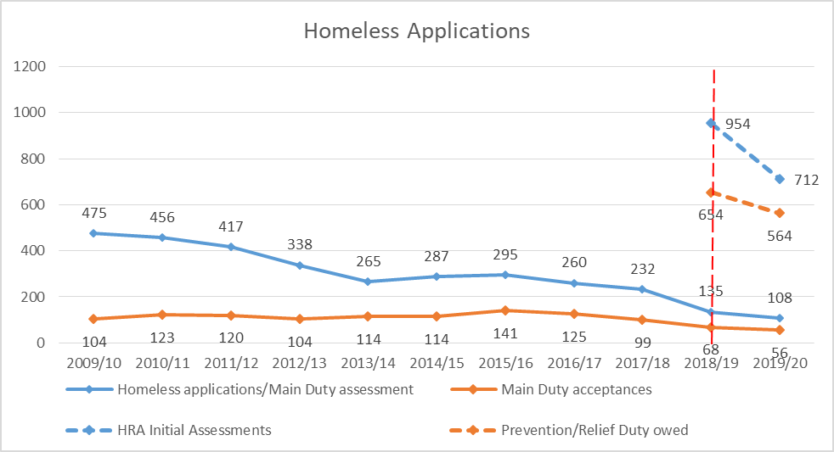

*Source: MHCLG P1E Homelessness returns (2010/11 to 2017/18) and MHCLG Statutory Homelessness: Detailed local authority level tables: financial year 2018-2019 and Detailed local authority level tables: financial year 2019-20*We should however point out that the changes to the way we work under the HRA does mean that it is very difficult to draw clear conclusions on overall levels of homelessness from comparisons between pre and post 2018 data, as already mentioned in chapter 4.1. This is because the new duties are aimed at preventing and relieving homelessness, meaning that fewer households are then assessed for Main Duty than previously due to better prevention and relief work resolving their cases before a main duty decision is made. This makes it more difficult to judge if actual homelessness levels have increased or decreased in the period through looking at Housing Options activity, aside from the clear increase of demand on the team from having to deliver the new HRA requirements, but does indicate more households are receiving support earlier to prevent and relieve their homelessness situation, and having their situation resolved before they need to have a Main Duty decision.

### 5.2 - Prevention and Relief Duties

In 2019/20, we accepted a Prevention or Relief Duty to a total of 564 households that sought help from the Council. This was a reduction compared to 2018/19, when we accepted a Prevention or Relief Duty towards 665 households.

The first quarter of 2020/21 saw a sharp increase in the number of households we owed a duty towards, which is primarily linked to the Covid-19 crisis and the provision of emergency housing for all rough sleepers (and acceptance of a Relief Duty). Subsequent quarters have seen levels of duties owed reduce to levels more comparable to previous periods and more normal circumstances. We expect that the reduction in duties in recent quarters is a result of fewer households approaching us who are threatened with homelessness due to being asked to leave their private rented accommodation. Since the pandemic started there has been a government imposed ban on evictions which is preventing landlords from evicting tenants in most circumstances. We fear that when this ban is lifted, we will see a surge in households being given notices to leave their accommodation that will then need our assistance.

The graph below illustrates the level of initial assessments of homelessness and needs (HRA Initial Assessments) that have been carried out since April 2019 and the outcome of these assessments.

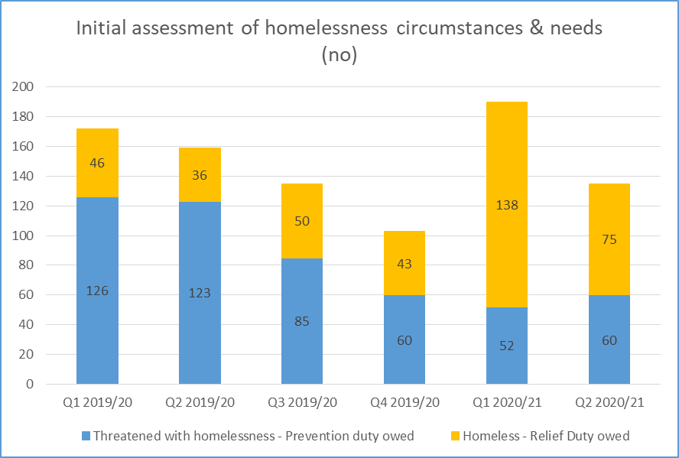

*Source: MHCLG Statutory homelessness: Detailed local authority level tables for relevant periods*

Before the pandemic, we accepted significantly more Prevention Duties than Relief Duties. The sharp increase in Relief Duties accepted during the first 6 months of 2020/21 (Q1 and Q2) is due to the ‘Everyone In’ mandate. All rough sleepers and single homeless people accommodated through the schemes set up from end of March 2020, were offered an initial assessment resulting in a Relief Duty.

In 2019/20 the proportion of households for which we accepted a Prevention or Relief duty was lower than the national average, but broadly in line with the regional average for the South East. Compared to the other local authorities in Oxfordshire, the proportion of accepted duties is significantly higher, based on the number of households resident in the areas.

During the same period, the percentage Prevention Duties we accepted as a percentage of duties accepted was significantly higher than the national and regional average. This indicated that households come to us for assistance before they are homeless and this improves the chances of us preventing homelessness from happening. Apart from West Oxfordshire, the other local authorities in the County show a similar picture, whilst areas like Bristol and Reading have a very high percentage of Relief Duties accepted.[18]

|  |  |  |  |  |
| --- | --- | --- | --- | --- |
|  | **Total households assessed as a duty owed 2019/20** | **Total households assessed as duty owed per (000s) households** | **Households owed Prevention Duty % of total duties owed** | **Households owed Relief Duty % of total duties owed** |
| Oxford | 564 | 10.54 | 69.5% | 30.5% |
| South East | 40,290 | 10.58 | 54% | 46% |
| England | 288,470 | 12.25 | 51.5% | 48.5% |
| Cherwell | 408 | 6.64 | 70% | 30% |
| South Oxfordshire | 381 | 6.64 | 82% | 18% |
| Vale of White Horse | 336 | 5.9 | 82% | 18% |
| West Oxfordshire | 287 | 6.1 | 53% | 47% |
| Bristol | 2,089 | 10.68 | 28% | 72% |
| Cambridge | 658 | 14.9 | 36% | 64% |
| Milton Keynes | 2,439 | 22.89 | 48.5% | 51.5% |
| Reading | 973 | 14.94 | 32% | 68% |

*Source: MHCLG Statutory homelessness: Detailed local authority level tables: financial year 2019-20*

### 5.3 - Main Homelessness Duty

Due to successful work under prevention and relief duty, the number of households we assessed for Main Duty, reduced following the implementation of the HRA. In 2019/20, 108 households were assessed for a Main Duty with 56 of these (51.9%) accepted. In previous years, we have assessed between 232 and 475 applications for Main Duty. A reduction in the number of Main Duty decisions made has also been a national trend following the implementation of the HRA.

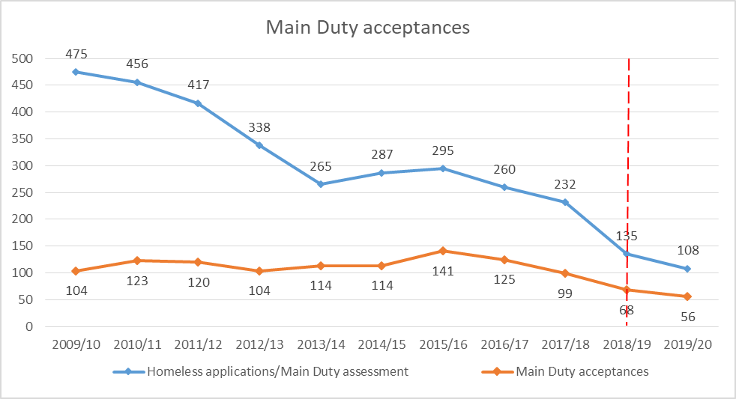

*Source: MHCLG P1E Homelessness returns (2010/11 to 2017/18) and MHCLG Statutory Homelessness: Detailed local authority level tables: financial year 2018-2019 and Detailed local authority level tables: financial year 2019-20*

Despite the decline in the total number of Main Duties assessed, the proportion of acceptances for Main Duty decisions has increased compared to previous years. The proportion of acceptances was at its highest in 2019/20 at 51.9%, whilst in 2009/10, the rate was only 21.9%. Whenever possible, we try to resolve homelessness before a case move on to a Main Duty, and in particular where we suspect that any decision under Main Duty would be a negative one (not homeless, not in priority need, intentionally homeless), as such a decision limits what the local authority can do to assist in the future. This approach has contributed to the increase to the proportion of decisions resulting in Main Duty owed. Compared to the national and regional averages however, our acceptance rate per total decision made is still lower.

When looking at Main Duty acceptance rates per 1,000 households in an area, our acceptance rate has generally been lower than the average for England over the years and this was still the case in 2019/20. Our acceptance rate was also lower than that of the South East and our comparator local authorities outside of Oxfordshire. We see this, along with the decrease in the overall number of Main Duty assessments carried out, as evidence of us preventing and relieving homelessness effectively, as this ultimately results in there being no need to progress the case and assess a Main Duty. However, our acceptance rate was higher than other local authorities in Oxfordshire. We know that our neighbouring districts do good prevention and relief work, which supports our view that a lower level of main duty acceptance is linked to preventing greater levels of homelessness.

|  |  |  |  |
| --- | --- | --- | --- |
|  | **Total number of main duty decisions 2019/20** | **Main Duty owed as % of total Main Duty decisions** | **Households assessed as Main Duty owed per (000s) households** |
| Oxford | 108 | 51.9% | 1.04 |
| South East | 9,550 | 64.2% | 1.6 |
| England | 62,490 | 64.1% | 1.7 |
| Cherwell | 35 | 37.1% | 0.21 |
| South Oxfordshire | 32 | 59.4% | 0.33 |
| Vale of White Horse | 29 | 48.3% | 0.25 |
| West Oxfordshire | 74 | 73% | 0.87 |
| Bristol | 879 | 80.7% | 3.62 |
| Cambridge | 210 | 42.4% | 2.02 |
| Milton Keynes | 795 | 90.7% | 6.74 |
| Reading | 228 | 65.4% | 2.29 |

*Source: MHCLG Statutory homelessness: Detailed local authority level tables: financial year 2019-20*

### 5.4 - Temporary Accommodation

Under certain circumstances the Council has a legal obligation to provide temporary accommodation to homeless applicants.

The number of households in temporary accommodation over the last decade has followed a fluctuating, but gradually declining trajectory. There was a clear reduction between summer 2018 and autumn 2019 from over 120 to under 80. The numbers have since fluctuated, but have broadly remained in line with the declining trend of the past decade. This is contradictory to trends for many other local authorities that have seen the need to use temporary accommodation increase since the introduction of the HRA.

However despite this positive picture, since the pandemic started we have seen an increase in the number placements of households in temporary accommodation, and a modest increase in total numbers in temporary accommodation.

Most of the temporary accommodation stock the council operates is either owned directly by the council through its housing revenue account or its general fund. Historically the council has made more use of private sector leased properties for temporary accommodation but has moved away this expensive model, with greater in-house provision, support by new investment in new stock including units in Bicester and Didcot. In urgent circumstances households can be placed in “nightly charge” accommodation, such as a hotel, to ensure they have a place to stay at very short notice. This is kept to a minimum, and stays in this form of accommodation typically last days before moving to more suitable accommodation. The council is also committed to no B&B use for families over 6 weeks, with no family stays in B&B over 6 weeks recorded for many years.

It is a priority for the Council to keep the number of households in temporary accommodation as low as possible, and only use this option as a last resort and when all other prevention and relief activities have been unsuccessful. Living in temporary accommodation can have a detrimental and destabilising effect on households, in particular children, and the provision and management of such accommodation is expensive for the Council.

Whilst the overall number of households in temporary accommodation has reduced over the last decade, we have seen a change to the household make-up of those placed, with marked increase in singles placed in temporary accommodation in previous years, the majority of households in temporary accommodation have been households with children.

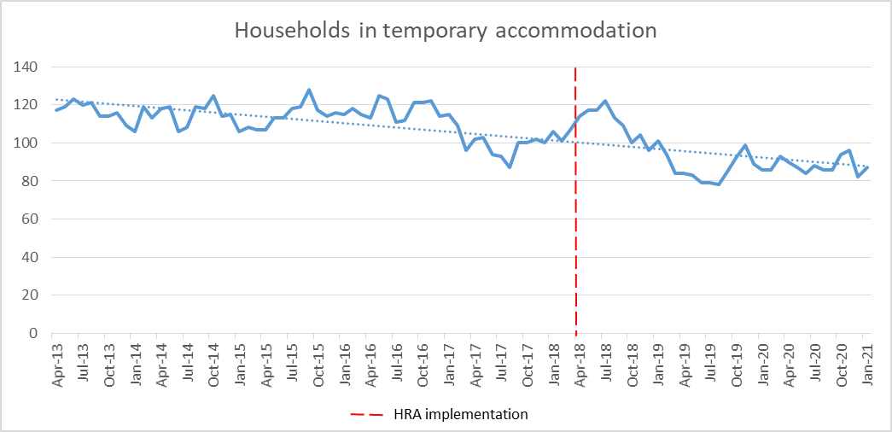

*Calculated as per P1E definition*

Compared to national and regional levels, our level of households in temporary accommodation is low, and we are doing significantly better than our comparison authorities in keep the number of households in temporary accommodation low. Compared to the other local authorities in the County however, we have a high number of households in temporary accommodation, but likely stems from the greater levels of demand from being an urban authority with higher levels of deprivation.

We explore temporary accommodation in greater detail in chapter 8.

|  |  |  |
| --- | --- | --- |
|  | **Total number of households in TA Dec 2019** | **Number of households in TA per (000s) households[19]** |
| Oxford | 87 | 1.58 |
| South East | 8,820 | 2.32 |
| England | 88,310 | 3.78 |
| Cherwell | 24 | 0.4 |
| South Oxfordshire | 10 | 0.18 |
| Vale of White Horse | 8 | 0.15 |
| West Oxfordshire | 22 | 0.48 |
| Bristol | 561 | 2.88 |
| Cambridge | 106 | 2.41 |
| Milton Keynes | 690 | 6.34 |
| Reading | 150 | 2.27 |

*Source: MHCLG Statutory homelessness: Detailed local authority level tables: October to December 2019(revised)*

### 5.5 - Households included on the register for social housing

The number of households included on the register for social housing in Oxford gives us an indication of how many households are seeking and waiting to access alternative more secure, suitable and affordable accommodation than they are currently in.

Oxford as of January 2021 has 2,852 households registered on the councils register for social housing, or 5% of the City’s population. 1,746 of these are on the general register, made up of households who do not currently live in social housing in Oxford, and 1,106 on the transfer register, households who are currently in social housing and seeking to move.

The Oxford housing register prioritises households via a criteria that places each households in band from 1 (being top priority) to 5, based on their circumstances. Of 2,852 households, 1,355 or 47.5% were placed into bands 1-4, due to hitting certain criteria that demonstrates their additional housing need. 1,497 or 52.5% have been placed in band 5, deemed as not hitting any band criteria and therefore not in sufficient housing need to be placed in a higher band.

The criteria that determine which band a household is placed into include examples such as overcrowding, under occupation, and homelessness. Breaking these criteria down to see how many households these are applicable for helps show where housing need is currently emerging from outside of the social housing stock (in bands 1-4 on just the general register, so excluding the transfer register). The largest group of 333 (49.1%) households were due to overcrowding in the current home, followed by 272 (40.1%) households currently either homeless or at risk of homelessness, followed by 30 (4.4%) awarded priority through an exceptional circumstance, 25 (3.7%) due to a health or disability need, and 18 (2.7%) in a variety of other smaller categories. There will be some cross over within these groups with households able to fit under multiple categories, with some households coming under the reason which gives them their greatest priority. Chapter 8 explores the distribution of allocations of social housing to each of these categories.

Around 3.1% of Oxford’s households were on the general register in 2019/20 seeking to move into social housing (excluding those already in social housing seeking to be rehoused). The number of households on the general register has fluctuated over the recent few years, and we need to be careful to draw conclusions on trends with no clear pattern emerging, with it more likely the fluctuations are linked to periodic drives to improve the management of the register by staff through the updating of information, which often sees many households excluded due to finding changes in their circumstances or a failure to reapply.

When comparing the number on the general register to other local authorities it can be observed we are roughly in line with our comparator urban authorities, who also have their own housing stock. The comparison however has limited use, with similar seemingly random fluctuations in the numbers on the lists observable in the other authorities data. The number of people on the register is likely only providing a partial indication of demand for social housing in each area, with each authority managing its own allocation scheme and register rules, that may include or exclude different groups, with different profiles and levels of social housing stock likely existing across the areas which could impact demand.

Certainly the earlier findings of this review have shown acute demand for affordable housing in the city, with a long term undersupply of affordable housing that people can bid on through the housing register, but this high and growing demand is not seen in Oxford’s housing register data over recent years. This creates the question of to what extent do the current rules and eligibility of the council allocations scheme exclude people from the housing register, masking true demand? And how many people in the city do not apply for social housing who would benefit from it, because they know how unlikely they are to be successful in gaining housing due to this undersupply?

|  |  |  |  |  |  |
| --- | --- | --- | --- | --- | --- |
| **Percentage of households on the housing waiting list (excl transfer applicants)** | | | | | |
|  | **2015/16** | **2016/17** | **2017/18** | **2018/19** | **2019/20** |
| Oxford City Council | 4.4% | 3.9% | 3.0% | 2.6% | 3.1% |
| Bristol City Council | 5.1% | 4.6% | 6.1% | 6.3% | 7.0% |
| Cambridge City Council | 4.9% | 5.0% | 5.3% | 5.9% | 3.8% |
| Milton Keynes Council | 0.0% | 0.0% | 0.0% | 1.2% | 2.5% |
| Reading Borough Council | 7.8% | 7.0% | 7.2% | 4.4% | 4.4% |

### 5.6 - Rough Sleeping

The number of persons rough sleeping in the City has increased significantly in the last 8 years, mirroring a national trend and peaking in 2017 with 63 persons counted during the annual street count[20]. Since then, the number of rough sleepers has decreased. The decrease can in part be attributed to the additional funding the Council has put into initiatives tackling rough sleeping, including funds received from the government’s Rough Sleeping Initiative.

In the last year, the number of rough sleepers has reduced to levels last seen in 2013, achieved as part of the ‘Everyone In’ mandate. Under this mandate, all local authorities in the country were asked to provide accommodation for all rough sleepers and those accommodated in communal areas to allow people to live in self-contained accommodation during the pandemic.

Between March 2020 and the end of January 2021, we have accommodated 319 individuals in interim accommodation under ‘Everyone In’, including around 60 persons who were decanted from communal settings into interim accommodation at the end of March 2020. In mid-March 2021, 116 people were accommodated across three sites of interim accommodation - 92 were rough sleeping at the time they accessed the provision, and the remaining 24 had been at imminent risk of rough sleeping at time of access.

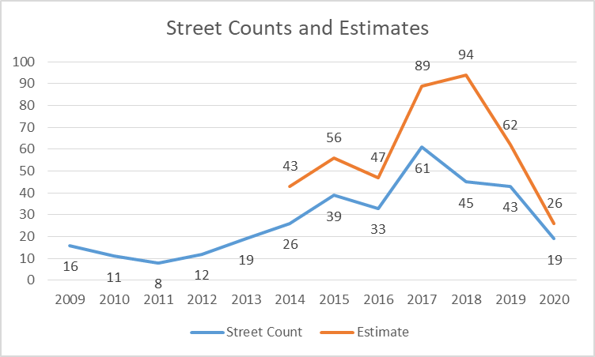

The number of rough sleepers is high for a city of Oxford size, with almost 8 persons rough sleeping per 10,000 households in 2019 (using the street count number for 2019). This is significantly higher than the national and regional average, and far higher than the level of rough sleeping seen in our neighbouring Districts. This is likely due to a range of factors, including the expensive and competitive Oxford housing market causing people to lose accommodation, alongside the well documented pull factors of people who sleep rough from surrounding areas to larger urban areas, made greater in Oxford due to its good range of statutory and charitable services on offer for people.

The level of rough sleeping per households reduced to 3.45 in 2020, the largest decrease in rough sleeping of all our comparator local authorities. Rough sleeping reduced only marginally in the other Districts in Oxfordshire, and West Oxfordshire saw an increase (by 1) rough sleeping.

Reduction to the number of rough sleepers was seen across the country in 2020 compared to previous years. When comparing street count and estimate numbers for 2020 to previous years however, MHCLG advises that ‘*This year’s rough sleeping snapshot coincided with a national lockdown throughout November and many areas were in the highest tier of restrictions in October. This is likely to have impacted people’s risk of rough sleeping and should be noted when comparing this year’s annual snapshot figures with previous years.*’ Most local authorities would also have had some form of emergency accommodation available to rough sleepers during this time due to the ‘Everyone In’ mandate. At the end of November for example, around the time when the street count was carried out, we reported to MHCLG that we had 118 rough sleepers or people at risk of rough sleeping living in emergency accommodation provided in response to the pandemic.

|  |  |  |  |  |
| --- | --- | --- | --- | --- |
|  | **Number of persons sleeping rough (2019 street count/estimates[21])** | **Number of persons sleeping rough in 2019 per 10,000 households** [22] | **Number of persons sleeping rough (2020 street count/estimates)** | **Number of persons sleeping rough in 2020 per 10,000 households** [23] |
| Oxford | 43 | 7.97 | 19 | 3.45 |
| South East | 900 | 2.36 | 474 | 1.26 |
| England | 4,266 | 1.81 | 2,688 | 1.16 |
| Cherwell | 11 | 1.80 | 10 | 1.67 |
| South Oxfordshire | 4 | 0.70 | 3 | 0.53 |
| Vale of White Horse | 3 | 0.52 | 1 | 0.19 |
| West Oxfordshire | 3 | 0.64 | 5 | 1.08 |
| Bristol | 98 | 5.0 | 50 | 2.58 |
| Cambridge | 33 | 7.5 | 16 | 3.56 |
| Milton Keynes | 35 | 3.27 | 18 | 1.68 |
| Reading | 28 | 4.31 | 19 | 2.88 |

*Source: MHCLG: Rough Sleeping snapshot in England: autumn 2019 and Rough Sleeping snapshot in England: autumn 2020*

In addition to the street count and estimates, we collect other data on a regular basis on the level of rough sleeping in Oxford. The data captures numbers and information on rough sleepers seen bedded down in the city by our commissioned outreach team. This gives us a more comprehensive picture and trend of the level of rough sleeping throughout the year, and not only on a particular night as a snap-shot.

When looking at the number of individual rough sleepers seen bedded down in every month since 2017, we can see that the number has fluctuated, but that the overall trend is reducing sharply. The trend for people rough sleeping for the very first time in Oxford has however remained fairly constant and shows that despite our increased success in assisting people off the streets and into accommodation in recent years, we have further work to do to prevent new people ending up on the street.

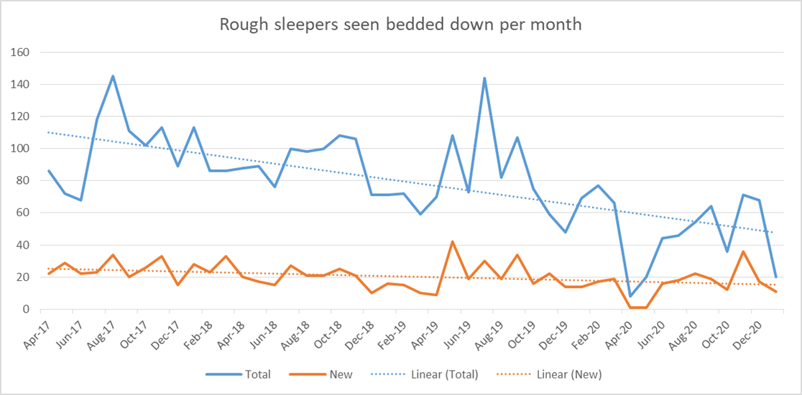

*Source: OxTHINK*

While the majority of people seen rough sleeping on a monthly basis are known to services and have rough slept in the city before (sometimes for long and extended periods of time), when looking at that annual figures for rough sleeping we can see that new rough sleepers made up a large proportion of those seen rough sleeping each year. In fact they made up a majority of rough sleepers in 4 of the last 5 years of which we hold records for. Between April 2020 and the end of January 2021, a total of 285 people had been seen sleeping rough, 154 of these rough sleeping for the very first time in Oxford.

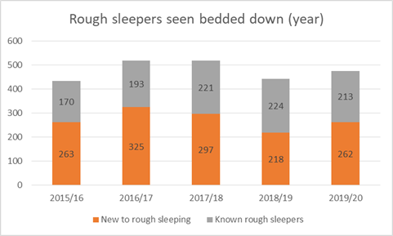

*Source: OxTHINK*

In the last year, we have seen a reduction in the number of persons who have been rough sleeping in the City for longer periods of time. The provision of emergency accommodation under the government’s “Everyone In” initiative, has provided an opportunity for longer term rough sleepers to access support and accommodation in a way that they haven’t before. This has led to some breakthroughs for people who have been rough sleeping and ‘circulating’ through supported accommodation projects for many years. At times in the last year, the number of long term rough sleepers seen bedded down, was as low as one, and whilst this may have been due to others living in the interim accommodation, it has shown a way forward to end long term rough sleeping.

### 5.7 - Hidden Homelessness

We have a good sense of the number of households that are included in the various groups of homelessness accounted for above because we have at some point interacted with them, and are therefore included in one of the data sources we use. We do however acknowledge that there are groups of people that are homeless that we do not routinely capture in our data. This group of people are often referred to as ‘hidden homeless’.

Those included in the ‘hidden homeless’ group can include those living in overcrowded, insecure or uninhabitable conditions; people living in squats; sofa-surfers; persons or families living with friends or family because they cannot afford their own home. They are described as ‘hidden homeless’ because they do not appear in any data or statistics. The government’s own statistical releases on homelessness, note ‘hidden homelessness’ as a phenomenon, but also states they cannot quantify it in numbers.[24]

The last piece of national research into hidden homelessness was undertaken by Crisis in 2011[25] which found a sizeable group hidden from view of any homelessness services - in squats, with friends, in police cells, with strangers, or sleeping rough in less visible locations. It found that single homelessness was synonymous with hidden homelessness. Since then no equivalent piece of research has been conducted. Last year Crisis estimated that 63,000 people in England were ‘sofa surfing’ on any given night, as part of research into this issue. People who are sofa-surfing are likely to constitute ‘hidden homeless’.

The Office for National Statistics has also published data on young adults living with their parents across the country, which gives further insight into the issue of sofa-surfing. It shows that between 2010 and 2019 the percentage of 20-34 year olds living with their parents increased from 23% to 27%.[26] The Office for National Statistics also published data on ‘concealed families’, which gives insight into the issue of ‘sofa-surfing’ for couples, couples with children and lone parents with children. The data available is from 2011, and showed that there were 858 such households in Oxford. The largest group were couple without children, making up 49% of ‘concealed families’. 21% were lone parents with dependent children. It is of course difficult to know if any or some of these households were in the council or other homelessness services. If we look at the accommodation information given at time of application for those we owe a duty towards, we can get a sense of the number of households who may have been sofa-surfing prior to approaching the council. We include here households who were living with friends and family as well as households stating that they had ‘no fixed abode’[27]. This shows that 31.9% (125 households) of those we owed a prevention duty towards and 51.2% (87 households) of those we owed a relief duty towards in 2019/20, may have been sofa-surfing and may therefore have been ‘hidden homelessness’ before they approached the council for assistance. We have not got the full data for 2020/21 available at the time of writing, but can see that during the period September to December 2020, the rates of those who were accommodated with family, friends or had no fixed abode increased for households owed a prevention duty, but decreased slightly were a relief duty was owed. We can’t unfortunately determine which household type these households were at this point in time.

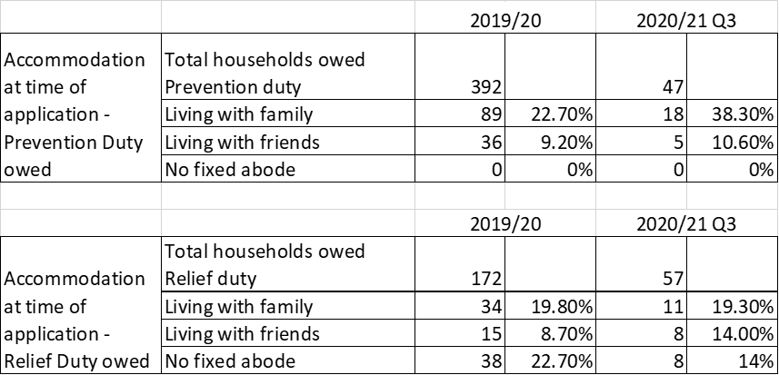

*Source: MHCLG Statutory Homelessness: Detailed local authority level tables: financial year 2019-20 and Detailed local authority level tables: September to December 2020*

Since the introduction of the Homelessness Reduction Act, we are capturing more households that would previously have been ‘hidden homeless’ as our duties to help households have expanded, but it’s likely a significant number remain beyond our knowledge.

As concluded in a recent report to Oxford City Council Cabinet discussing ‘hidden homelessness’ - ‘In order to end homelessness, it must first be understood. Understanding requires evidence, and the Housing Needs service is making more and more use of data, not just to understand the picture of homelessness today, but to try and identify those households that are likely to be at risk of homelessness in the future. In this way we can ensure that homelessness is visible to us, which will allow us to develop the right solutions to end it.’[28]

### 5.8 - Covid-19 impact on the extent of homelessness in the City

As touched on in chapter 4, the Covid-19 pandemic has introduced significant challenges to all aspects of society, including homelessness in the City. We also predict that the effects will be felt and play out for the foreseeable future.

We have seen some big changes to homelessness in the city since the start of the pandemic and the measures put in place both locally and nationally. The patterns here are similar to those seen in the rest of the country and the most prominent trends are:

* We saw an increase in pressure on our housing options service during the first few months of the pandemic in particular, driven in large part by a sharp increase in single people already homeless. Over the last quarter, the breakdown of household types we owe a duty towards has however changed, returning to similar levels as before the pandemic.
* The number of households threatened with homelessness due to a tenancy in the private rented sector ending, usually by far the most common reasons for homelessness, reduced significantly. We see this as a direct link to the ban on evictions. We fear that this is merely delaying evictions from taking place though, and that approaches from households being evicted from accommodation will gradually increase once the ban is lifted.
* Friends or family asking households to leave has been the predominant reason for homelessness since the start of the pandemic. Whilst this group may under normal circumstances have been able to stay with friends and family, the stringent measures introduced on all aspects of life during the lock-down, will have put extra strain on relationships.
* The number of rough sleepers has reduced dramatically compared to previous years, due to the additional accommodation provided through the ‘Everyone In’ scheme, which continues to this day.

We can also see from our internal data that the collection of rent across the tenancies in our council owned housing stock have been impacted by the pandemic. Initially arrears rose during the first lockdown, most likely due to the economic impact and jobs losses, alongside an ending of many forms of arrears recovery action. Despite this the arrears situation has improved through the year, with arrears now returning to close to pre-pandemic trends in recent months. A study by the Resolution Foundation carried out in February 2021 looking more broadly at arrears across the country, found that rent arrears across tenures have seen a steady increase as the pandemic has continued. The report estimates that 9% of families living in social housing were behind with their rent payment in January 2021, with 6% of those living in the private rented sector in arrears and 2% of those with a mortgage behind with payments. This equates to over 750,000 families being behind with payment, with 300,000 of these with dependent children. The report further points out that this level of arrears are at least twice as high as before the pandemic.

The report has further found that a higher proportion of those in the private rented sector have seen earnings fall or lost their job compared to those with a mortgage.[29] With a significantly higher proportion of households living in the private rented sector in Oxford than other parts of the country, the impact on homelessness in Oxford could therefore also be significantly higher.

With households in Oxford already spending a very high proportion of their income on housing costs, there is a real risk that those households that have accrued arrears, may eventually be evicted from their homes once the ban on evictions is lifted. Home owners will also be at risk when the mortgage holiday ends.

We also know that unemployment rates in Oxford are at a much higher level than before the pandemic and the effects are expected to last for a long time. With incomes affected, as well as potential debt incurred during financial hardship and falling behind with rent payments, both in the social and the rented sector, this may mean that there will be an increase to the number of households that will struggle with already unaffordable hosing costs.

We also face big challenges in relation to the ongoing pressures to provide accommodation for those accommodated under the ‘Everyone In’ scheme. As pointed out in a Crisis study into the initial impacts of the pandemic on homelessness across the country, there is ‘growing anxiety around how long the expectation of providing emergency Covid-19 accommodation will continue for and how they are expected to maintain this level of support without additional move-on options…’.[30] We are however making good progress to overcome these challenges and have put mitigations in place, working with partners to deliver these. We have been awarded funding from the Next Step Accommodation Programme to secure longer term accommodation such as Housing First and shared accommodation units to ensure that no one has to return to rough sleeping.

### 5.9 - In summary – The overall picture of homelessness levels in Oxford

Bringing the different sources of information contained in this chapter together to form a picture, we get a better overall view of the level of homelessness in Oxford, where it is heading, and what is possibly driving it.

Overall the rate of homelessness is high, and has been for some time. On almost all measures Oxford reports higher rates than its Oxfordshire neighbours, such the number of homelessness presentations, the numbers in temporary accommodation, and the number of rough sleepers. When you move away from rural Oxfordshire, and look to similar urban areas that may be a better comparison Oxford is more in line with the rates observed there. Oxford has a similar rate per head of population for relief and prevention duties as Bristol, and lower rates than Reading, Cambridge and Milton Keynes, while for temporary accommodation rates Oxford comes out as the lowest of all the urban comparison group. However our rough sleeping rates are some of the highest in the comparison group.

To add to this complex picture we are also seeing different trends in different parts of the homelessness system. Temporary accommodation use has been declining gradually for almost 10 years now, contrary to increasing trends observed in many other urban areas, whereas rough sleeping grew for the first three quarters of the past decade, but is now declining.

Taking this all together, it is clear that Oxford has a persistently high rate of homelessness compared against the County average, and high rates of rough sleeping compared to national averages, but that most measures have shown improvement in recent years compared to 2018, when the previous homelessness strategy came into place. This certainly can be observed in the rough sleeper and temporary accommodation data, with it harder to make as firm conclusions in the homelessness presentations data due to the HRA fundamentally changing how we work with these clients. This slight improvement to the overall picture of homelessness can likely be attributed to an increase in investment into homelessness services by the Council enabled by extra central government grant funding, allowing for the provision of extra homelessness prevention support, as well as providing more services for rough sleepers, but this will be explored further in future chapters.

It also needs noting that while the rates of homelessness may have improved over the last strategic period, the city now finds itself in a very different time, with the effects of the pandemic only just being seen in the data sets for this review at time of publication, and significant upward pressures on homelessness likely with the ending of the pandemic’s emergency measures such as the eviction ban and furlough.

## **6.0 - Who are becoming homeless in Oxford?**

|  |
| --- |
| Key Findings – Who are becoming homeless in Oxford?   * We can observe some important changes in the profile of homelessness households receiving support from the council, with a significant increase in the number of single households over recent years. * The Homelessness Reduction Act has resulted in the council supporting significantly more men, who have historically made up a low share of cases supported by the Council. * Working households make up the largest group of homeless households in Oxford when broken down by economic status. Different to the wider region and country. * The black community is significantly overrepresented in Oxford homelessness cases, compared to share of the population. * We have witnessed a huge shift in the homelessness age breakdown over the last 10 years. Homeless households led by 16-24 year olds have gone from 57.7% in 2010/11 to 17% in 2019/20. * 32.6% of households owed a homelessness duty declare at least one support need, with underreporting probably masking the true picture, alongside a majority of rough sleepers having multiple support needs. |

The review has already established that homelessness can take many different forms. It is also the case certain people and groups are more vulnerable to homelessness, with certain groups of people impacted by homelessness more than others. Therefore just as it is important to understand the overall levels of homelessness in Oxford, it is also important to understand who is affected by homelessness and how patterns have changed in the past and may change in the future, in order to inform service development and design.

The following chapter is broken into different sections covering areas such as gender, ethnicity and support needs.

Unfortunately we do not hold sufficient data on certain protect characteristics, such as sexual orientation, to provide detail and analysis. This is an area that will be considered in the future strategy to ensure we strengthen data collection to be able to provide this information in the future.

### 6.1 - Household Type and Gender

One of the main aims of the changes to legislation introduced by the Homelessness Reduction Act was to improve the legal framework to prevent and tackle single homelessness. Since the introduction of the act, we are now working with significantly more single person households than we did in the past.

In fact, the majority of households we accept a Prevention or Relief Duty towards are singles. One of the main drivers for this change is that both Prevention and Relief Duties are blind to priority need and whether or not a person is intentionally homeless and we are therefore obliged to prevent and relieve single person’s homelessness. In the past, we would only have had to assist single persons under a homelessness Main Duty, which required persons to be deemed in priority need and unintentionally homeless, which is a threshold many single households fail to meet. This has resulted in a significant shift of emphasis of services away from dealing with family households, to a mix of singles and families.

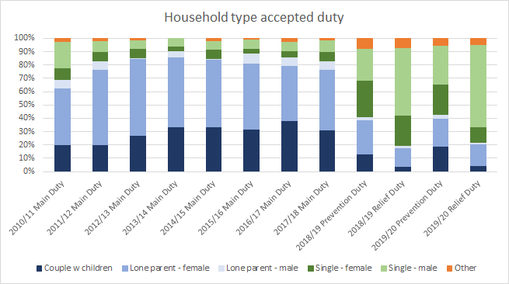

*Source: MHCLG P1E Homelessness returns (2010/11 to 2017/18) and MHCLG Statutory Homelessness: Detailed local authority level tables: financial year 2018-2019 and Detailed local authority level tables: financial year 2019-20*

Households where a relief duty has been accepted, i.e. someone is already homeless, are overwhelmingly single persons and predominantly male.

The overall gender profile for households we work with under statutory duties has changed significantly since the introduction of the HRA, with the proportion of duties owed to males increasing significantly. This is primarily due to the increase in both prevention and primarily relief duties owed to single males. In 2017/18 the proportion of households owed a duty (Main Duty) who were either single or lone parent male was 15.2%. In 2019/20, single and lone parent males owed a prevention duty was 32.4% and for relief duty this was 62.8%. Whilst the data pre and post HRA is not directly comparable, this does show that we are working with more males under a statutory duty than in the past.

Lone parents who are female remain the predominant group for non-singles owed a duty post HRA.

We have also seen a sharp increase in the number of singles placed in temporary accommodation since the introduction of the HRA, which is directly linked to the increase in singles we owe a statutory duty towards following HRA, and these duties being blind to both priority need and intentionality.

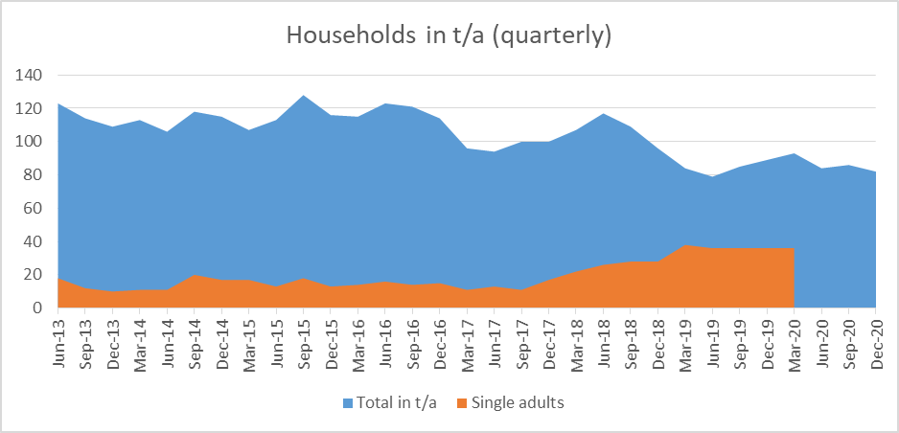

*Source: MHCLG P1E Homelessness returns and MHCLG Statutory Homelessness: detailed local authority level tables for relevant periods.* *Please note that numbers in t/a from April 2020 and onwards, does not include those placed in emergency accommodation through the ‘Every One In’ scheme.*

The proportion of single male and single females in our temporary accommodation has fluctuated throughout the years, and the average for the two groups is also similar, but with a slightly higher average of males – at 9.96 compared to females at 9.93 - having been in temporary accommodation calculated over the period June 2013 to March 2020. We can however see, that since the introduction of the HRA, the proportion of single males in temporary accommodation as compared to females, has gradually increased.

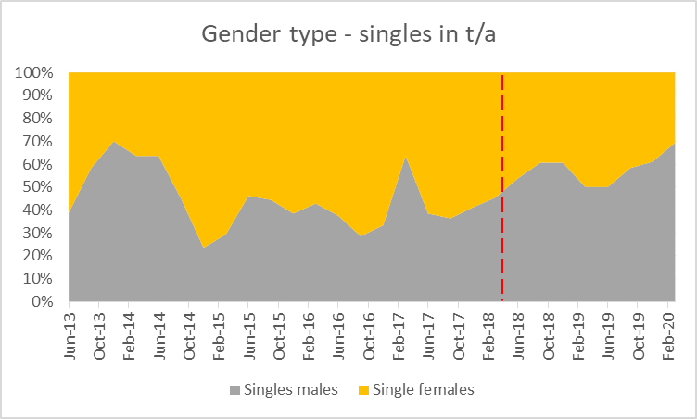

*Source: as above*

The gender breakdown of those rough sleeping in the city has been consistent over the last few years, with males being more likely to be found rough sleeping than females.

|  |  |  |  |
| --- | --- | --- | --- |
| Gender | 2017/18 | 2018/19 | 2019/20 |
| Male | 82% | 83% | 83% |
| Female | 18% | 17% | 17% |

*Source: OxTHINK*

### 6.2 - Ethnicity

In 2019/20, the largest proportion of households we owed a homeless duty towards identified themselves as White British[31]. This has also been the case for the last 10 years.

Whilst White British made out the largest proportion of households we owe a duty towards, this is a lower share than compared to the population. Black/African/Caribbean/Black British were proportionally more affected by homelessness than any other ethnic groups compared to their overall population share in Oxford.

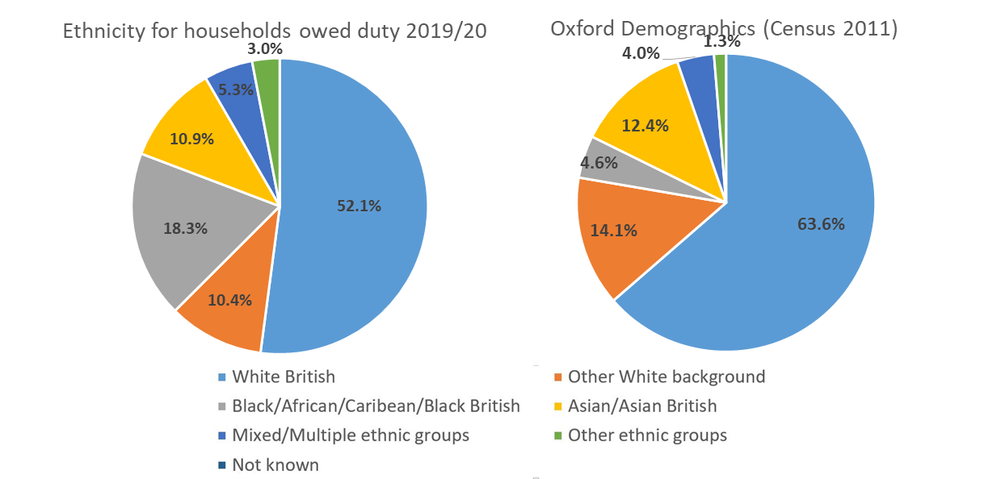

*Source: MHCLG Statutory Homelessness: Detailed local authority level tables: financial year 2019-20 and Census 2011*

The ethnicity for rough sleepers in Oxford are more similar to the overall demographics of the City. People identifying themselves as White British and of any other white background make up the largest proportions. Asian and Asian British persons are under-represented amongst rough sleepers. compared to the overall population. 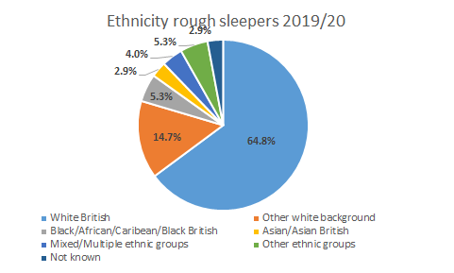

*Source: OxTHINK*

In 2019/20, we saw an increase to the number of rough sleepers in the City who were EEA nationals compared to the two previous years.

|  |  |  |  |
| --- | --- | --- | --- |
| Nationality | 2017/18 | 2018/19 | 2019/20 |
| UK | 85% | 84% | 81% |
| EEA | 8% | 8% | 14% |
| Non-EEA | 7% | 8% | 5% |

*Source: OxTHINK*

### 6.3 - Age

The age group categories captured and reported before the Homelessness Reduction Act came into effect are not the same as reported now under the HRA. However, we can see that over the last 10 years, we have seen a change in the age profile of homeless households. The proportion of people in the age group 16 to 24 has reduced from 57.7% in 2010/11 to 17% in 2019/20. This may be linked to the wider shift we have observed of less homelessness being driven from friend/ family eviction (see below chapter 7.1), who are often young adults leaving a parental home, and more homelessness now being driven by end of private tenancies which is more likely to be young families renting properties, and single adults in HMOs, coming from older demographic groups, these factors are explored further in the next chapter.

From 2019/20 data on households aged 16-24 we owed a prevention or relief duty towards, we can further see:

* 34% had dependent children, compared to 37% across all age groups
* 64% were single households, compared to 59% across all age groups
* 52% were male and 48% female, compared to 67% and 33% respectively for all age groups

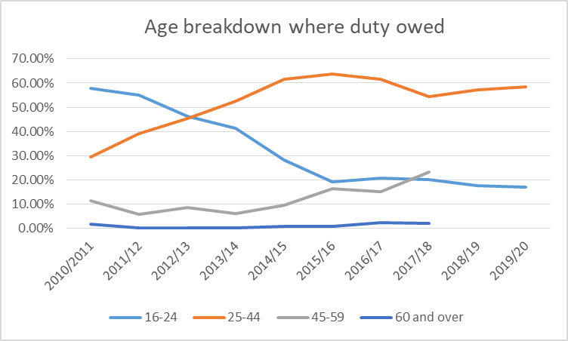

*Source: MHCLG P1E Homelessness returns (2010/11 to 2017/18) and MHCLG Statutory Homelessness: Detailed local authority level tables: financial year 2018-2019 and Detailed local authority level tables: financial year 2019-20*

In 2018/19, 25-34 year olds were the largest proportion of households we owed a duty towards at 31.8%. In in 2019/20, this had reduced to 25.9%, with 35-44 year olds the largest proportion with 32.6%. The age of main applicants for who we owed a duty towards in 2019/20 were broadly in line with the picture across England and the South East, but with a slightly higher proportion of households ages 35-44.

|  |  |  |  |
| --- | --- | --- | --- |
| 2019/20 |  |  |  |
| Age | Oxford | South East | England |
| 16-17 | 0.0% | 0.6% | 1.1% |
| 18-24 | 17.0% | 20.5% | 20.0% |
| 25-34 | 25.9% | 29.5% | 30.5% |
| 35-44 | 32.6% | 22.4% | 22.9% |
| 45-54 | 12.8% | 14.5% | 14.4% |
| 55-64 | 8.9% | 7.7% | 7.1% |
| 65-74 | 2.5% | 3.0% | 2.4% |
| 75+ | 0.4% | 1.8% | 1.1% |
| Not known | 0.0% | 0.0% | 0.6% |

*Source: MHCLG Statutory Homelessness: Detailed local authority level tables: financial year 2019-20* 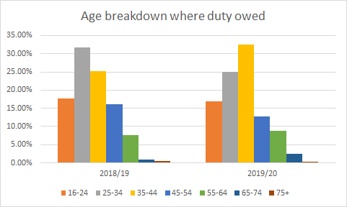

*Source: MHCLG Statutory Homelessness: Detailed local authority level tables: financial year 2018-19 and Detailed local authority level tables: financial year 2019-20*

The age of those seen rough sleeping in the city correspond with the groups for those we have accepted a Prevention or Relief Duty towards and have not changes significantly over the last few years. The most dominant age group for rough sleepers is 35 – 44 year olds.

|  |  |  |  |
| --- | --- | --- | --- |
| Age | 2017/18 | 2018/19 | 2019/20 |
| 18-24 | 6% | 7% | 9% |
| 25-34 | 22% | 25% | 22% |
| 35-44 | 34% | 33% | 33% |
| 45-54 | 26% | 24% | 23% |
| 55-64 | 10% | 9% | 11% |
| 65+ | 2% | 2% | 3% |

*Source: OxTHINK*

### 6.4 - Economic status

Since the introduction of the Homelessness Reduction Act, the employment status of those owed a homeless duty is now collected. This give us a better insight into the wider circumstances of households faced with homelessness that can help us shape the prevention and relief activities we provide in the future.

In 2018/19, households where the main applicant was in full-time work was the largest group we owed a prevention or relief duty towards. Those in full-time work made up 22.3%. During the same year, 20.3% of households were registered unemployed. The following year, 2019/20, the largest proportion of households we owed a Prevention or Relief Duty towards were unemployed, making up 28% of those we owed a duty towards, an increase of almost 8% on 2018/19.

In both 2018/19 and 2019/20, those in work (full-time and part-time combined) made up the largest proportion of households where a Prevention or Relief Duty were owed. Compared to the national and South East averages, the proportion of households in work (full-time and part-time) where we owe a duty, is higher. Compared to the other Districts in the County however, we see a lower proportion of households owed a duty who were in work.

The relatively high levels of households who are homeless or threatened with homelessness in Oxford and that are in work, is a sign that even for those working, housing is unaffordable in the City for some. This is linked to section 2.6 of the review, which explore how many in the city are on incomes not sufficient to afford average house and rent prices, and seems to confirm the high levels of unaffordability, for even those working, is leading to homelessness.

The effects of the pandemic has however had an impact on the employment status of those we owe a duty towards. The employment status of those we owe a duty towards has significantly shifted since April 2020 and the start of the pandemic. Households were the main applicant was registered unemployed saw a large increase during the period April to December, compared to figures for 2019/20, and the rate for those in employment decreased. Unemployment rates in Oxford increased during this period.

|  |  |  |  |
| --- | --- | --- | --- |
|  | Apr-Jun 2020 | Jul-Sep 2020 | Oct-Dec 2020 |
| Registered unemployed | 44.0% | 44.9% | 37.5% |
| Not working due to long-term illness/disability | 15.0% | 10.9% | 19.2% |
| Full-time work | 11.4% | 15.2% | 16.3% |
| Part-time work | 6.2% | 8.0% | 7.7% |
| Not seeking work/at home | 4.1% | 6.5% | 4.8% |
| Not registered unemployed but seeking work | 6.2% | 5.1% | 6.7% |
| Retired | 1.6% | 1.4% | 1.9% |
| Student/training | 0.5% | 1.4% | 0.0% |
| Other | 5.2% | 0.7% | 3.8% |
| Not known | 5.7% | 5.8% | 1.9% |

*Source: MHCLG Statutory Homelessness: Detailed local authority level tables for relevant periods*

When compared to the overall Oxford demographics, those registered unemployed are significantly over-represented amongst households we owe a duty towards. Those not working due to long-term illness/disability were also over-represented when compared to the overall Oxford population.

|  |  |  |  |
| --- | --- | --- | --- |
|  | **2018/19** | **2019/20** | **Oxford demographics (Census 2011)** |
| Registered unemployed | 20.3% | 28% | 3.2% |
| Not working due to long-term illness/disability | 16.5% | 13.1% | 2.6% |
| Full-time work | 22.3% | 20.4% | 36.2% |
| Part-time work | 16.7% | 14.4% | 10.4% |
| Not seeking work/at home | 9.9% | 9.6% | 3.5% |
| Not registered unemployed but seeking work | 6.6% | 5.3% | Not available |
| Retired | 1.4% | 2.8% | 7% |
| Student/training | 0.6% | 1.4% | 28.1% |
| Other | 4.6% | 3% | 8.8% |
| Not known | 1.1% | 2% | Not available |

*Source: MHCLG Statutory Homelessness: Detailed local authority level tables: financial year 2018-19 and Detailed local authority level tables: financial year 2019-20 and Census 2011*

### 6.5 - Support Needs

We have already seen above, that those not able to work due to long term health or disability, are proportionately more affected by homelessness. The new data reporting requirements under the Homelessness Reduction Act means that we are now also collecting data on a wider set of support needs that households may have. This gives us a good insight into the wider support needs that households facing homelessness are faced with.

In 2019/20, 32.6% of households owed a Prevention or Relief Duty had one or more support needs identified. Compared to other local authorities, this number is relatively low. We do believe however, that we are under-reporting the level of support needs and we are working to improve our data collection and data quality here. During the period September to December 2020, the rate of households with identified support needs was 43.3%, which indicates that we have improved our data collection to some extent, but may also be because of the changing profile of those needing support during the pandemic.

|  |  |  |  |
| --- | --- | --- | --- |
|  | **Percentage (households w support needs of total owed duty)** | **Total households with support need(s) owed a duty** | **Total number of support needs for those owed a duty** |
| Oxford | 32.6% | 184 | 399 |
| South East | 46.3% | 18,640 | 39,340 |
| England | 46.6% | 134,410 | 285,290 |
| Cherwell | 35.5% | 145 | 232 |
| South Oxfordshire | 55.6% | 212 | 365 |
| Vale of white Horse | 54.2% | 182 | 287 |
| West Oxfordshire | 48.8% | 140 | 313 |
| Bristol | 75.3% | 1,572 | 3,706 |
| Cambridge | 45.0% | 296 | 847 |
| Milton Keynes | 42.5% | 1,036 | 2,117 |
| Reading | 37.0% | 360 | 554 |

*Source: MHCLG Statutory Homelessness: Detailed local authority level tables: financial year 2019-2020*

The most common support need registered for households in Oxford was mental health, followed by physical health and disability.

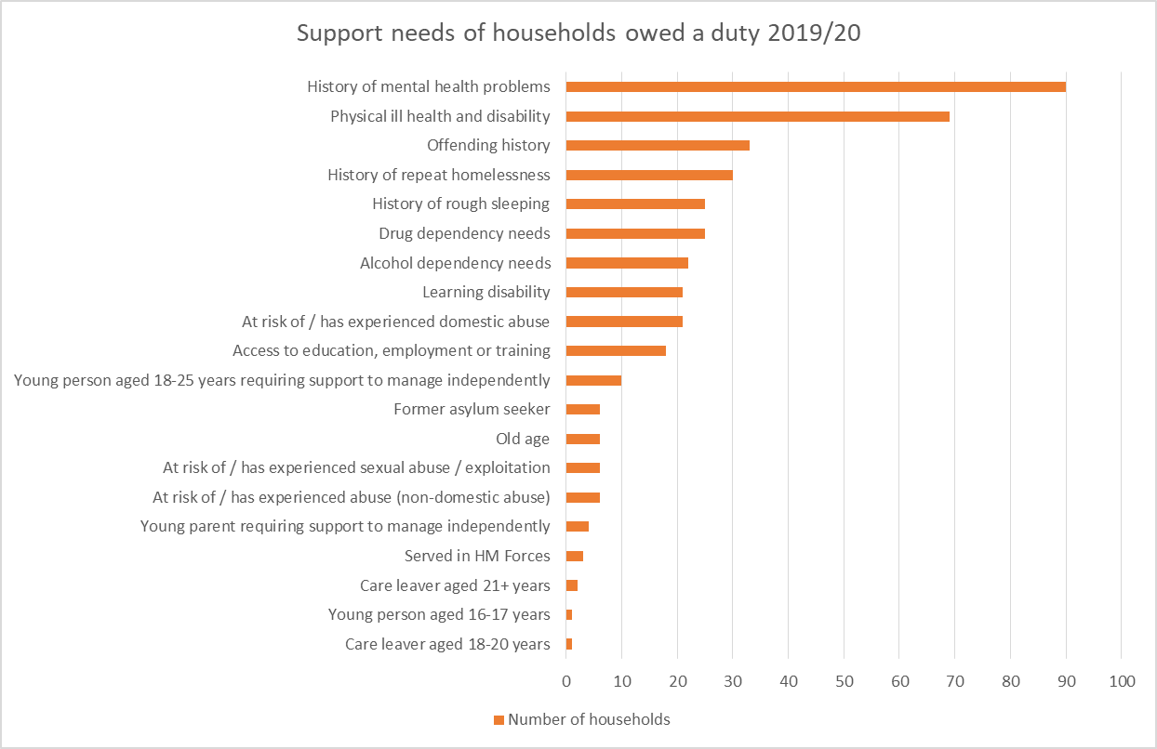

*Source: MHCLG Statutory Homelessness: Detailed local authority level tables: financial year 2019-2020*

If we look at the priority need categories for households owed a homelessness Main Duty since 2013/14 to 2019/20 this gives us an alternative view of certain support needs, and a longer time frame to consider trends, before the HRA was implemented. We can see that the proportion of households in priority need due to physical or mental health/disability has increased since the introduction of HRA, but the largest proportion of households owed a Main Duty continues to be those with dependent children (which is a reason for priority need). One of the reasons why the proportion of households with children has reduced in the last two years, may partly be due to the increased prevention and relief work, which means households with children are better able to sustain existing accommodation or move to secure accommodation before the case progress to a Main Duty. It may be that it is harder to assist those who have high support needs, as this often requires multiple agencies to work together to find a suitable housing solution and this can take time, resulting in the need for a Main Duty to be triggered.

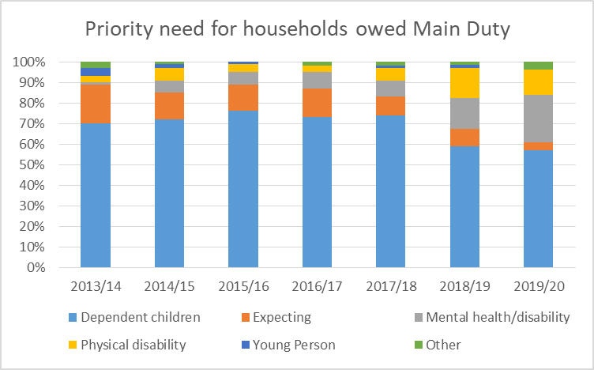

*Source: MHCLG P1E Homelessness returns (2010/11 to 2017/18) and MHCLG Statutory Homelessness: Detailed local authority level tables: financial year 2018-2019 and Detailed local authority level tables: financial year 2019-20*

We also hold separate data on the support needs for those seen rough sleeping in the city. This shows that the vast majority of those rough sleeping have support needs, with mental health the most dominant. The vast majority of rough sleepers have a multiple of needs, which makes them more vulnerable and can create barriers to securing accommodation.

Out of the 475 persons seen rough sleeping in the city in 2019/20, 138 had an assessment of support needs in the same period. 22% had a combination of alcohol, drug, physical and mental health needs and 16% drug, physical and mental health needs. Only 4% of those assessed had no support needs and 85% had more than one support need.

|  |  |  |  |
| --- | --- | --- | --- |
|  | 2017/18 | 2018/19 | 2019/20 |
| Drug need | 61% | 65% | 59% |
| Mental health need | 71% | 70% | 70% |
| Alcohol need | 57% | 50% | 59% |
| Physical health need | 53% | 55% | 69% |

*Source: OxTHINK*

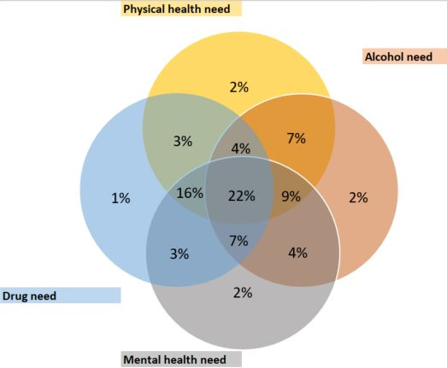

*Source: OxTHINK*

## **7.0 – What is causing homelessness in Oxford?**

|  |
| --- |
| Key Findings – What is causing homelessness in Oxford?   * Structural factors that contribute to homelessness in Oxford include high levels of unaffordability in the housing market, and significant areas of deprivation in the city. These structural issues combine with individual factors to cause homelessness. * The council’s data on the causes of statutory homelessness shows the ending of private rented tenancies being the most significant cause in the city, although the eviction ban throughout the pandemic has decreased occurrences. Eviction from the homes of family and friends is the second biggest factor. * Comparing to regional and national averages, our district neighbours, and our comparator urban authorities, the ending of private rented tenancies has the greatest impact in Oxford. * Other council data sets support the PRS being the major source of homelessness in the city, such as 50.5% of Discretionary Housing Payments awards going to the PRS so far this financial year seeking to avoid cases of homelessness. * The picture of what is causing rough sleeping is more mixed. With the PRS, relationship and family breakdown, and prison leavers all significant factors. |

In order to combat and prevent homelessness it is important to understand why people are being made homeless in the UK, and in our city. This understanding of the underlying reasons is crucial to providing even better prevention and pre-prevention services to combat homelessness.

The report Homelessness - Rapid Evidence Assessment (Alma Economics, March 2019)[32], commissioned by the Ministry of Housing, Communities and Local Government, summarises the existing evidence on causes of homelessness in the UK. The research they looked at divided the causes of homelessness into structural and individual factors.

* *“Structural factors are wider societal and economic issues that affect opportunities and social environments for individuals. This includes unfavourable housing and labour market conditions, reduced welfare and benefits, rising levels of poverty and the growing fragmentation of the family.*
* *Individual factors apply to the personal circumstances of a homeless person. These factors may include personal crisis, traumatic events, mental health or addiction challenges. Relationship problems can include domestic abuse and violence, addiction, mental health problems of other family members and a lack of financial resilience.*

*Structural factors create the conditions within which homelessness will occur and people with personal problems are more vulnerable to these adverse social and economic trends than others. Hence, the high concentration of people with personal problems in the homeless population can be explained by their susceptibility to structural forces and not solely by their personal circumstances.”*

Our introductory chapters describing Oxford and its housing market described some of the structural factors that can lead to homelessness in an area. We have an unaffordable housing market with wages not in line with house prices and rents, there has been a national squeeze on welfare benefits and the Local Housing Allowance does not cover market rents in the city. We have also seen that there are areas of Oxford that suffer from poverty and deprivation.

The previous section that looks at who is homeless in the City, we can also clearly see evidence of the individual factors that make people more vulnerable to homelessness in Oxford, such as having one or more support needs or being unable to work due to ill health or disability. We have also seen that even those in work, may struggle financially to afford to live in the City and become homeless.

### 7.1 - What is causing statutory homelessness?

We can also look at data collected for those we owe a statutory duty towards to find out why a household either lost or nearly lost their homes. Looking at information in relation to those households we owed a Prevention and Relief Duty towards in 2019/20, the most common reason why the households we owed a Prevention Duty towards lost their last settled home was that their private rented tenancy ended (end of an Assured Shorthold tenancy (AST) and non-AST 42%) On the other hand, those households that we owed a Relief Duty towards, stated that the reason they lost their last settled home was due to family or friends no longer being able to accommodate them (23%).

Households owed a Relief Duty were more likely to have lost their accommodation due to relationship breakdown, violence/harassment, leaving institution or being evicted from supported housing than applicants owed a Prevention Duty. Households owed a Prevention Duty on the other hand, were more likely to have lost their accommodation due to eviction from social housing than those owed a Relief Duty.

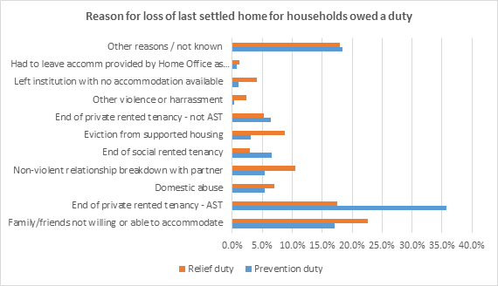

*Source: MHCLG Statutory Homelessness: Detailed local authority level tables: financial year 2019-20*

Whilst the end of a tenancy in the private rented sector is the main reason for homelessness over all, the main reasons why young people (16-24) lose their home is due to family and friends no longer being willing or able to accommodate them. 54% of young people where we accepted a prevention or relief duty in 2019/20 lost their last settled home due to family or friend evictions, compared to 19% for all age groups.

We have however seen a drop in the proportion of households losing their PRS assured shorthold tenancies and an increase in households being asked to leave family and friends’ homes during the first two quarters of 2020/21. This can be attributed to the ban on evictions due to Covid-19. We have however seen an increase to households losing their accommodation due to the end of their non-assured shorthold tenancy ending.

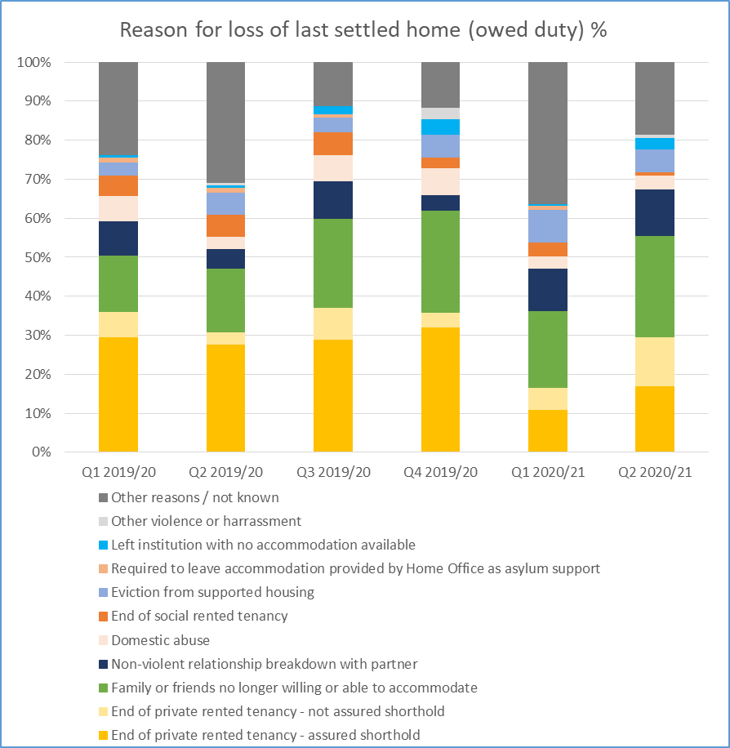

*Source: MHCLG Statutory Homelessness: Detailed local authority level tables for relevant periods*

Compared with England as a whole, and also compared to our neighbouring local authorities, applicants in Oxford were more likely to apply as homeless due to losing a private rented tenancy and less likely to be evicted by family or friends across both prevention and relief duties. Oxford has an expensive and competitive private rented housing market, and the data suggests this is leading to greater numbers of households becoming homeless as a result.

A higher percentage of applicants in Oxford owed prevention and a relief duty, had lost their accommodation due to being evicted from supported housing than in England and our neighbouring local authorities. There is a large number of supported accommodation units in Oxford City compared with the rest of the County which explains why the rate may be higher in Oxford City. However, it does show us that even when people live in supported accommodation, they can struggle to sustain a tenancy

A lower percentage of households in Oxford owed a relief duty had lost their accommodation due to domestic abuse compared to the average for England and also compared to our neighbouring local authorities.

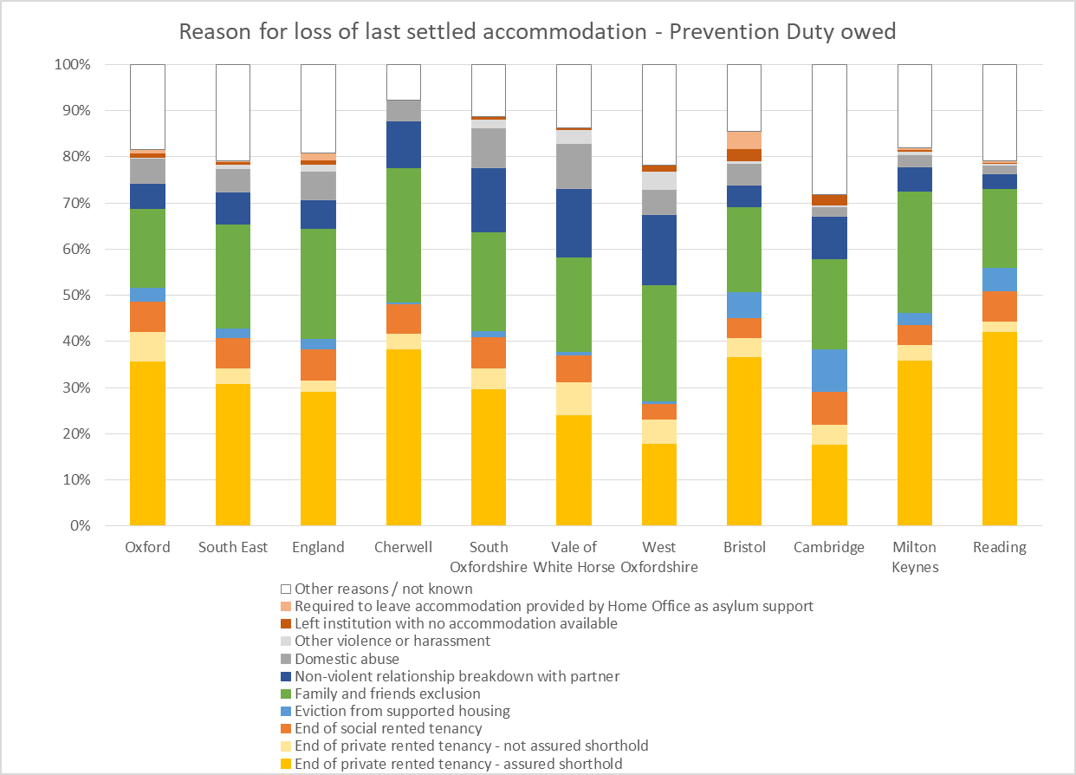

*Source: MHCLG Statutory Homelessness: Detailed local authority level tables: financial year 2019-20*

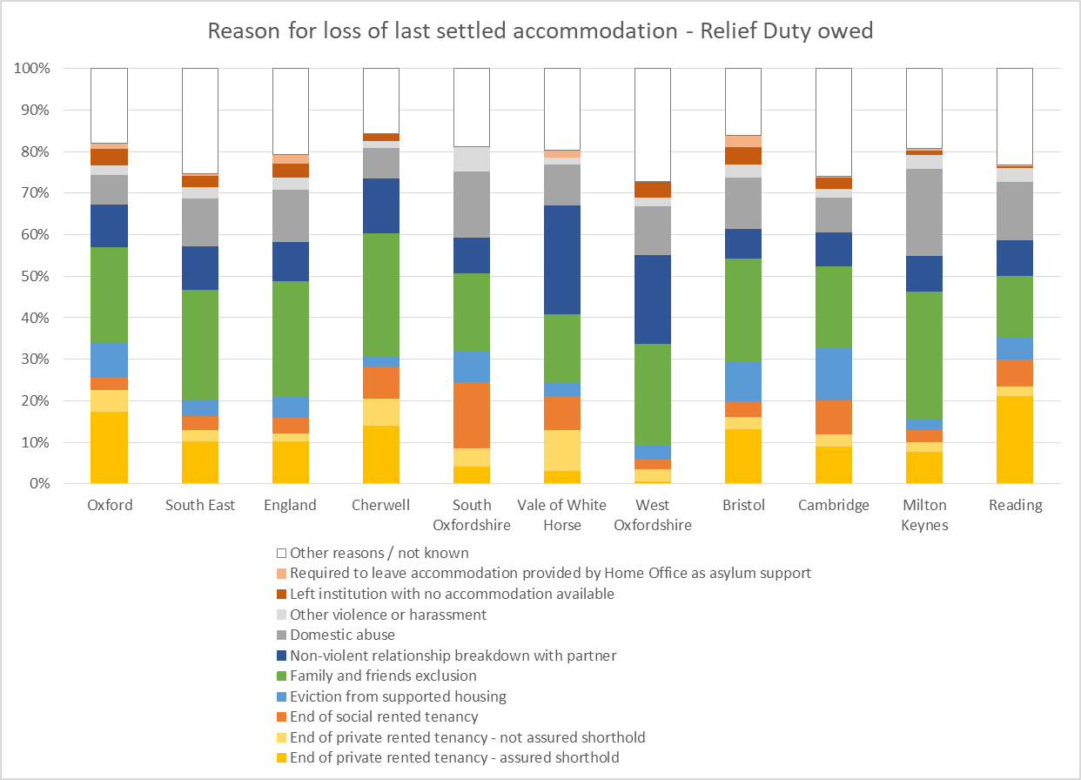

*Source: MHCLG Statutory Homelessness: Detailed local authority level tables: financial year 2019-20*

Looking at the data, it is clear that the main reasons why households become homeless and threatened with homelessness in Oxford, is that they lose their private rented tenancy, with perhaps the quarters during the pandemic being the exception due to the eviction ban.

Looking deeper into why private tenancies end, we see in our homelessness data that in 2019/20, the main reason was due to landlords wishing to sell or re-let their properties. This was the reason for 55% of PRS tenancies ending for those owed prevention duty and 16.7% for those owed a relief duty. Compared to 2018/19, there was a slight decrease in landlords wishing to sell or re-let their properties.

However this should be taken with a note of caution, it is suspected this stated reason is over reported on homeless applications to avoid questions on arrears and property upkeep that could jeopardise future rehousing, and therefore may be hiding the real issues of unaffordability and rent arrears. Plus it may be in a landlord’s interest to declare this reason, in order to get the local authority to support moving their tenant, even if selling isn’t the intention.

When considering why Oxford sees greater amounts of homelessness due to end of private rented tenancies, it certainly does not seem plausible that the reason for this is that we have a greater number of landlords simply seeking to sell or re-let properties, and instead it is more likely this is being driven by high rents and unaffordability, masked by misreporting. It is also likely to be included in the high reporting of “other”. Further research into this area may prove valuable.

We can see some indication of financial difficulties leading to loss of a tenancy in the private rented sector when looking at data sources. Following landlords wishing to sell or re-let their properties, the next most common reason (apart from ‘other’), where both Prevention and Relief Duty was owed, was due to tenant having difficulty budgeting or making other payment(s).

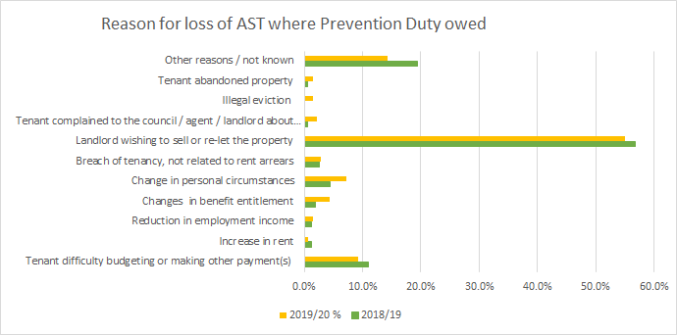

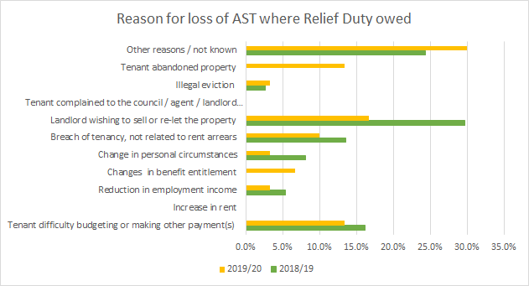

*Source: MHCLG Statutory Homelessness: Detailed local authority level tables: financial year 2019-20 and Detailed local authority level tables: financial year 2019-20*

### 7.2 - What is causing rough sleeping?

The council’s commissioned outreach team collects information from rough sleepers of their last settled base prior to rough sleeping as well as the reasons for leaving this accommodation. This data is however limited in scope, as it has not been possible to collect this information from everyone sleeping rough. We have here used data in relation to those who were new to rough sleeping in the city over the last two years, in order to get a better picture of why people end up rough sleeping in the first place.

Much of the data isn’t precise enough and the data sample is small and there are therefore limitations to us drawing firm conclusions from this data set. The information does however show a similar picture for reasons for homelessness for those we owe a prevention and relief duty towards. The picture that emerges from the rough sleeping data is complex, and shows the diverse reasons for rough sleeping. A significant number of people are clearly losing their PRS accommodation, but relationship breakdown is also a major driver.

|  |  |  |  |  |  |  |
| --- | --- | --- | --- | --- | --- | --- |
| Last settled base – new rough sleepers seen bedded in year[33] | | |  | Reason for leaving last settled base – new rough sleepers seen bedded in year[34] | | |
|  | 2019/20 – base 90 | 2020/21 – base 74 |  |  | 2019/20 – base 79 | 2020/21 – base 66 |
| Asylum support accommodation | 0% | 3% |  | Abandoned | 8% | 11% |
| Family home | 18% | 34% |  | Evicted | 18% | 12% |
| Hostel/supported accommodation | 4% | 7% |  | Left prison | 10% | 9% |
| Social Housing (LA and HA) | 9% | 4% |  | Relationship breakdown | 25% | 35% |
| Other | 10% | 5% |  | Seeking work | 1% | 2% |
| Prison | 10% | 8% |  | End of PRS (incl. end of tied a/c) | 5% | 2% |
| Private rented (incl. tied a/c) | 38% | 22% |  | Leaving family home | 0% | 6% |
| Staying with family/friends | 8% | 15% |  | Other | 33% | 24% |
| TA - non-LA | 1% | 3% |  |  |  |  |
| TA – LA | 2% | 0% |  |  |  |  |

*Source: OxTHINK*

### 7.3 - What is driving demand for Discretionary Housing Payments?

In addition to the data available in relation to statutory homelessness that gives us some information in relation to why people are homeless or become threatened with homelessness, we can see the financial pressure households in Oxford are under through other work the council delivers.

Households can apply to the council for a Discretionary Housing Payment if they cannot afford to pay their rent, with payments made in order to temporarily sustain a tenancy while a long term solution is sought to avoid homelessness. The number of claims for this payment that has been paid out and the average amount for each claim paid, has fluctuated over the last few years, but we can see that a high number of claims are paid in order to help households stay in their tenancies.

|  |  |  |  |  |  |
| --- | --- | --- | --- | --- | --- |
|  | 2016/17 | 2017/18 | 2018/19 | 2019/20 | 2020/21 (up until end Feb 2021) |
| No claims paid | 549 | 674 | 475 | 512 | 509 |
| Total spend | £379,009.00 | £494,566.00 | £415,865.00 | £440,762.19 | £505,525.77 |
| Average payment per claim | £690.36 | £733.78 | £875.51 | £860.86 | £993.37 |

In 2020/21, even though the data available is not for the full financial year, we can already see that we have had high demand for assistance, with the average payments per claim significantly higher than previous years.

The main reason for successful DHP claims are due to the Welfare Reforms introduced over the last decade – Benefit Cap and the Bedroom Tax - as well as the Local Housing Allowance not covering the whole rent charged. “Other” can cover often very short term payments for things such as means tested shortfalls in benefit or non-dependant deductions that can be covered in cases of exceptional hardship.

|  |  |  |  |  |  |
| --- | --- | --- | --- | --- | --- |
| Reason for application (successful claims: | 2016/17 | 2017/18 | 2018/19 | 2019/20 | 2020/21 (up until end Feb 2021) |
| Benefit Cap | 33.6% | 40.9% | 30.7% | 24.9% | 29.7% |
| Bedroom Tax | 22.9% | 19.9% | 23.9% | 30.1% | 28.9% |
| LHA shortfall | 34.5% | 28.7% | 24.3% | 29.6% | 23.9% |
| Combination of reforms | 0.5% | 0.2% | 1.4% | 1.0% | 3.3% |
| Other | 8.5% | 10.4% | 19.8% | 14.4% | 14.2% |

We can also see that the majority of claims that are paid out are to households living in the private rented sector, including households housed via our Home Choice Scheme, and that households are primarily in receipt of Universal Credit.

Around a third of DHP goes to council tenants, typically to cover Benefit Cap and Bedroom Tax. Under occupancy has fallen in recent years within the council housing stock (see chapter 10) but a share of tenants continue to require DHP to cover their Bedroom Tax charge. With ongoing pressure on the DHP fund, the new strategy should consider what more could be done to support council tenants still impacted by the Bedroom Tax.

This last financial year, although incomplete, we have seen an increase in claims from households in the PRS compared to previous years. We have also seen a marked increase in claims paid to households in receipt of Universal Credit. This could be linked to an increase in households in general that have seen a change to their employment status due to the pandemic and have had to claim Universal Credit.

|  |  |  |  |  |  |
| --- | --- | --- | --- | --- | --- |
| Tenancy type (successful claims): | 2016/17 | 2017/18 | 2018/19 | 2019/20 | 2020/21 (up until end Feb 2021) |
| Private Rented Sector | 35.7% | 34.2% | 36.6% | 38.5% | 43.4% |
| Council Tenant | 31.5% | 34.8% | 34.3% | 35.8% | 34.9% |
| Housing Associations | 17.0% | 16.5% | 20.7% | 17.9% | 14.5% |
| Home Choice (Councils PRS access scheme) | 15.8% | 14.5% | 8.4% | 7.8% | 7.1% |

|  |  |  |  |  |  |
| --- | --- | --- | --- | --- | --- |
| Income type (successful claims): | 2016/17 | 2017/18 | 2018/19 | 2019/20 | 2020/21 (up until end Feb 2021) |
| Passported benefits (Income Support, Income Based Job Seekers Allowance and Employment Support Allowance etc.) | 66.4% | 68.8% | 41.6% | 30.6% | 17.9% |
| Working, low earnings | 24.9% | 16.7% | 14.5% | 10.3% | 5.4% |
| Not pass ported benefits but not working | 4.6% | 4.1% | 2.5% | 2.0% | 0.5% |
| Pensioner | 1.6% | 1.8% | 1.1% | 1.5% | 0.5% |
| Universal Credit | 2.2% | 8.1% | 39.1% | 55.5% | 75.8% |
| No income | 0.4% | 0.5% | 1.1% | 0.2% | 0% |

This is further evidence showing that many households in the city that have to rely on the private rented sector, cannot afford the high rents, with added pressure on households due to the Welfare Reforms introduced over the last decade. Looking at evidence from the most recent financial year, we link the increase in claims to additional pressures households are facing due to the pandemic.

### 7.4 - Summary of the causes of homelessness

In summary, a range of structural and individual factors cause each case of homelessness, but clear trends can be observed within the data and evidence to show us what the major structural issues are that drive homelessness in Oxford.

The private rented sector is clearly the most important source of homelessness, generating a plurality (although not a majority) of the homelessness in the city. This can clearly be observed in the statutory homelessness data showing the ending of PRS tenancies as the biggest single factor, and Oxford recording the greatest share of homelessness caused by ending of PRS tenancies when compared to regional and national averages, and our district and urban authority comparators. DHP data also supports this picture, and shows the high demand for support from those in the PRS, depending on this support to avoid homelessness. Linking these findings to early sections of the review, it is clear the high levels of unaffordability in the Oxford housing market are a major driver the high rate of homelessness coming out of the PRS, although the data the council holds on reasons for loss of PRS tenancy are less clear, we believe partially due to misreporting.

Other significant drivers of homelessness include eviction from family and friend provided accommodation, non-violent relationship breakdown, domestic abuse and eviction from supported accommodation.

The picture of what is causing people to become street homeless for the very first time is more mixed. With the PRS, relationship and family breakdown, and prison leavers all significant factors, however there has been significant variation in the data over the past two years, and only captures a portion of the rough sleeping population.

## **8.0 - What are the Council and other organisations doing to tackle homelessness?**

|  |
| --- |
| Key Findings – What are the Council and other organisations doing to tackle homelessness?   * We are broadly in line with the national and regional averages with our success in preventing and relieving homelessness for those we have a legal duty towards, and are more successful in delivering prevention outcomes than most of our urban authority peer group. * We are very effective at prevention and relieving homelessness by securing private rented accommodation for homeless households, exceeding rates nationally and in the county. However we have less success supporting homeless households into the social rented sector. * There is a diverse and good homelessness prevention offer in Oxford, delivered by the city council and its partners, but this will need to be built on and better coordinated in order to meet ambition to prevent more cases of homelessness. * The number of households in temporary accommodation is low when compared both historically and to other authorities, but we face challenges such as supporting increasing numbers of singles with greater support needs in the accommodation, and tackling long stays in the accommodation. * We have had considerable success with our private rented sector access schemes, but that long term trend of rents increasing faster than wages and benefits puts considerable pressure on their continued viability, and they require continued adaption and renewal to stay effective. * Last year only 20.4% of social housing lets in Oxford went to households who were defined as homeless or at risk of homelessness, and within this figure only 4.5% to rough sleepers/ those leaving supported accommodation. * There are extensive services available in the city to house and support rough sleepers, many of which have expanded and improved in recent years, resulting in a drop in the street count. However to achieve further progress new commitments and approaches need to be made, work that is being taken forward by the county-wide homelessness and rough sleeping strategy, which focuses on greater prevention of rough sleeping, and more flexible and holistic support. |

Oxford has a strong network of statutory and non-statutory services that, directly or indirectly, provide support to households to prevent and relieve homelessness. The City Council as the housing authority for Oxford provides a number of statutory services supporting homeless households, such as a Housing Options Service that provides advice and support to households facing homelessness, and provides temporary accommodation to those who are homeless before we assist a move to move permanent accommodation. We also operate schemes that help us access accommodation in the Private Rented Sector for homeless households, and we operate the housing register to allocate social housing for those in need.

As well as the services we are required to deliver under law, the City Council also has a strong non-statutory homeless offer such as rough sleeping services and ‘upstream’ homelessness prevention services, which are in line with the Council’s values and prioritises.

Alongside the City Council sits a wider network of services that work with us to combat homelessness, including the County Council, Health and Police etc; and a strong 3rd sector providing a range of different support, including debt and finance advice and access to training and education.

### 8.1 - Statutory support and assistance to prevent and relieve homelessness available in Oxford

As a local authority, we have many different teams that work with and within communities and that will provide activities contributing to homeless prevention. The service many households will first approach is the Council’s Housing Options Team that delivers the front line of our statutory response to homelessness.

When households approach the Council asking for assistance and advice in relation to their housing, but who are not yet homeless or threatened with homelessness within 56 days, the Housing Options team will provide general advice. Such advice includes how to find private rented accommodation in the city, providing information on how to get help with the payment of a rent deposit, the level of Local Housing Allowance that would be applicable to the household and contact details to other organisations in Oxford that may be able to assist. It is key that the advice given is good and comprehensive, so that households can take actions, or be assisted to do this, in order to prevent them from becoming threatened with homelessness. Therefore, if a household has specific needs or needs specific assistance, we will also help households get link in with more specialist organisations.

When advice is not enough, and a household becomes threatened with homelessness within 56 days and we owe a Prevention Duty under the HRA, we face a number of different challenges to prevent homelessness. In 2019/20 we assisted 53.6% of households we owed a prevention duty towards to secure accommodation (existing or alternative accommodation) and prevented their homelessness. Unfortunately, we could not prevent homelessness for 19.7% of the households we had a prevention duty towards and these therefore progressed to relief duty.

Nationally, 58.5% of prevention outcomes during 2019/20 were for accommodation secured at end of prevention duty, so we are just below the national average. We also have lower prevention rates than our neighbouring Districts South Oxfordshire and Vale of White Horse, that have rates just above 80% when it comes to securing accommodation at end of prevention duty, although this is perhaps due to the lower demand on homelessness services and greater amounts of affordable housing development v. demand in those districts. However when looking to our comparator group of urban authorities with similar challenges in their housing markets and levels of deprivation, our successful prevention outcomes are approximately level or exceed the other cities.

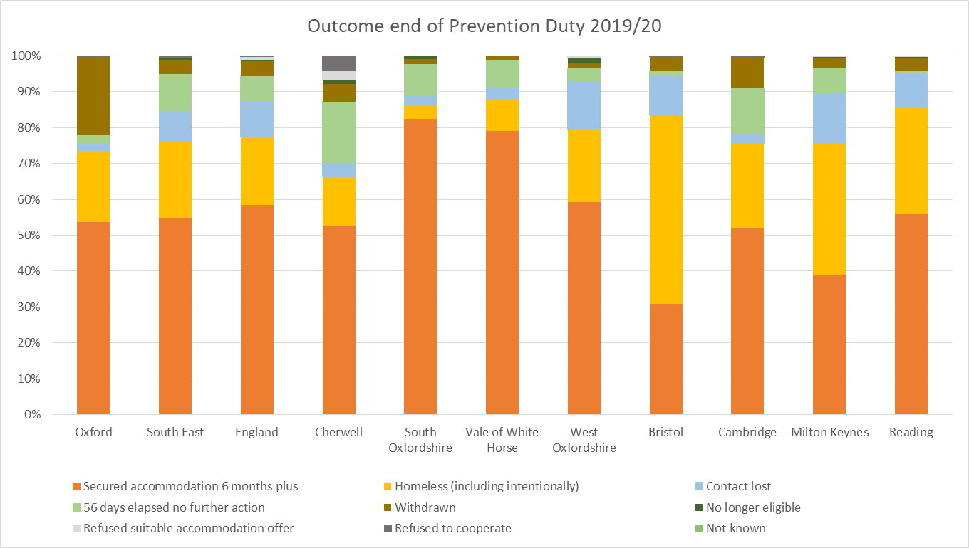

*Source: MHCLG Statutory Homelessness: Detailed local authority level tables: financial year 2019-20*

For households where accommodation was secured (existing or alternative accommodation) at end of prevention duty, our neighbouring local authorities had a very high proportion of households being assisted to secure social rented accommodation. In Oxford however, securing accommodation in the private rented sector was most common. This shows our considerable success in rehousing homeless households into the private sector. Our ability to access new or secure existing PRS for households, despite the challenge of doing this is a competitive and often unaffordable market is crucial as this is the largest tenure sector in the city. Our comparatively low rate of accommodation secured for households in the social sector is likely due to both the low rate of households threatened to lose their accommodation in the social rented sector in the first place, and the limitations of availability of social housing as alternative accommodation source. Our limited access to social housing is linked to particular challenges in urban arears where there is lower supply of new build social homes due to available land and significantly higher demand for social housing due to higher deprivation levels and unaffordability in the private sector.

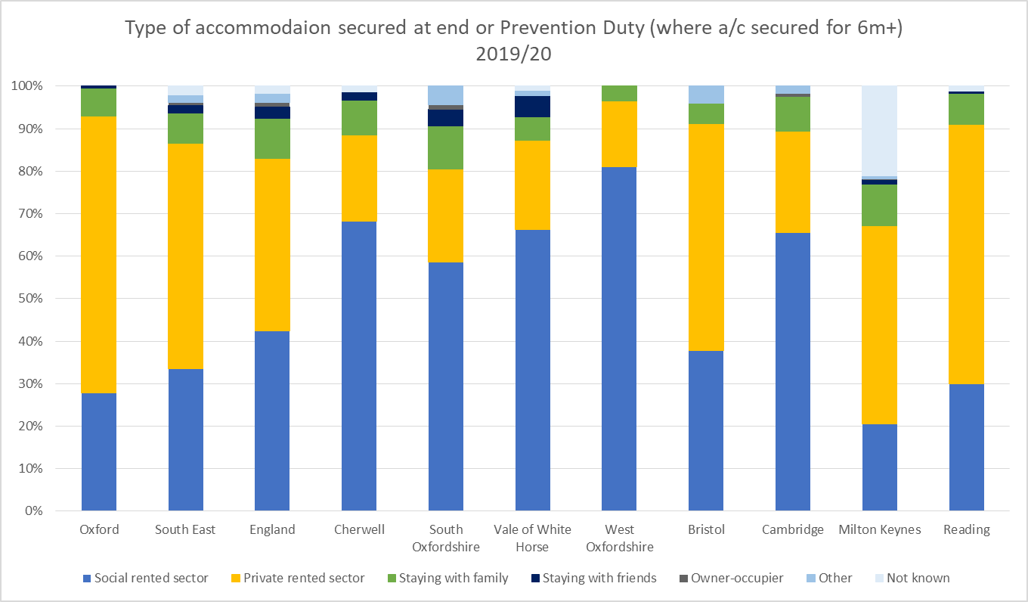

*Source: MHCLG Statutory Homelessness: Detailed local authority level tables: financial year 2019-20*

It is difficult to compare prevention duty outcomes here like-for-like as circumstances both nationally and regionally are very different. Our challenges in having access to affordable housing in general, and social housing in particular, makes prevention more difficult. As previously examined, a high proportion of households we worked with were in full-time employment, but still had to seek assistance from us to prevent their homelessness. We see this as a direct link to the unaffordability of housing in the city, both in terms of renting and buying a home.

All these findings underline the ongoing need to ensure effective access to the private rented sector, both in assisting households to stay in PRS they are at risk of losing and where this is not possible, we need to provide assistance to secure alternative accommodation in this sector. This is going to be challenging with the government again freezing the local housing allowance, and the ongoing impact of the Benefit Cap. The council should also consider new ways to improve access to social housing for those experiencing homelessness.

Where possible, we want to assist households to stay in their existing accommodation, as the upheaval of moving home, is stressful and costly. For those households we assist to secure accommodation (i.e. prevented homelessness), we have a high rate of households assisted to stay in their existing accommodation compared to our neighbouring local authorities. . Our rate is however below the national average, and further how we can prevent households from having to move from their existing home in order to prevent homelessness is something we should work on improving in the future, particularly in the context that it is difficult to access affordable accommodation when an alternative is needed.

|  |  |  |  |
| --- | --- | --- | --- |
|  | **Secured accommodation for 6+ months (reason for prevention duty ending)** | **Moved to alternative accommodation** | **Stayed in existing accommodation** |
| Oxford | 201 | 76.10% | 23.90% |
| South East | 11,200 | 69.00% | 31.00% |
| England | 81,510 | 63.20% | 36.80% |
| Cherwell | 148 | 82.40% | 17.60% |
| South Oxfordshire | 256 | 81.30% | 18.80% |
| Vale of White Horse | 219 | 82.60% | 17.40% |
| West Oxfordshire | 84 | 92.90% | 7.10% |
| Bristol | 148 | 70.30% | 29.70% |
| Cambridge | 122 | 75.40% | 24.60% |
| Milton Keynes | 450 | 57.80% | 42.20% |
| Reading | 167 | 59.30% | 40.70% |

*Source: MHCLG Statutory Homelessness: Detailed local authority level tables: financial year 2019-2020*

For the households we owe a relief duty towards, we see similar challenges to assist households to secure accommodation when ending Relief Duties. Whilst we assisted over 50% of households owed a Prevention Duty to secure accommodation, this rate is only 32.9% at the end of Relief Duty. This is in line with the regional average, but lower than all local authorities in the County apart from West Oxfordshire.

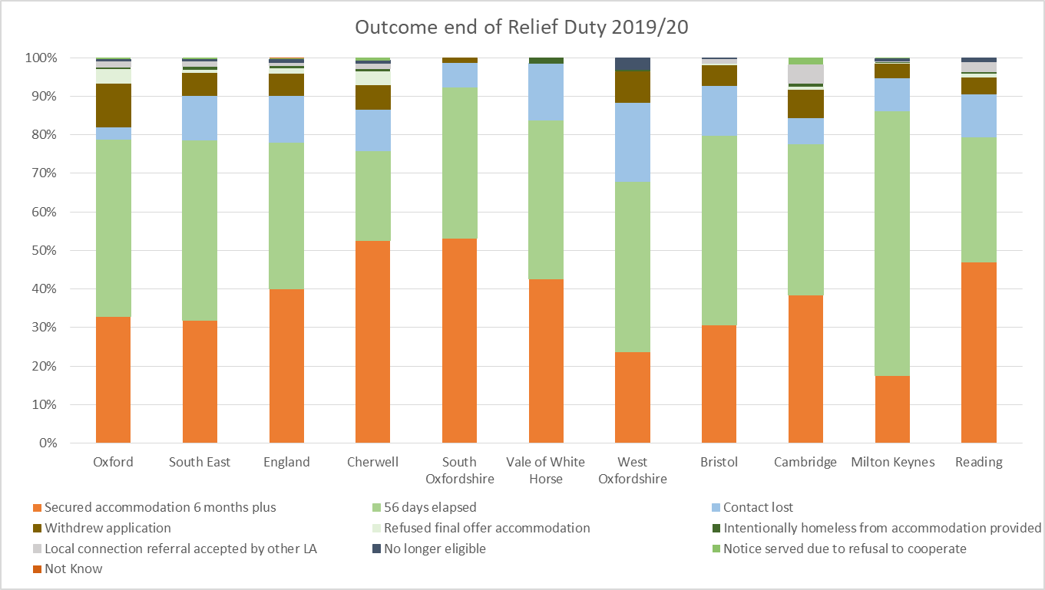

*Source: MHCLG Statutory Homelessness: Detailed local authority level tables: financial year 2019-20*

Similarly to the accommodation secured under prevention duty, we make good use of the PRS sector when securing accommodation for households under relief duty in Oxford. It is interesting to see that local authorities such as Bristol and Reading, that are heavily reliant on the PRS to prevent homelessness, have a significantly higher reliance on the social rented sector when securing accommodation for those owed a relief duty.

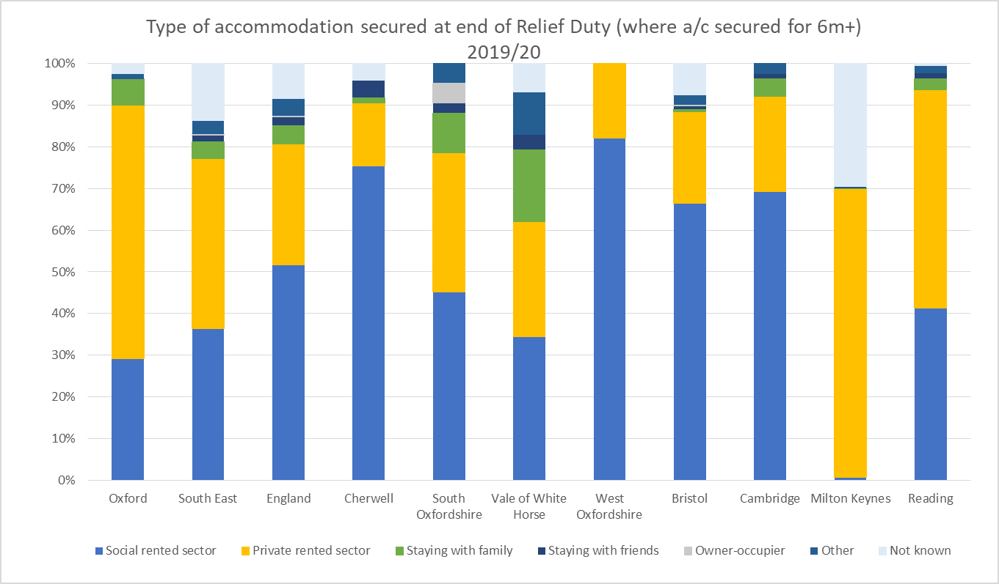

*Source: MHCLG Statutory Homelessness: Detailed local authority level tables: financial year 2019-20*

### 8.2 - Homelessness prevention in Oxford

We have a number of different tools to provide applicants with support and help depending on their circumstances and what they need and want assistance with to prevent or relieve their homelessness. We work in partnership to provide the necessary support and assistance to prevent homelessness, both before a prevention duty comes into force and as measures under the prevention duty.

To achieve good prevention outcomes overall, our housing options team will often work with both internal teams and external agencies. In addition to the activities our Housing Options service provide, we have also developed a number of other prevention measures that sit across the organisation. Some of these measures will be used as ‘early prevention’ measures, meaning that we will work to prevent homelessness before a statutory duty is triggered. Where this has not been possible, the officers supporting a households under a statutory duty, will also work to seek to prevent homelessness.

Internal service and support we provide includes,

* We have a homeless prevention fund that can be used to make one-off payments to help prevent someone becoming homeless, e.g. by assisting with relocation expenses, paying a deposit or paying a landlord to ensure a household can stay in their accommodation for a short period before other alternative accommodation is available.

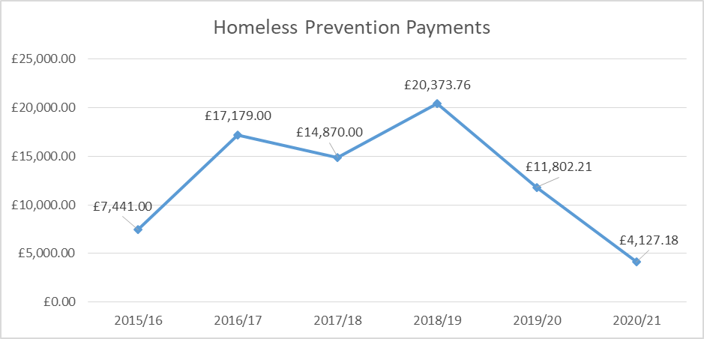

* We run a Sanctuary Scheme in partnership with the police that support households that experience domestic abuse or hate crimes to remain in their existing home. A range of measures can be installed in a property free of charge to the customer to enable them to remain living safely in the home without the need to move to alternative accommodation.
* Over recent years, we have worked with housing associations and providers of supported housing to establish ‘pre-eviction’ protocols. This means that accommodation providers, other services and the Council should work proactively and collaboratively to provide support for households that may become at risk of or are at risk of being evicted from their home, so that eviction is always the very last resort.
* Our Welfare Reform Team helps people who experience changes to their benefits or who are struggling to maintain tenancies due to financial difficulties. The team supports households to maximise their income through claiming the right benefits, find work or access training. A Discretionary Housing Payment (DHP) can also be offered as a temporary measure to assist with rent payments. In 2019/20, the team prevented 166 households from becoming homeless.
* The Council’s Tenancy Relations officer works in partnership with internal teams and external agencies to prevent illegal evictions and harassment of tenants who live in the Private Rented Sector. In 2019/20, 152 households were prevented from becoming homeless due to this work.
* Our Tenancy Sustainment Team work with tenants in the Council’s accommodation who struggle to sustain their tenancy, and a specialist Income Officer supports tenants that have issues with their Universal Credit.
* We have a ‘Furnished tenancy scheme’ in place, where we provide furnishings to new tenants moving into Oxford City Council accommodation and who, without our assistance, may not be able to afford it. Furnishings include items such as carpets, cooker, refrigerator, beds and bedding and other items that are needed to set up a new home. The scheme seeks to ensure that the property becomes a home and that the tenancy is more likely to succeed, thus preventing homelessness.
* The HRA introduced a new duty – the Duty to Refer - on certain statutory agencies such as prison and probation services, social services and health and mental health services, to refer households who are homeless or at risk of becoming homeless to the local housing authority. Organisations that do not have a formal duty to refer under the new legislation, can and do also refer cases to local authorities in an effort to prevent homelessness. Such organisations include advice agencies, support housing providers, street services for rough sleepers, private landlords and faith organisations. We receive a large number of referrals through Duty to Refer, In 2019/20, we received a total of 272 referrals, with 40% of these referrals from prison services. We also received a total of 97 referrals in respect of households threatened with homelessness from organisations that do not have a Duty to Refer under the HRA. Referrals are often received when a household is very close to becoming homeless, and the prevention activities that we and other organisations can then put in place are very limited, which ultimately makes it more difficult to reach positive outcomes. The number of households that we carried out a homelessness assessment for following a referral, is captured in the data collection we provide to MHCLG on a quarterly basis. In this we can see that in 2019/20, a total of 75 households where assessed, with 62.7% of the referrals received from an organisation subject to the Duty to Refer and 36% referred by agencies not subject to the duty. This data indicates that the vast majority of referrals we receive, never have an HRA initial assessment most likely due to failure for the referred household to engage with the service or the referred household not being someone we can support (such as sent to the wrong council or household not at risk of homelessness). Current data collection methods means we are unable to track outcomes from these cases. We acknowledge the need to strengthen our Duty to Refer offer, with better data collection and working with partners to increase the quality of referrals to ensure the best use of it to prevent cases of homelessness. We are also using embedded housing workers within key partners to support referrals ensuring they are regularly made, are of good quality, and ensure they are done as earlier as possible to maximise the chance of successful homelessness prevention, alongside broader benefits improving joint working to improve client outcomes. There is currently an embedded worker within the mental health system, and the potential for one working within the prison in the future.

There is also a wide network of organisations working to preventing homelessness in Oxford. The City Council supports many of these organisations through various grants in order to ensure that there are different and specialist services in Oxford, including longer term preventative approaches.

* Crisis Skylight specialises in single homeless households, through approaches such as having Housing Coaches that help to find accommodation in the Private Rented Sector, as well as help to fund deposit payments. Crisis can also provide a range of other support, including a wide and comprehensive range of education and training programmes for homeless people.
* If an applicant needs debt advice or support with benefit issues, the Citizens Advice or other local advice centres can provide assistance, as well as advice on other issues.
* Connections Support provides advice, advocacy and practical help in relation to homeless prevention, tenancy sustainment, drug and alcohol misuse, offending and mental health difficulties.
* Where a household has multiple and complex needs, Elmore Community Services can offer more specialised support.
* When we think there is a need for a care package to be in place, we will refer to and work with Adult Social Care.
* For victims of domestic abuse, referrals can be made to the women’s refuges or to an Independent Domestic Violence Advisor (IDVA). IDVA works with people in Oxfordshire who are deemed at high risk of significant harm and trauma through abuse.

The Council and partners deliver a good range of preventive services, above what it has to do under its statutory requirement, covering a range of needs and clients groups. However learning gained over recent years from work such as the Trailblazer Programme, the Crisis led Housing-Led feasibility study and learning from the Homelessness Reduction Act rollout, tell us that homelessness prevention in Oxford needs to go further, and ideally happen at an even earlier stage.

While we have significant and diverse provision for homelessness prevention, we need to consider if this sufficiently covers those client groups in most need. For example, we need to provide better and more comprehensive and holistic advice to households, and in particularly singles, that come to us to seek help, but who may not meet the threshold for statutory duties. We also believe that the current prevention offer for those living in the Private Rented Sector is insufficient, with the biggest source of homelessness in the city coming from the PRS, as evidenced by the last chapter.

Whilst it is positive and necessary to have a multitude of teams and services providing support, this strength does present some challenges. Providing diverse and specialist provision across multiple teams and external providers creates the challenge of better coordination and prioritisation across teams within the Council and external organisations, at the moment services can be too fragmented and do not as standard coordinate support closely enough to deliver the best outcome for clients. The Council will need to ensure its own teams working on the prevention of homelessness are closely coordinating and prioritising when facing high demand, in particular due to changing patterns of homelessness, to ensure the best outcomes for clients, but also engage external partners to ensure the best possible client journeys across organisations, maximizing opportunities to prevent homelessness.

To really make sure that we focus our prevention measures where they are needed and to make these work well to make the biggest difference, we also need to be more data and evidence led. This means that we need to use the data we have to inform what service and support we need to provide as well as collecting more information where there are gaps in our knowledge.

### 8.3 - The provision of Temporary Accommodation

As discussed in chapter 5, we have a legal obligation to provide temporary accommodation in certain circumstances to relieve homelessness. We mainly have our own stock for temporary accommodation use, some of which are Housing Revenue Account properties and some general fund and Oxford City Housing Ltd. properties. The majority of these properties are located in Oxford, but a few are in Cherwell and South Oxfordshire. In some cases, if there is no suitable temporary accommodation available, we will place the applicant in bed & breakfast/hotel accommodation for short periods until temporary accommodation in our own stock becomes available, or another more sustainable housing solution is found.

When living in temporary accommodation, households are supported by staff to settle into the accommodation, manage the accommodation and to find suitable and permanent accommodation. We also link in with and refer to more specialised support agencies where this is needed.

As an organisation, we are striving to reduce the number of households that need to be placed in temporary accommodation. As previously explained, the last decade has seen gradually falling temporary accommodation usage in Oxford, a trend not seen universally in the county. Since the introduction of the HRA in particular, trends across the country have seen most local authorities use temporary accommodation more. The reduction of use in Oxford, may be attributed to a number of complex factors, but we believe is mostly linked to our improved homelessness prevention offer, more focus on move-on in our temporary accommodation stock, and our improved Private Rented Sector access schemes both avoiding temporary accommodation placements and moving people from temporary accommodation on into the private sector. This leaves us in the position that while we have higher temporary accommodation rates than rural Oxfordshire, we have significantly better per capita temporary accommodation rate than our peer group of urban authorities (see chapter 5.4).

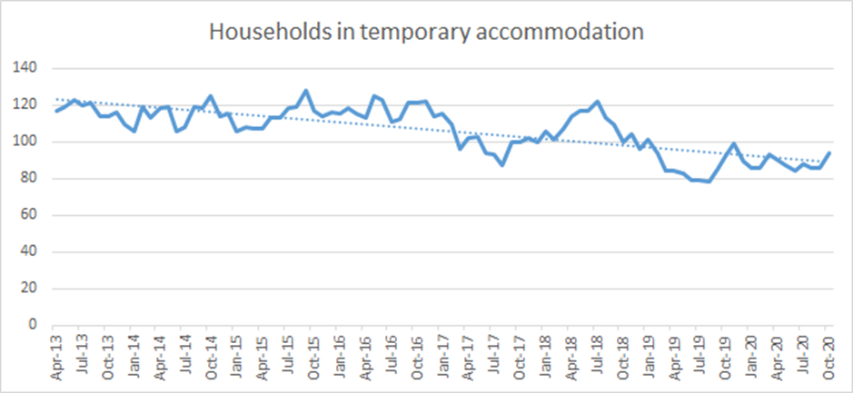

Calculated as per P1E definition

While numbers in temporary accommodation are historically low, the length of time some households stay in this accommodation is far longer than we would want. At a snap-shot in October 2020, 54 (61%) out of the 88 households in accommodation at that time had lived in temporary accommodation for over 6 months, and 27 over 12 months. We want to prevent unnecessarily long stays in temporary accommodation from happening in the future.

Despite the success with our approach to temporary accommodation we believe we need to do more to both keep the number in temporary accommodation as low as possible and to reduce the time households spend in temporary accommodation. A range of different research carried out over the last decade shows that stays in interim or temporary accommodation have detrimental effects on households, and in particularly on children. Being uncertain of the future of their housing situation, living in a place that can’t really be called a “home”, have negative effects on mental and physical health, education, and ultimate life chances[35], and it is therefore imperative that we keep numbers in temporary accommodation as low as possible and stays as short as possible.

In addition to the challenges in relation to numbers and length of stay, we have also seen a change to the type of households we are placing in temporary accommodation since the introduction of the HRA that presents further challenges. The new legislation has driven an increase in single households in our temporary accommodation and a large proportion of these singles have multiple support needs and require a high level of support to manage independently in their accommodation. This presents a number of challenges to us, both in relation to the kinds of support we and other agencies need to put in place for this cohort and also the kind of accommodation that we have available. If we are successful in future years in bringing down numbers in temporary accommodation further, and continue to see more demand from singles over other large households, this will also create the need to review the profile of temporary accommodation housing stock, as demand for larger size units drops.

For all households, and in particularly for singles, there are a number of barriers to moving on from temporary accommodation and into permanent accommodation. Going forward, we need to find ways of tackling barriers to move on such as rent arrears and anti-social behaviour, for example through preventative support and ensuring those who have support needs can access effective assistance, if we are to realise our ambition for households not to live in temporary accommodation for long periods of time. This may involve a move away from the concept of “tenancy ready”, where we work with a client in temporary accommodation until they are ready to sustain a permanent tenancy, to “tenancy supported” where support is provided in temporary accommodation and on into permanent accommodation, breaking the need for a tenant to “prove” they are ready to move on, which should enable more effective move on for clients.

### 8.4 - Support to access accommodation in the Private Rented Sector

Due to the significant demand on social housing in the City, we have developed different schemes over the years to aid our ability to help homeless households or those threatened with homelessness to find accommodation in the private rented sector. Assisting households to find alternative accommodation in the private rented sector is the most common outcome for households we are assisting to prevent and relieve homelessness (see previous sections). Some of the households we assist to move into private rented sector housing previously lived in our temporary accommodation.

The majority of households we owe a Prevention or Relief Duty towards will be referred to our Private Rented Sector Team that oversees the different schemes and work with landlords and households to find a suitable and affordable property.

The different schemes we operate include:

* Home Choice Scheme – set up in 2003 and offers incentives to landlords to let properties to homeless households, such as finder’s fees, provision of cash or bond deposits and rent in advance. These measures support homeless tenants better access the private sector, overcoming issues such as lacking money for a deposit, or landlords turning down tenants who receive Housing Benefit.
* Real Lettings – We have invested £5m into the Real Lettings Scheme (via the National Homelessness Property Fund), in partnership with St Mungo’s and Resonance, who have match funded £5m. This has enabled the purchase of 69 properties in Oxfordshire (mostly 2-bedroom properties) that we can nominate households to, whilst also securing a return on our capital investment. Tenants who are accepted and move into these properties receive support from St Mungo’s, focussed on achieving financial independence and to sustain a tenancy to enable them to move on to independent accommodation after 3-4 years. Rents for these properties are set at LHA level to enable tenants to save money.
* Rent Guarantee Scheme launched in November 2016. Through this scheme, we offer support to tenants to sustain a tenancy, while attracting landlords through the offer of this tenancy sustainment and financial incentives. We pay rent directly to the landlord and we then collect rent from the tenants. The landlord is therefore guaranteed to receive the rent due in respect of the property. Tenants accommodated through the scheme benefit from coaching from our Housing Coaches, with the aim of tenants becoming financially independent and able to manage and sustain their tenancies. We currently have 103 households accommodated through this scheme.

Wherever possible, we try to secure properties within the city. However, as there is a big gap between rent levels and LHA rates in Oxford, this has proved to be increasingly difficult over the last few years and consequently we also have to offer some suitable and affordable housing in areas outside of Oxford.

Over the last few 10 years, the number of households we have been able to assist into private rented sector accommodation has decreased. However, the establishment of the Real Lettings and Rent Guarantee Schemes have seen some recovery in recent years.

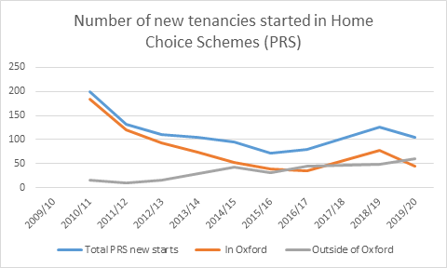

In addition to these schemes which are assessable for those we have a statutory homeless duty towards, we also have two rent deposit schemes through which we assist households with deposits and rent in advance payments to help them find their own accommodation.

The Lord Mayor’s Deposit Guarantee Scheme assists with deposits and rent in advance to singles and couples threatened with homelessness. It has become increasingly difficult for people to find private rented accommodation that is affordable when on a low income, and because we can only support with a deposit where we are confident the household can afford the rent, this has caused the number of successful applications to fall over the last decade.

We did however see an increase in successful applications to the scheme in 2019/20 due to an increase in referrals to the scheme made for those we owe a statutory duty towards, it is estimated that around 2/3 of all successful applications were due to referrals for such cases, with 1/3 being households who approached us for assistance where we did not owe a duty. We have also seen a large increase in applicants assisted through this scheme in 2020/21 – as of December, we had helped 65 applicants. This is largely due to the offer of assistance to those housed through the ‘Everyone In’ scheme from the end of March 2020, where we were more flexible with clients during the pandemic and lockdown.

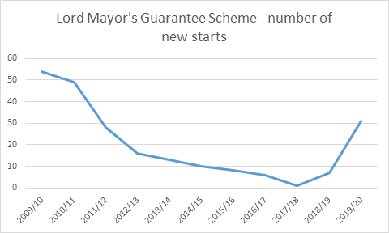

The Make It Happen & Move On Fund (partly funded through the Rough Sleeping Initiative) is another financial assistance scheme that is primarily aimed at assisting single people who:

* Are rough sleeping or at imminent risk of rough sleeping
* Live in the Adult Homeless Pathway
* Live in emergency accommodation provided due to Covid-19.

The aim of this fund is to help people into accommodation so that they do not have to access accommodation provided through the Adult Homeless Pathway and to increase options for move-on for those who are in the pathway or emergency accommodation.

Across the different private rented sector access schemes the council operates we have had a considerable success over the last 10 years in moving and sustaining homeless households in the sector, in very challenging circumstances. However, the persistent growth in rents, which aren’t being kept up with by benefits or wages, are causing more acute unaffordability, and continue to put pressure on the viability of our schemes for the future. This is a significant challenge, as we not only want to ensure continued access to the PRS for homeless households, but expanded access in order to underpin our wider aspirations such as more effective move on into the PRS from the Adult Homeless Pathway, temporary accommodation and as a homelessness prevention measure.

Therefore a major challenge for the next strategic 5 year period will be to renew and reinvigorate our approach and offer in the sector to maximise access for homeless households to affordable and quality private rented accommodation. Learning from our newer schemes approach such as the Rent Guarantee Scheme, and how we have used the Lord Mayor’s scheme more flexibly through the pandemic, offers a potential way forward. A review of the multitude of current schemes to consider their relative effectiveness, and future sustainability will be needed, and a revised offer formed to ensure the continued success of our private rented access.

The likely future direction of schemes will see greater emphasis and importance of support being provided beyond the placement in the privately property, with ongoing tenancy sustainment key as we respond to more clients who have support needs and history of tenancy failure. With an increasing demand from single clients, move on to rooms in shared accommodation and one bedroom accommodation in the private sector will be key, with the emphasis of most our current schemes being for family accommodation. This changing demand from homelessness trends will certainly require a reprioritisation of our property procurement to target different types of units, with an updated Home Choice offer that appeals to and encourages landlords with this different form of accommodation.

This raises the potential of our schemes having a greater involvement with the HMO market in the future, a housing type traditionally that has had a small part to play within our private rented sector access schemes, with potential for some trial sites in the near future as we seek to unlock greater amounts of move on accommodation for single households. The move to using HMO accommodation however would pose significant challenges for the council due to the increased management they require, and the concentration of potentially vulnerable clients, so this will be an approach that will need to be developed with care. We also need to ensure alignment between our private rented sector access schemes and the councils HMO licencing schemes, with the aim of a complimentary approach between these sections of the Council that encourages private landlords to let their properties through the council in a social responsible way.

### 8.5 - The allocation of social housing

Households who want to access social housing in the city can apply to be included on the Housing Register. We have formed a partnership with the major registered providers of social housing in the city and maintain a common register on behalf of this partnership (Oxford Register of Affordable Housing (ORAH).

The Housing register consist of two lists:

* The Transfer List – this is for tenants who live in social housing in the city and who want to move to alternative social housing.
* The General Register – this is for all other households applying for social housing.

A Homeless List is also kept as part of the wider General Register, this is specifically for households that the Council has accepted a statutory duty towards and who have been placed in temporary accommodation, so other homeless households are on the wider General Register and only provides a partial picture of homelessness on the full housing register since the implementation of the Homelessness Reduction Act.

There are certain eligibility criteria that need to be met before a household is included on the register, for example a household need to have a local connection to Oxford, demonstrate that behaviour is acceptable and that the household is financially responsible. Depending on a household’s needs and circumstances, they are placed in placed in priority system – Band 1-5 – where those in most need are placed in Band 1, and those considered in lowest need, in Band 5, in accordance with our Allocations Scheme. Due to the acute need for social housing in the city, the majority of households included on the register will never receive an offer of social housing unless they are in one of the top priority bands. Even then, the wait for an available property can take a long time.

The Council allocates social housing to applicants on the housing register through its choice based lettings system, which includes council owned and registered provider owned properties. We allocate around 500 properties per year across the lists.

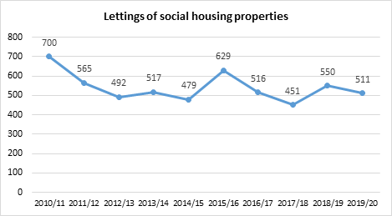

The majority of the properties allocated each year are flats and maisonettes - 70% in 2019/20 – as opposed to houses or bungalows. In 2019/20 around 60% of lettings were on family-sized properties, the rest being non-family, elderly and sheltered.

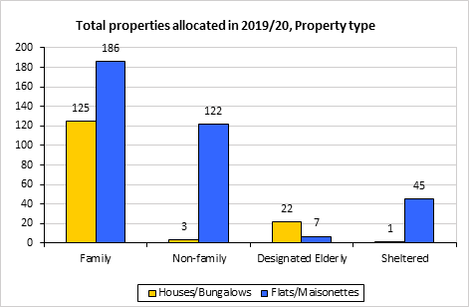

The two charts below show lettings to singles follows fairly closely the availability of bedsits and 1-beds, and demonstrate how much of the ratio of lettings between singles and families is determined by the supply of stock in each given year.

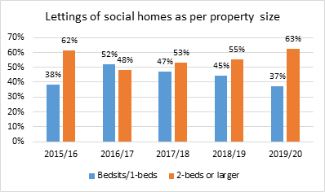

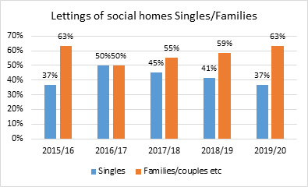

There is a higher percentage of lettings to 25-44 year olds in the years where there is a higher percentage of family sized properties available to let, as this age group is more likely to have dependent children and require family-sized accommodation.

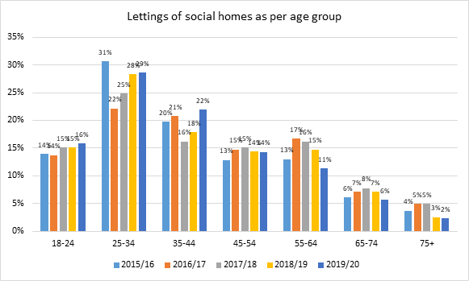

The proportion of lettings to singles/families and different age groups is mainly dependent on what properties come available for letting. Letting in the past decade have largely been determined by churn within the current social housing stock, due to low levels of new development, a position that is forecast to change in the coming years (see chapter 11).

We can break down allocations to see how many properties are allocated to different lists on the register, such as homeless, transfer, etc, in order to give us a view on how the allocations policy is prioritising different groups in need. The number of lettings to applicants accepted as statutory homeless has gone down in the last five years in line with the number of homelessness Main Duty acceptances going down from 141 in 2015/16 to 56 in 2019/20 as explained in a chapter 5 with the implementation of the Homelessness Reduction Act.

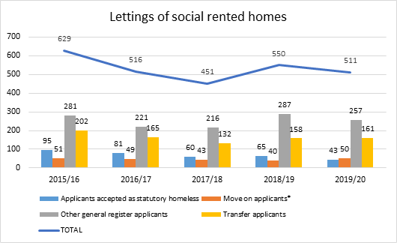

However this only paints a partial picture as the Homelessness Reduction Act has changed the nature of how homelessness cases are supported, with more upfront prevention support, which in turn impacts how we treat them on the housing register.

By breaking down the reasons for why people have received their relevant band we get additional insight into what circumstances are causing households to be in housing need on the register, and then compare this housing need to who then actually gets allocated properties from the register.

This comparison excludes the transfer register (due to homelessness applications not being included in the group), and band 5 where there isn’t a defined housing need, to allow us to compare the causes of housing need on the general register, and how this corresponds to the percentage of allocations.

It can be observed that overcrowding has both the highest number of cases on the register, and in turn gets the most allocations, with homelessness second for both. It can also be seen that while need and eventual allocations do seem to influence each other strongly, there is not a total correlation. We proportionally allocate far greater number properties to smaller categories such as those who are deemed as greater need by the exceptional circumstances panel, and in the “other” category (made up of cases such as succession cases and those who fit into multiple groups). Of particular note is that while homeless cases make up 40% of applications in bands 1-4, they only receive 32.4% of allocations.

Considering the full picture, once you add back in those allocations that went to those on the transfer register, and those in band 5 (no defined housing need), only 20.4% of lets went to homeless households in 19/20.

The Crisis commissioned housing led feasibility study for Oxfordshire[36] considered the current allocations schemes in the county, including the City’s, and highlighted some key issues with the schemes and how they are working for homeless households. One example the report provides is looking at the number of allocations that are made to those who are either currently rough sleeping or leaving supported accommodation (such as hostel accommodation), only 4.5% of allocations went to this group in Oxford, while other local authorities that promote access for this group achieve much higher numbers, such as Hull who allocates 21.4% or Coventry at 18.3%.

The report raises a number of areas the City and Districts should consider to improve access to homeless households, and suggests we are inadvertently restricting access to some homeless people at present. These measures include reviewing eligibility rules for the social register, managing the risk of placements better, making better use of reasonable preference groups, and more use of direct matches.

These findings will need to inform our future approach to social housing allocations for the next strategic period, as increasing access to social housing for homeless households will be essential for our wider goals to relieve homelessness more rapidly, and to bring down the prevalence of rough sleeping.

### 8.6 - Supported accommodation for homeless people and those vulnerably housed

As seen above, we can assist households to access independent accommodation in the city through a number of means. However, some people are not able to live independently for different reasons, and when this is the case, there are different forms of supported accommodation that people can access and that are available in the city. Where people are homeless but not able to live in independently, there are a number of different supported accommodation projects available in the city which we can help persons to access.

There are three large ‘pathways’, commissioned by statutory organisations such as the City Council, County Council and the Oxfordshire Clinical Commissioning Group, that provide accommodation for persons who are vulnerably housed and who are not able to live in independent accommodation.

### 8.7 - Adult Homeless Pathway

For single adult rough sleepers and those at imminent risk of rough sleeping, the Oxfordshire Adult Homeless Pathway provides 132 units of supported accommodation across the County, with 79 of these units located in the city and available for use by those linked to Oxford. These units are jointly commissioned in partnership between the City and District Councils, Oxfordshire County Council and the Oxfordshire Clinical Commissioning Group.

The current pooled budget arrangements are due to end in March 2022, and a re-commissioning process is starting in spring 2021. County partners are committed to working together and in line with the new County-wide Homelessness and Rough Sleeping Strategy, and informed by the key findings of the housing-led feasibility study for Oxfordshire, to ensure that the new arrangements are as effective as possible, with a consultation completed for this new strategy in the first months of 2021. Details of the new commissioning proposals are outlined at the end of this section.

In addition to the units commissioned via the pooled budget, Oxford City Council currently commissions an additional 118 units of supported accommodation for rough sleepers and those at imminent risk thereof. Interim accommodation under the ‘Everyone In’ scheme and funded through the Next Steps Accommodation Programme currently adds another 118 units. Additional beds provided throughout the winter and funded by Cold Weather Funding are currently also in place. The latter 126 units will be decommissioned during 2021/22.

The accommodation available consists of hostel accommodation (Matilda House and O’Hanlon House), shared accommodation in the community (provided by Homeless Oxfordshire, Connection Support and Mayday Trust) and self-contained accommodation in the community with intensive support (provided by Homeless Oxfordshire and Response).

The accommodation caters for different level of support needs that people may have, with those in need of more support receiving more ‘contact hours’ with support staff, and those with lower needs, receiving less support. All support provided is geared towards residents being able to live independently and to be able to sustain a tenancy when moving on from supported accommodation. The length of time that residents can stay in supported accommodation is limited and residents are also supported to find suitable accommodation to move on to when they are ready to do so.

During the cold winter months, when temperatures are forecast to be zero or below, we also trigger an emergency protocol – SWEP – that means that we offer all those who are rough sleeping a place in accommodation. During winter 2020/21, we therefore have an additional 25 bed spaces that are made available.

A breakdown of the accommodation currently available in the city, the funding source and when current arrangements are due to end is below:

|  |  |  |  |
| --- | --- | --- | --- |
| **Project/provider** | **No units** | **Funding source** | **End of current agreement** |
| O’Hanlon House – Homeless Oxfordshire | 27 (for city use) | Pooled budget | Apr 22 |
| Connection Support | 31 | Pooled budget | Apr 22 |
| Mayday Trust | 20 | Pooled budget | Apr 22 |
| Project 41 – Homeless Oxfordshire | 41 | OCC Homelessness Prevention Funds | Mar 22 |
| Housing First – Homeless Oxfordshire | 5 | OCC Homelessness Prevention Funds | Mar 22 |
| Acacia – Homeless Oxfordshire/Response | 8 | OCC Homelessness Prevention Funds | Mar 22 |
| Connection Support (complex/progression, previously delivered by Mayday Trust) | 10 | OCC Homelessness Prevention Funds | Mar 22 |
| Matilda House | 37 | OCC Homelessness Prevention Funds | Aug 2024 |
| Pre-recovery House – Homeless Oxfordshire/Turning Point | 7 | RSI | Jun 21 |
| Women’s only project – Homeless Oxfordshire | 5 | RSI | Jun 21 |
| Supported Lettings – Connections Support | 5 | RSI | Jun 21 |
| Canterbury House, Covid emergency a/c – St Mungo’s | 76 | NSAP | Jul 2021 |
| YHA, Covid emergency a/c – St Mungo’s | 42 | NSAP | Dec 21 (or sooner) |
| Hotel – St Mungo’s | 8 | Cold Weather Funds | May 21 |
| SWEP – various | 25 | OCC Homelessness Prevention Funds | Mar 21 |

There are plans in place to offer an additional 41 units of accommodation in the City following successful bids to the Next Steps Accommodation Programme, including 20 units of Housing First and 21 units of move-on accommodation (7 of which are already in use). These units are due to go live in the first half of 2021.

We have increased our spending on tackling rough sleeping significantly over the last few years, enabled by successful bids to MHCLG to funds such as Rapid Rehousing Pathway, Rough Sleeping Initiative and most recently the Next Steps Accommodation Programme. One of the main developments have been to develop Floyds Row in central Oxford to a new multi-agency assessment centre, including communal and dormitory style beds spaces for rough sleepers to use while assessment is taking place and alternative accommodation is sought. The original plans would see the centre provide up to 56 beds spaces. Parts of the Floyds Row building opened at the end of January 2020. Due to the pandemic, Floyds Row has since the end of March not provided any bed spaces for rough sleepers due to the need for social distancing in communal accommodation, but has been used as a triage centre to carry out assessment.

Despite the increase in services available for single homeless people in the city – both accommodation and ‘wrap-around’ services, we are still seeing rough sleeping numbers in the double digits, and as seen above in chapter 5, while numbers of rough sleepers are significantly down on their peak from 2017/2018, numbers remain higher than a decade ago. Preventing people from ending up on the streets in the first place, therefore needs to be a priority going forward.

We have also seen that a large proportion of rough sleepers have been known to services in the past and many have been in the supported accommodation provided before, some multiple times. We can also see the level of people we accept a statutory duty towards that have been evicted from supported accommodation is high, a further sign that the provisions we have in place, do not work for some of the most vulnerable people in society. For different reasons the supported accommodation on offer does not work for all and people return to rough sleeping, or avoid entering into this kind of accommodation at all. Ensuring good and effective supported accommodation services, meeting a range of different needs, is another priority that need to be tackled if we are to prevent people from returning to the streets. This is further backed up when looking at the multitude of support needs that the majority of rough sleepers face in the city. Support in both supported accommodation and in more independent accommodation, needs to be holistic, and include a substantial offer from mental health and health services and not only be focussed at providing a housing solution. This needs to include good and timely move on options, with necessary support put in place in order for the individual to sustain their move.

Although the pooled budget arrangements have been in place for several years now and has created some form of stability for the parts of the system that it funds, the majority of the supported accommodation available in the city is funded either by the city council’s own funds or government funding, with no long term commitment. This creates uncertainty and a risk that funding for these project in the longer term will not be available.

The issues raised above are discussed in depth in the Housing-led feasibility study for Oxfordshire and new approaches and commitments to tackle these issues have been set out in the Oxfordshire Homelessness and Rough Sleeping Strategy that will inform future commissioning of services for single people. Our own priorities and actions therefore need to be closely aligned with this work, only through this significant change in approach can we achieve further reductions in the numbers of rough sleepers, in line with local and national aims.

The recommissioning of services from the pooled budget arrangements seeks to deliver many of the aims of the Strategy referenced above. Key developments are the inclusion of a greater range of services than the current pooled arrangements with the majority of services currently commissioned by the city and district councils, brought within the pool. The services will be procured using an alliance commissioning approach. An alliance of providers will be responsible for all services, rather than individual providers being responsible for each element. The new alliance governance structure will include a role for commissioners. This will help to ensure that services are delivered in partnership and managed at a systemic level, improving the outcomes for people accessing it.

### 8.8 - Mental Health Pathway

Funded by the Oxfordshire Clinical Commissioning Group and Oxfordshire County Council, two organisations – Response and Oxfordshire Mind – provide supported accommodation for single people who suffer from mental health conditions, would struggle to live independently and who have no other accommodation options. Commissioners of this provision estimate that 75% of people living in this accommodation would be homeless if they did not have this accommodation.

A range of different accommodation options are available, including self-contained flats and shared houses, with varying level of support in place depending on the need of service users. Just under 500 units of accommodation across the County are available, with the majority of units in the City.

There are set eligibility criteria for this accommodation, and people can refer themselves, or be supported by someone else to apply for housing.

### 8.9 - Young people's supported accommodation service (YPSAS)

Young people's supported accommodation service (YPSA) is a countywide service that provides accommodation to young people aged 16-24 who have a support need and who meet the eligibility criteria, while supporting them to develop their independent living skills, find employment, education or training. The service is a short-term intervention which includes a plan to help young people meet their long-term needs. It accommodates care leavers as well as vulnerable young people at risk of homelessness due to family breakdown including those with complex needs. The YPSA service is co-commissioned by the City, District and County Councils with input from providers and young people using the service. It was launched on 1 October 2020, following funding commitments from all City and District authorities in Oxfordshire, with the City Council committing £128k in Year 2 (2021/22) rising to £135k in Year 5

There are a total of 288 beds in the new service and it is delivered via a number of different service packages and by a number of providers countywide – see table below.

The new service differs from the previous one in a number of key areas:

* The move away from larger foyer style properties to houses of no more than 4 young people living together.
* The separation of the 16-17 year olds from the older young people and bringing the service for them in house to the County Council.

Referrals into the service are received from Social Workers and from City and District Housing Officers. The service provides intensive, focussed support in order to help young people develop the independent living skills they need to move into independent accommodation after approximately 18 months. Increased mental health support is available via two clinical psychologists who work with and advice support providers in their support of individuals using the service. In addition young people in the service can be referred to the Mental Wealth Academy.

|  |  |  |  |
| --- | --- | --- | --- |
| **Service Package (SP)** | **Locality** | **Total Number of beds including Emergency beds** | **Organisation delivering the service** |
| SP1 – 16-17 year olds.  Shared accommodation with up to four young people living together | All | 68 | OCC in house  Response commissioned to deliver accommodation |
| SP2 – 16-17 year old newly arrived unaccompanied young people. Up to four young people living together for up to four months. (after this they move to SP1) | Banbury  Oxford City | 12 | OCC in house  Response commissioned to deliver accommodation |
| SP3 16-17 year olds. Move on homes providing intensive support for up to nine months | South and West Oxfordshire | 8* | OCC in house |
| SP4 -16-24 year olds. Supported Lodgings – Support offered in a family enviornment | Various depending on location of hosts | 25* | OCC in house working with Supported Lodging hosts |
| SP5 18-24 year olds  Shared Accommodation with up to four young people living together | All locations | 130 | Response in conjunction with Oxfordshire Youth |
| SP6 18-24 year olds.  Single self contained properties for young people not able to live safely with others | Bicester and Banbury  Oxford City  South Oxfordshire  Vale or White Horse  West Oxfordshire | 28 | Key 2 Futures  Key 2 Fuutures  Connection Support  Stonewater  Stonewater |
| SP7 16-24 parents. Shared accommodation for a parent/s to live with their children | Banbury  Oxford City  South Oxfordshire  Vale of White Horse  West Oxfordshire | 40 | Sanctuary Housing  A2Dominion  A2Dominion  Stonewater  A2Dominion |
| SP8 -16-24 year olds  Out of County due to risk of exploitation (self contained or shared accommodation for young people who cannot live safely in Oxon | Out of county | 10 | Connection Support |

*These are not included in the total of 288

### 8.10 - Other supported accommodation

In addition to the three large ‘pathways’, there is good provision of other supported accommodation in the City (not funded by the City) and include:

* Accommodation tied to employment
* Approved premises that provide accommodation for offenders under the supervision of probation services.
* Residential detox and rehabilitation for those experiencing substance misuse
* Abstinence based accommodation for those in recovery from addiction
* A range of supported accommodation projects for those who are homeless or vulnerably housed that are not funded by the City, Districts or County Councils.

### 8.11 - Other support available in the City

Oxford has a large number of non-statutory organisations that provide help and guidance for those who are threatened with homelessness. These include three advice centres that can provide support with everything from benefits, finances, debt, housing and employment.

For single homeless people and rough sleepers, we commission a breath of services aimed at preventing and tacking rough sleeping in addition to providing the supported accommodation described above. We have increased our funding for such services over the last few years as reducing rough sleeping is one of the main priorities for the Council under the current Housing and Homelessness Strategy as well as the Corporate Strategy. We have also secured additional funds from successful bids to the MHCLG to this end.

The external services (projects/staff costs) we commission directly are:

* St Mungo’s that provide an outreach service to engage and assess rough sleepers and help them access accommodation and support. St Mungo’s also operate the assessment hub at Floyds Row, provide ‘navigators’ who work with long term rough sleepers to help access accommodation and act as a main point of continuous support when people have moved into accommodation, and a specialised EEA migrant outreach service.
* Pre-recovery support in-reach into the pre-recovery accommodation project delivered managed by Homeless Oxfordshire.
* A specialist Tenancy Sustainment Officer at Elmore is funded support residents in Oxford City Council accommodation to maintain their tenancies and thus prevent homelessness.
* Day centre services at the Gatehouse and The Porch, which provide food, clothing, general sign-posting and support, as well as a range of different activities.
* Workers at Aspire to provide training and employment opportunities for homeless and/or vulnerably housed individuals in the City. Aspire is a social enterprise working towards becoming self-sufficient.
* A Tenancy Ready Course, that help people develop a range of skills that will enable them to become tenancy read, is delivered by Connection Support.
* Funding is provided to the Thames Valley Police City Centre Unit to provide targeted support to reduce rough sleeping through outreach, enforcement, tackling begging and antisocial behaviour. The City Centre Unit has a dedicated police constable for the purpose of this work.
* A Make-it Happen & Move on Fund that provide financial assistance for single homeless people who are rough sleeping or in adult homeless pathway accommodation.
* A further fund, delivered and match funded by Greater Change, to help people accommodated in the ‘Everyone In’ interim accommodation to move into more settled private rented housing by paying for deposits and rent in advance.
* The OxTHINK data base to maintain web-based database management system that collates data and provides monitoring reports on rough sleeping

From our Homelessness Prevention Funds, we also fund the following services that sit within Oxford City Council:

* The City Centre Ambassadors provide a visible presence within Oxford City Centre. They assist people with enquiries, liaise with businesses to keep the city centre clean and litter free, and work closely with the police to spot and deter anti-social behaviour. They engage with homeless people, referring them into the appropriate support services
* Contribution to the Welfare Reform Team towards the work of a team focussing on the impact of welfare reform across the City.
* Funding is provided for a post in the Anti-Social Behaviour Team to support victims of domestic abuse and enable them to stay in their own homes through the Sanctuary Scheme.
* Funding contribution towards the Council’s Rough Sleeping and Single Homelessness Team.

In addition to the services commissioned by us, there are a range of services that provide good support to single homeless people and those experiencing rough sleeping. The Oxfordshire Homeless Movement, established in 2018, is a partnership of organisations that are working together to prevent and tackle rough sleeping in the city. They have developed a directory of services across the County and City that provide support and assistance.

## **9.0 - What are we doing to build more new homes?**

|  |
| --- |
| Key Findings – What are we doing to build more new homes?   * The last three years has seen an increase in the annual number of affordable homes delivered in the city, after low rates of development seen during most years in the middle of the last decade. * The pipeline of sites from the City Council, OCHL and Housing Associations indicates a significant increase in delivery over the next three years, projecting the delivery of 1,036 affordable homes. * Agreements have been reached with the surrounding districts to Oxford, to ensure city residents in housing need can access affordable homes developed in the wider county. * The greatest need for affordable housing now comes from those who need one bedroom accommodation, linked to the increasing number of single homeless people seeking help from the council. In 2018, those in housing need with one bedroom need made up 33% of the general register, they now make up 44%. This needs to inform the profile of future affordable housing developed. * A number of innovative housing development solutions are being taken forward in Oxford, such as community housing and an Oxford Living Rent. |

Oxford City Council has an ambitious agenda to increase the rate of delivery of affordable housing in the city, in order to tackle the issues of affordability residents face, in particular those on low incomes, to ensure the city continues to be a home for those on lower incomes.

This aim was a centre piece of the previous housing and homelessness strategy, and is now enshrined as a key priority in the council strategy and annual business plan.

However the context of development, and in particular affordable development, in the city is a challenging one. Land in the city suitable for development is limited, with little remaining for easy development, with what land remains often brown field that can bring with it a variety of issues, and increase the cost of development and decrease the affordable housing element. This is compounded by the fact land is already at a premium price, and the labour market for construction workers competitive, further increasing cost. When viable sites are found, the city’s historic nature limits the size of developments, and adds additional considerations on design. The city also has a tight boundary, not taking in much of the rural areas surrounding the urban core, causing challenges for urban extension. These long term factors when combined with Brexit, the pandemic and the resulting economic uncertainty over the past few years has had the impact of disrupting the housing market, and increased risk for developers. This full picture combines to make significant affordable development in the city a significant challenge, but one the city council has sought to overcome.

While affordable development may be difficult in the city, there is a great need for it. The Oxfordshire Strategic Housing Market Assessment (SHMA) Update 2018 indicates a need to deliver 678 affordable homes a year in Oxford if all households who are not able to meet their needs in the housing market were to be allocated an affordable home. The number of affordable homes developed each year has come nowhere near this in recent years, averaging 73 a year over the previous decade.

While the pandemic has been another challenge for the delivery of affordable housing, it may open new sites for the development of affordable housing in the future as the city changes in the conditions of the post pandemic world. There may be new opportunities for redevelopment on previously unavailable sites as the economy adjusts, with a potential drop in demand for retail and office space, including in the city centre.

### 9.1 - New builds and acquisitions

The previous housing and homelessness strategy was developed over 2017-18, and followed the middle part of the last decade which saw a low rate of social housing development in the city. In the 5 years from 2013, the best year that was achieved was in 2015/16 when 166 units were delivered, but the other 4 years saw between 45 and 4 units being delivered. This was in a context of limited borrowing powers given to local authorities for the development of new social homes due to cap imposed by central government, strict rules on use of right to buy receipts, rent rise restrictions on all social landlords, and reduced grant funding for affordable housing development from central government.

The years following the implementation of the new strategy have been more positive, with 102 delivered in 18/19, and 89 delivered in 19/20, and 123 in 20/21. This is partially a result of a slightly more favourable national policy context with some changes brought in by central government such as on the borrowing cap and rents policy, but also through the growing capability and capacity of the council’s housing company OCHL with the gradual establishment and progression of a pipeline of new builds being delivered by them.

This success in increasing development over the last few years is set to be built on in future years, as the combination of the Council, its housing company Oxford City Housing Ltd and registered providers in the city move forward with their ambitious pipelines of sites and delivery. 2020/21 was another good year, with 123 homes delivered, which within the context of the pandemic and lockdown was a significant achievement. A total of 1,036 affordable homes are now planned for the period 2021-2024 on identifiable sites, far exceeding the yearly averages seen in the previous decade, and taking the city closer to the level required to meet need. These identified sites are at different stages of delivery, with dates subject to change due to considerations such as planning and site preparation.

### 9.2 - Oxford City Housing Ltd.

Oxford City Housing Ltd. is one of the main factors in increasing supply of affordable homes in the city over recent years, and crucial to the significant increase projected for the next three years. Oxford City Council set up the housing company in 2016 to deliver new affordable homes for a range of tenures to help address the city’s acute housing need.

The three main purposes of the company are:

• To increase the supply, quality and range of housing and particularly new affordable housing in Oxford

• To provide financial returns to the Council

• To deliver on the Council’s accelerated carbon reduction agenda moving towards Zero carbon by 2050

The company has to date completed 95 affordable rented homes at Barton Park. A total of 354 homes will be owned by the company at Barton Park when completed. Building is also currently taking place at two sites in Rose Hill, Bracegirdle Road, Between Towns Road, Mortimer Drive and Broad Oak, Elsfield Way and Cumberledge Close.

Over the next 10 years, OCHL aims to build around 1,900 new homes, in addition to the 354 homes being built at Barton Park, with around 1,100 homes for social rent and a further 300 for shared ownership and other intermediate tenures.

In the three year period 2021/22 to 2023/24 OCHL plans to build a total of 339 properties, 230 social rent, 46 affordable rent and 63 shared ownership.

### 9.3 - Oxford City Council’s Housing Revenue Account

The City Council will also continue to develop new homes directly through the housing revenue account (HRA) over this period. A total of 233 properties are planned for the period 2021/22 to 2023/24, 154 social rent, 32 affordable rent and 47 shared ownership.

The HRA has been able to make more significant investments into things such as new development in recent years due to the lifting of the borrowing cap previously imposed on it, as explored in section 4.6.

The government is currently in the process of changing the rules on Right to Buy receipts which will make it easier to invest into new affordable development in the future, while limiting their use for purchase of existing properties, section 4.7 explores this further.

An important consideration for the next strategy will be the prioritisation of long term investment made by the HRA, in areas such as new affordable development, investment in regeneration and current stock condition, and decarbonising the housing stock. Section 12.3 later in the document explores more widely these considerations on the housing revenue account.

### 9.4 - Registered Providers

The Council will continue to work with Registered Providers (housing associations) to facilitate the development of new affordable housing in Oxford. We recognise that while the Council and its housing company play a critical role in leading on and delivering more affordable housing, we alone will never deliver the number of affordable homes the city needs, and therefore it is essential that we work with housing associations to encourage their investment in the city, and support their development activities.

It is currently projected that Registered Providers plan to build a total of 464 properties in Oxford in the period 2021/22 to 2023/24, 239 social rent, 12 affordable rent and 213 shared ownership, significantly higher than the average recent rate of delivery from the sector.

We recognise that while we have built up our enabling function in recent years to work with register providers, we needs to go further, and we will continue to develop our enabling work in the coming years to increase joint work and support to Housing Associations to increase their activity further, through proactive engagement, support through better coordination between council teams such as housing, planning and regeneration, and providing assistance such as with local data and information on sites.

Housing associations have in particular a significant amount of sheltered and designated elderly stock in the city, as outlined in the table below, which as the needs and wishes of the elderly population change may mean changing demand. The City Council will want to work alongside these housing associations to explore any regeneration or remodelling opportunities on these sites to best meet the current housing need in the city.

|  |  |  |  |  |  |  |  |
| --- | --- | --- | --- | --- | --- | --- | --- |
| **HA nomination properties 1 April 2020** | |  |  |  |  |  |  |
|  | **Number of bedrooms** | | | | | |  |
|  | **0** | **1** | **2** | **3** | **4** | **5+** | **Sum:** |
| **General needs - Flat / Maisonette** | 144 | 730 | 460 | 34 | 1 | 0 | **1369** |
| **General needs - House / Bungalow** | 0 | 35 | 526 | 776 | 147 | 25 | **1509** |
| **Designated elderly** | 2 | 84 | 156 |  |  |  | **242** |
| **Sheltered** | 203 | 461 | 51 | 2 | 0 | 0 | **717** |
| **Sum:** | **349** | **1310** | **1193** | **812** | **148** | **25** | **3837** |

While working in partnership with housing associations to encourage affordable development, we will continue to help ensure housing association tenants enjoy well maintained and managed homes through engagement with tenants and their associations.

### 9.5 - Oxfordshire Growth Board[37]

The Oxfordshire Growth Board is a joint committee of the six councils of Oxfordshire together with key strategic partners. It has been set up to facilitate and enable joint working on economic development, strategic planning and growth. This cooperation has helped Oxfordshire to secure over £500m of additional investment, such as through the City Deal, Housing and Growth Deal, Housing Infrastructure Fund and the Oxfordshire Rail Connectivity Study.

The Housing and Growth Deal helps support Oxfordshire’s ambition to plan and support the delivery of new homes – including additional affordable housing – across the county between 2011 and 2031 to address the severe housing shortage and expected economic growth. The Housing and Growth Deal also includes forward funding for infrastructure improvement schemes to benefit existing communities and unlock new development sites. It will also unlock funding from developers for community infrastructure such as schools, health centres and community centres.

As part of the Growth Deal agreement with the Government, all local authorities in Oxfordshire have committed to producing a joint statutory spatial plan (JSSP), known as the Oxfordshire Plan 2050. The aim of the plan is to collectively consider the needs of the county and align its strategies so that future housing and infrastructure is more joined up.

The Plan will not allocate sites for housing or employment. Instead, it will identify key areas for sustainable growth with associated housing / employment numbers, while considering how to help tackle climate change, improve water efficiency and mitigate flood risk. Districts will then use this to produce future Local Plans which will provide a detailed view of how housing and infrastructure will be delivered, and how they will address the climate emergency.

### 9.6 - Oxford Local Plan 2036

Oxford City Council adopted its Oxford Local Plan 2036 in June 2020. The 2036 Local Plan sets out a new framework underpinning all planning applications in Oxford over the next 16 years.

Oxford Local Plan 2036 includes:

* Defining where nearly 11,000 new homes will be built within Oxford’s boundaries.
* Ambitious carbon reduction policies that, using incremental increases, will see all new residential developments constructed in Oxford be zero carbon by 2030.
* Focus of town centre uses on the city centre, district and local centres – including Cowley Centre, Summertown, Headington, East Oxford (Cowley Road) and Blackbird Leys – to both increase the density and height of buildings, and strengthen neighbourhoods by encouraging new community, leisure and cultural assets.
* Protecting and enhancing both Oxford’s heritage, particularly the historic buildings within Oxford city centre, and the city’s vital network of parks, open space and waterways.
* Supporting business by encouraging the modernisation and intensification of Oxford’s existing science and business parks.

### 9.7 - Oxford’s unmet housing need

As previously mentioned, Oxford is unable to meet its assessed housing needs within the administrative boundary of the city, so for the past five years, the City and District Councils in Oxfordshire have been developing proposals whereby these needs – indeed the needs of Oxfordshire – can be best met through a distribution across local authority boundaries.

The following table breaks down the agreed allocations across the local authority areas of Oxfordshire, followed by the sites earmarked for delivery of the homes. These homes will be delivered over a 2021-31 timeframe, and regularly reviewed over the period to ensure delivery and to inform onward plans.

So far the additional requirements to meet Oxford’s unmet housing need have been incorporated in each district council’s local plan. The City Council is currently working with each District Council to reach agreements on how the proportion of affordable homes for rent will be allocated to make sure residents with a local connection to Oxford have priority to these homes.

The only development currently on site is the South of Kennington site in the Vale of the White Horse but the first affordable units.

|  |  |  |  |  |
| --- | --- | --- | --- | --- |
| **Oxford Unmet Need** |  |  |  |  |
|  |  | **Affordable Homes** | **Affordable Rented** | **Shared Ownership** |
| **District Apportionment (2011-2031)** | **All Homes** |
| Cherwell | 4400 | 2200 | 1760 | 440 |
| Oxford | 550 | 275 | 220 | 55 |
| South Oxfordshire | 4950 | 2475 | 1980 | 495 |
| Vale of White Horse | 2200 | 1100 | 880 | 220 |
| West Oxfordshire | 2750 | 1375 | 1100 | 275 |
| **Total** | **14850** | **7425** | **5940** | **1485** |

### 9.8 - Community-led housing

Community-led housing is where people and communities play a leading role in addressing their own housing needs, and provides an additional option for some in need of housing. It encompasses a range of approaches, including Community Land Trusts (CLTs), cooperatives, cohousing, self-help housing and group self-build, and can involve new build, regeneration or the use of existing buildings.

The core principles include a requirement that meaningful community engagement and consent occurs throughout the process, that the local community group or organisation owns, manages or stewards the homes and a requirement that the benefits of the scheme to the local area and/or specified community group are clearly defined and legally protected in perpetuity.

In Oxford there are two examples of housing co-operatives taking over existing homes: Dragonfly Housing Co-op in East Oxford, which was formed in 2001, and Kindling Housing Co-op in Cowley, which was formed in 2016.

Research commissioned by the Council concludes that delivering community-led housing schemes in Oxford is challenging and Oxford land prices and competition for sites makes it very difficult for local groups.

Enabling activity that would particularly help Oxford groups and potential future schemes are strategic leadership, access to land and access to finance.

Some of the priority actions recommended for the Council are:

* Unlocking sites for community-led housing.
* Liaising with landlords of empty properties and poorly managed houses of multiple occupation to promote and facilitate opportunities for community-led housing groups to bring the properties back into occupation.
* Setting up a revolving loan fund that community-led housing groups can access for cheaper finance.
* Developing practical responses to help support and encourage community-led housing including providing support and guidance for the identification of appropriate sites and working with landowners.

The viable delivery routes identified in the research are:

* Fully mutual housing co-operatives, accommodating groups of sharers in large houses;
* Small units for single people, developed across a number of small sites;
* Cohousing on a single site;
* Community land trust as part of a large site.

The City Council supports community-led housing in its local plan, and is exploring ways of making community-led housing work in Oxford, looking at support, funding and what sites would be suitable. A pilot scheme is under way with the Council working in partnership with local architecture practice Transition by Design and Oxfordshire Community Land Trust to develop a small unused garage site in Littlemore.

Discussions are underway between Oxford City Council and Oxford Co-housing to develop an area of the Redbridge site for a community led scheme including a potential area for new residential moorings.

Oxford City Council have received a grant for £19,994 from the LGA Housing Advisors Programme (HAP) fund to work in partnership with Transition by Design and Oxford Community Land trust on a blue print for the development of affordable housing on disused or brown field sites in the city. The funding will be used to map a pipeline of sites within the City with 5 sites being shortlisted for further design and community engagement work to provide much needed accommodation.

### 9.9 - Employer-linked affordable housing

Employers in Oxford are facing significant challenges in recruiting and retaining staff as a result of the lack of availability and affordability of housing. To meet this need the Local Plan 2036 includes a policy that allows employers to address their recruitment and retention issues by providing housing for their employees at a rent affordable to them on employer owned sites listed in the policy.

By exempting these developments from the normal requirements for affordable homes, the City Council is offering a significant opportunity for those employers to provide for their own needs and address the sector of society between those able to access traditional affordable housing and those able to access market housing for sale or rent.

### 9.10 - Regeneration[38]

Oxford City Council and Catalyst Housing are working in partnership to redevelop Blackbird Leys by building 281 new homes, including 167 homes for social rent. The redevelopment also includes a new community centre and shops, together with improvements to green and public spaces.

There are also plans for regeneration in Barton and the Oxpens area. Oxford City Council has formed a joint venture with Nuffield College – OxWED - to redevelop the Oxpens site. The site is a 15-acre site off Oxpens Road, on the opposite side to the new Westgate Centre. Oxpens is part of wider plans for the Oxford West End Innovation District and the Council ran a consultation on a new West End and Osney Mead Masterplan Supplementary Planning Document (SPD) in spring 2021. OxWED is planning to hold a consultation on the redevelopment of Oxpens in the summer of 2021 and submit a planning application in 2022. Oxpens will deliver both homes and new employment/business space for the city – potentially supporting over 3,000 jobs and the provision of around 450 residential dwellings.

### 9.11 - Housing for the elderly

In 2016, the City Council undertook a review of accommodation supply and needs of older residents in Oxford which identified that there is an oversupply of sheltered accommodation in some locations in Oxford and there is a limited need for Extra Care and Specialist Housing (dementia care) for older people in the City. The County Council comments on need for care services in Oxfordshire in their Market Position Statement 2019-22.[39] Data has been reviewed since the publication of the MPS and current predictions are that there will be a shortfall of approximately 83 units of Extra Care Housing in the City by the end of 2023. By the end of 2026, the shortfall is expected to increase to 129 units, and rising to approximately 157 units short in the City by the end of 2031 units.

The review also confirmed that as people get older they would prefer to live in locations familiar to them with access to existing support networks, as well as good access to shops, health services and public transport. Those ‘under-occupying’, regardless of tenure, indicated that they would be reluctant to move unless it was to the right property (i.e. well designed, with sufficient outdoor space and storage) and would still want a minimum of 2 bedrooms to allow visitors or carers to stay as needed.

Changes in demand as highlighted through our own review of housing need and supply for older people, as well as the County Council’s Market Position Statement that sets out demand, capacity, future requirements and commissioning intentions for care and support, and accommodation based services for adults, will need to inform strategy development. The views of people leaving across these tenures will also be a key to inform strategy development.

### 9.12 - Accessible and adaptable homes

According to the Family Resources Survey 2018/19, 44% of state pension age adults, 19% of working-age adults and 8% of children in the UK reported a disability. Mobility was the most prevalent impairment with 48% of disabled people reporting mobility issues.[40]

The Census 2011 shows that 12.4% of the population in Oxford have a long-term health problem or disability, with half of those over 65 having a long-term health problem or disability,

Oxford has a relatively young population, but the older age groups are projected to increase and hence the need for adapted properties. Providing accessible and adaptable homes will help people with disabilities maintain their independence and help alleviate pressure on health and social care.

The City Council’s planning policies require that all affordable dwellings and 15% of general market dwellings on sites of 10 or more dwellings are constructed to the Category 2 standard (accessible and adaptable dwellings). 5% of all dwellings for which the City Council is responsible for allocations or nominations on sites of more than 20 dwellings should be provided to Category 3 (wheelchair user) standards.

### 9.13 - Property sizes

Another changing dynamic that needs to inform our housing strategy is that there is an increasing demand for affordable housing for single people, indicating a need to look at increasing the supply of 1-bed properties. 44% of applicants on the general housing register in bands 1-4 need a 1-bed property. In 2018 the corresponding figure was 33%. The Crisis Housing-led Feasibility Study for Oxfordshire also highlights the need for better access to social housing for single homeless people.

There is also a need for large family homes (5-bed properties or larger), as there are few large social housing properties in the city, and the turnover is low, which leads to families being severely overcrowded and having to wait a very long time for a suitable property to come available.

For applicants on the housing register in bands 1-4 the highest need is for 1-beds, followed by 3-beds. For general register applicants the highest need is for 1-beds, and for transfer applicants the highest need is for 3-beds. The majority of the transfer applicants requiring a 3-bed are currently living in a 2-bed and are overcrowded. Overall, the most common band reason for applicants in bands 1-4 is overcrowding.

Policy 4 in the Local Plan has the following mix of dwellings as a requirement for affordable housing element of new developments.

1 bedroom homes . . . . . . . . . . . . . . . . . . . . . . . . . . . . . . . . 20-30%

2 bedroom homes . . . . . . . . . . . . . . . . . . . . . . . . . . . . . . . . 30-40%

3 bedroom homes . . . . . . . . . . . . . . . . . . . . . . . . . . . . . . . . 20-40%

4+ bedroom homes . . . . . . . . . . . . . . . . . . . . . . . . . . . . . . . 8-15%

### 9.14 - Living rent

The term “living rent” is used to describe different formulas and methodologies that seek to set a rent level which is informed by the circumstances of local people, in order to ensure the rent is affordable to them by linking the level of rent to a measure of average income in a geographic area. Many of these formulas have used a percentage on or around 35% as a share of household income that can be used on housing costs while still be affordable. These formulas may be seen as particularly relevant in Oxford where market rent levels are unaffordable for those on an average wage. The Mayor of London has set a Living Rent for London that is used as part of London’s affordable housing funding programme.

The Council passed a motion in support of exploring an ‘Oxford Living Rent’ in November 2019, and a commitment to explore and develop a living rent is now in the City Council’s corporate business plan. A living rent could be used by Oxford City Housing Ltd, the Council, and any other developers and landlords in the city who wish to sign up to it, as an intermediate rental product, offering something for those in housing need who are not able to access social housing due to their circumstances, but still let at a rent that is affordable. It’s likely it would be lower than the 80% of market rent that many affordable rental properties are let at. The council will need to consider how to set the formula for this, and how prospective tenants could access the tenancies with these rents. An Oxford Living Rent could also be used to influence the private rented sector in the city, to encourage more landlords to offer a rent that’s affordable for the majority of the city’s population. The Council is now in the early stages of developing a living rent for Oxford.

## **10.0 - Oxford City Council as a social landlord**

|  |
| --- |
| Key Findings – Oxford City Council as a social landlord   * Oxford City Council is the largest landlord in the city, owning and letting 7669 homes at affordable rents to those in need. * The 2013 increase of the Right to Buy discount saw a significant increase in losses of affordable housing, but the 1.9% of the stock lost to it in the past 5 years is the lowest of our comparator group of urban, stock owning authorities. * 34% of our 2+ bedroom stock is underoccupied, down from 40% in 2015. * The new Social Housing white paper will require a number of changes within the Council’s landlord function in order to bring us into full compliance, similar to the vast majority of the sector. * The challenge of the pandemic led to a more locality based way of working, bringing services closer to the community. This improved way of working now needs to be consolidated and used to inform our ongoing service offer post-pandemic. |

Oxford City Council is the largest provider of social housing in the city, and uses its homes to house those locally in greatest need, offering principally secure lifetime tenancies, charging rents at an affordable level, significantly lower than the market rate.

As of April 2020 the council has 7669 properties in its Housing Revenue Account.

The majority of Council properties are charged at social rent. This is set using a formula taking into account such things as local earnings, property valuations and the number of bedrooms. Social rents are typically around 40% of market rents in Oxford. A few Council properties are charged ‘affordable rent’, which is set at up to 80% of market rent.

The housing stock is diverse, and includes flats, houses, maisonettes and bungalows, and includes a significant amount of sheltered/ older peoples housing.

|  |  |  |  |  |  |  |  |
| --- | --- | --- | --- | --- | --- | --- | --- |
|  | **Number of bedrooms** | | | | | |  |
|  | **0** | **1** | **2** | **3** | **4** | **5+** | **Sum:** |
| **General needs - Flat / Maisonette** | 148 | 1033 | 1682 | 149 | 5 |  | **3017** |
| **General needs - House / Bungalow** |  | 269 | 823 | 2802 | 245 | 30 | **4169** |
| **Designated elderly** | 3 | 167 | 6 |  |  |  | **176** |
| **Sheltered** | 14 | 251 | 26 |  |  |  | **291** |
| **Sum:** | **165** | **1720** | **2537** | **2951** | **250** | **30** | **7653** |
| Excludes properties leased to external organisations | |  |  |  |  |  |  |

The City Council loses a number of properties every year through Right to Buy which has put a significant downward pressure on the overall number of homes the council owns since the 1980’s, with us struggling to develop enough homes to replace the losses most years. A large increase in the rate of Right to Buy was recorded in 2013/14 which can be observed across stock owning councils and was a result of central government increasing discounts. Relatively speaking our Right to Buy impact has not be as severe in recent years as other councils has faced, most likely because of Oxford’s high house prices making homeownership unachievable for many tenants even with the large discount.

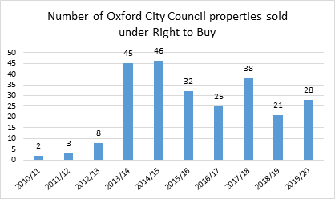

Total RTB sales during the years 2015/16 - 2019/20 as a percentage of stock owned (excl shared ownership) in 2014/15 (LAHS return)

We let around 300-400 Council (Housing Revenue Account) properties per year.

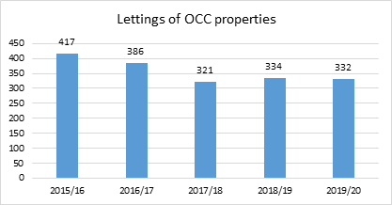

In addition we let 22 Oxford City Housing Ltd. (the council’s housing company) properties in 2018/19 and 46 properties in 2019/20.

26% of council properties are under-occupied using the same criteria as the Allocations Scheme when calculating the number of bedrooms required for a household. If we only look at family-sized properties (2-beds and larger) 34% are under-occupied. This is less than in 2015 when the corresponding figures were 30% and 40% respectively.

Two thirds are under-occupying by one bedroom and one third by two or more bedrooms. 65% of under-occupiers are aged 60 or over.

The majority of those under-occupying require only a 1-bed.

|  |  |  |  |  |
| --- | --- | --- | --- | --- |
|  | **Number of bedrooms required** | | | |
| **Size of under-occupied property** | **1-bed** | **2-bed** | **3-bed** | **4-bed** |
| 2-bed | 712 |  |  |  |
| 3-bed | 592 | 575 |  |  |
| 4-bed | 17 | 26 | 36 |  |
| 5-bed | 2 | 1 | 2 | 3 |
|  | **1323** | **602** | **38** | **3** |

134 of 1,966 tenants who are under-occupying are on the transfer register looking to downsize.

One of the things we are doing to help address under-occupation is the offer of the ‘Removal Expenses and Mobility Scheme (REMS). The scheme is for council tenants who are under-occupying their properties and who want to move to a smaller property that is easier to manage and afford. Tenants accepted on the scheme are given a higher housing priority to facilitate a quicker move and are placed in band 1 on the housing register if they are giving up two or more bedrooms or in band 2 if they are giving up one bedroom. They may also be eligible for compensation plus certain other expenses.

There are currently (Jan 2021) 787 council tenants on the transfer register. This is 10% of all tenants. The majority are in bands 1-3, indicating a fairly high housing need.

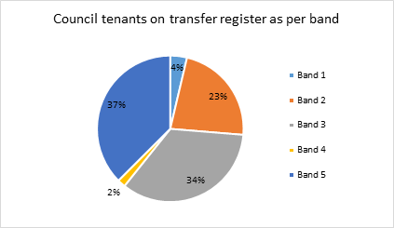

One third (261) of council tenants on the transfer register are overcrowded, and 17% are under-occupying.

The council has an award winning tenant involvement service that achieved TPAS (Tenant Participation Advisory Service) re-accreditation in 2020 for a further 3 years. The Council wants all tenants and leaseholders to be able to influence decisions about their homes and the Tenant Involvement team provides resources, support and training to facilitate for tenants and leaseholders to get involved and help shape our service. This can be through mystery shopping examining the quality of our service, through the Editorial Team producing the Tenants in Touch newsletter, as Champion Ambassadors representing tenants and leaseholders in meetings on issues and services that affect them, through the Tenants and Leaseholders’ Forum which acts as a consultation group when developing housing policies, or as an inspector who will examine two service areas annually.

In 2020 tenants and leaseholders have been involved in satisfaction surveys and reviewing sites and works programme for the Great Estates scheme, been involved with recruitment to the housing service, reviewed the Corporate Strategy and tested the new Choice Based Lettings portal, among other things.

The Council also has an Energy Advice Team (EA) which is part of the Tenancy Management Team. The EA Officers conduct home visits and give phone advice to council tenants in order to assess their properties’ energy efficiency and reduce costs to them and the council. These visits help to reduce fuel poverty, sustain tenancies, maintain council properties and reduce carbon emissions.

### 10.1 - What the Social Housing White paper means for Oxford City Council

As mentioned in chapter 4, the recently published Social Housing White paper will mean greater regulation in relation to building safety, performance, complaints, consumer standards, tenant involvement and engagement and the quality of homes and estate. Some of these measures are introduced through the Building Safety Bill.

The main changes that will affect the Council are:

* More stringent regime for the design, construction, day-to-day management and maintenance of higher-risk buildings.
* ‘Accountable Person’ for each higher risk building to produce and implement a resident engagement strategy.
* Proposal for smoke alarms and carbon monoxide alarms to be installed in all properties. (Consultation closed on 11 Jan 2021)
* The council to provide a clear breakdown of how income is being spent, to be published alongside tenant satisfaction measures.
* New code of complaint handling.
* Stronger consumer standards and redress.
* 4 yearly inspections by the Regulator for Social Housing.
* Opportunities and empowerment programme open to all social housing residents, to support their effective engagement with the Council as a landlord.
* Review of Decent Homes Standard, including how it can better support the decarbonisation and energy efficiency of social homes, and improve communal and green spaces.

The council welcomes these increased standards for the sector, and we will ensure we are fully compliant.

### 10.2 - The council as a social landlord through the pandemic

The City Council was well placed at the outbreak of the pandemic and the start of lockdown to support our communities, with us already having good community relations, with staff experienced in working with residents in their homes and communities. At start of lockdown a decision was made to deliver our response through locality hubs, centres manned by officers and volunteers in the local community, distributing food, providing support, and collecting local information through networks. The City Council’s Housing Services in particular was key in this local response, with its staff already established in the community and aware of local needs, so critically able to support this work. Staff supported this work throughout the first lockdown, and again in subsequent lockdowns.

As we look to the future the learning from this experience will help us shape services in a better way, based in our communities and more responsive to their needs. A review is underway to ensure this learning is now embedded and changes to working practices and structures are now permanently embedded to consolidate the improved community working.

## **11.0 - Reducing carbon emissions and improving energy efficiency in the housing stock**

|  |
| --- |
| Key Findings – Reducing carbon emissions and improving energy efficiency in the housing stock   * The City Council has declared a climate emergency, and last year Oxford achieved a 40% reduction in carbon emissions across the city on a 2005 baseline. * Improving the housing stock is crucial to achieving a zero carbon future, this includes raising the standards to ensure new builds are significantly more energy efficient, and that the energy efficiency standards of the existing housing stock are improved. * Oxford City Housing Ltd. will have to meet building standards of a minimum of 70% more energy efficient than the existing 2013 Building Regulations, with the aim of implementing net zero carbon build as far and fast as practicable. * The council is developing an investment plan to retrofit the existing stock, including looking at insolation and heat pumps, and £7million due to be invested in 21/22, with the aim of 95% of our stock being EPC level C or above by 2030. |

In January 2019, Oxford City Council unanimously declared a climate emergency in Oxford and agreed to create a Citizens’ Assembly to consider new carbon targets and additional measures to reduce emissions. The response to climate change is a key priority for the City Council and is a critical consideration for our future housing plans, both in terms of development of new low and zero carbon homes, and decarbonisation of the existing housing stock.

A lot has already been achieved, last year Oxford achieved a 40% reduction in carbon emissions across the city on a 2005 baseline. In February 2021 the Council held a Zero Carbon Summit where leaders of Oxford’s major businesses and organisations gave their support to the aspiration of achieving net zero carbon emissions as a city by 2040, and a new Zero Carbon Oxford Partnership was formed.

The Council has set out a vision to reach zero carbon across its own operations by 2030 and has established a Carbon Management Plan to help achieve this.

As part of this plan, the Council has ambitions to bring down carbon emissions in its housing stock by ensuring all new builds are significantly more energy efficient, moving towards near-zero or zero carbon standards, and by making energy efficiency improvements to existing housing stock.

Emissions inventory for Oxford (2017) excluding land use. Source: Anthesis.

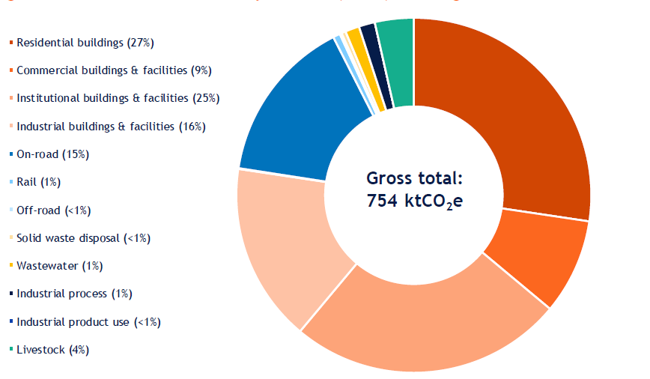

There is a need for an interconnected approach to decreasing emissions from housing while simultaneously working to resolve the current affordable housing and homelessness crisis in Oxford.

We are clear that the new Housing Strategy for Oxford will need to address the housing challenges the climate emergency possess.

### 11.1 - Decarbonisation of the council housing stock

The City Council has invested heavily over the last 10 years in its housing stock to increase energy efficiency and tackle fuel poverty. Investment programmes have included

* 270 Cavity wall, 57 external wall and 2013 loft insulations benefiting a total of circa 2340 homes.
* Carried out a programme of solar PV installs in Rose Hill and Barton including the ERIC project which piloted battery storage benefitting circa 80 units
* Scoped whether a heat network utilising waste heat from Heyford Hill Sainsburys was possible with Bioregional
* Converting approximately 100 homes with inefficient electric heating systems to modern gas central heating systems.
* Implementing a rolling programme of boiler replacement and whole system replacement

In order to inform a future targeted investment programmes to secure carbon reduction we have used a carbon asset management programme, CROHM, alongside an extensive EPC and building survey approach in order to:

* Check and update existing data to improve accuracy to the required standard
* Set confidence levels for data
* This enables us to work out what energy efficiency measures can be applied to different properties, such as through cavity and loft insulation, and low carbon heating options.
* Target the worst performing homes (E, F and G in EPCs)
* Establish an investment programme to meet a target of 95% of homes to be EPC level C or above by 2030

The stock modelling exercise indicates that overall the bulk of the housing stock is performing well with 93.6% returning an Energy Performance Certificate (EPC) rating of D or above, which demonstrates that the vast majority of our stock performs at current average or above with regard to energy efficiency.

Energy ratings of council owned homes (2019)

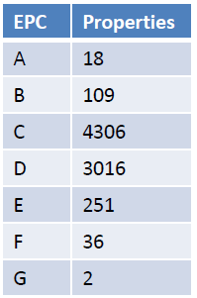

However the report also highlights the significant challenge the council faces trying to decarbonise its housing stock, and in particular to reach a zero carbon position. The report highlighted that an investment of approximately £80 million would be required to bring all those properties to zero carbon where it is possible, and this would still leave 3720 properties short of being zero carbon. The Council recognises therefore that not all of its stock is appropriate for retrofit, as it may not be economically viable, with replacement the preferred option.

In order to achieve this significant investment would be required over a long period of time, with anticipated further support to decarbonise housing stock may be made available from central government in time. It should be noted that in the absence of substantial external investment the current legislation requires that the costs of the retrofit and replacement programme will be borne by the tenants of the councils’ stock. Reflecting concerns expressed by both councillors and Citizen Assembly Members, any plans must not place an intolerable burden on tenants, who are often those on lowest incomes in our society.

A significant next step following the report is the ongoing validation of the EPC ratings continued in the report to confirm the actual state on the ground in many of our properties through surveying, and consideration of feasibility on different measures, first concentrating on the worst buildings which will deliver the greatest improvements quickly.

Further Future actions that have already be identified and committed to including:

* Developing an investment plan and a targeted programme of retrofitting existing council stock. Retrofitting council housing will include a range of innovative insulation solutions and fitting ground/air source heat pumps as we make the transition away from gas boilers. The aim is to trial ground source heating on 15 properties in 2021/22.
* Target of 100% of our stock being EPC level C or above by 2030.
* Investing over £50 million in retrofitting and improving council stock, with £7 million invested in 2021/22. The funding will come from a mixture of Council borrowing and government funding. The Council is consulting tenants on their views of retrofitting of council homes during spring 2021.

In addition this work will mean the Council is well placed to access central Government funding programmes as they come on stream. The Council will continue to explore all avenues that could lever in additional funds.

The new strategy will need to consider the need for ongoing invest into our council owned housing to improve energy efficiency, alongside competing requirements for investment in regeneration and new affordable development, and consider the right balance is struck in investment plans between these priorities.

### 11.2 - Decarbonisation of the council’s housing development

Alongside the condition of the existing housing stock, another important area for decarbonisation is ensuring new properties the council is delivering are part of the solution to the climate crisis.

The Council’s wholly owned housing company, Oxford City Housing Ltd (OCHL), already follows ambitious low carbon goals in its development program and is bound by the Oxford City Council local plan, which requires new developments to go 40% further than government building regulation targets on carbon emissions.

The City Council and OCHL have made the following commitments in regards to their developments:

* All new house building commissioned by Oxford City Housing Ltd will have to meet building standards of a minimum of 70% more energy efficient than the existing 2013 Building Regulations.
* Establishing a modular construction framework for new housing schemes.
* Implement net zero carbon build as far and fast as practicable.

In practice this means Oxford City Housing Limited’s business plan includes provision for developing all new build to above Part L of Building Regulation standard and without gas heating in the future. It will also take a fabric first approach which incorporates appropriate renewable sources of energy is the approach that will be taken to ensure reduced carbon emissions. As the company moves to electric only development, this will be done with clear objectives focused on keeping tenant energy costs low, and done in a way that works for tenants.

In addition, the Council will seek to bring forward some demonstration net zero or Passivhaus homes, to build capability and generate local interest. In time, as acceptance of Passivhaus homes among tenants and buyers increases, and the incrementally higher costs of this form of housing narrows, it is anticipated that this will be the norm for OCHL construction. In time we will develop our understanding of this journey and potential timetable.

OCHL has commissioned some exemplar sites, being delivered by Oxford Direct Services (ODS). These will be used as learning and stretch projects to speed up the transition to higher standards. ODS has commenced work on building eight zero carbon council homes across three sites in Oxford. The new homes will be zero carbon for regulated energy use, lighting, space and hot water heating. Two one bedroom and two two-bedroom retirement homes will be built on a site between existing homes in Bracegirdle Road and Chillingworth Crescent. Garages behind Mortimer Drive will be replaced with two one-bedroom and one two-bedroom single-storey retirement homes. A further two-bedroom single-storey retirement home will be built in Broad Oak.

While seeking to deliver the highest standard of energy efficiency possible, the council also has to reflect that Oxford is regularly listed as being the least affordable place to buy a house in the country and the number of families on the waiting list for social housing. So the Council and OCHL have a difficult task to optimise both environmental standards, financial return to the Council and maximising the availability of housing, particularly housing that is truly affordable.

Evidence is that there is currently no premium in value terms to homes built for private sale but societal behaviours could well change going forward. The Council is looking to review the business case as to the value of properties purchased by the HRA when whole life costing is taken into account which has the potential to help the viability of schemes built to the equivalent of a passivhaus standard.

In the meantime trade-offs will need to be made by elected members on behalf of the Council and in acting as the client and Shareholder of OCHL.

### 11.3 - Decarbonisation of the wider Oxford housing market

Decarbonizing the housing stock held in private ownership in the city will also be key to meeting the challenge of the climate crisis. Much of the city’s older housing stock is within the private rented sector or in private owner occupiers, where retro-fitting will be more complex and costly.

Following a successful bid to central government the Council undertook a project in relation to enforcement of the regulations in relation to Minimum Energy Efficiency Standards in the private rented sector. This work has continued on a reactive basis in the private rented sector, with enforcement action taken to improve cold homes following complaints from occupiers. In the period 2016-19 there were 468 excess cold hazards assessed following complaints with 357 being category 1 ( the most serious home hazard).

We know that much of the current housing stock in the city has low rates of energy efficiency that is both contributing to emissions, but also puts extra the cost of heating and electricity on tenants, including some on low incomes who live in the lowest standard accommodation in the city, leading to fuel poverty. Many of the risks that may result from climate change will also fall on those on lower incomes disproportionality, including those who cannot implement resilience measures such as air conditioning and flood insurance.

## **12.0 - How are housing and homelessness services funded?**

|  |
| --- |
| Key Findings – How are housing and homelessness services funded?   * The amount of funds the Council has spent on homelessness and rough sleeping in the City has increased significantly over the last few years. The increase in the overall spend has been possible due to government grants received following successful bids for funding by the Council. * The Council’s Housing Revenue Account is making a significant investment in order develop new affordable housing over the next 10 years, forecast at £323 million. * The Council, like other local authorities, is under financial pressure due to the impact from the Covid-19 pandemic, with the MTFP identifying savings through transformation, while seeking to maintain service levels. |

### 12.1 - Overview of resources for housing, homelessness and rough sleeping in the city

Funds for the provision of housing, homelessness and rough sleeping services come from different sources and are all vital to meet demand on our services. The Covid-19 emergency has put considerable financial pressure on local authorities in the country and these pressures are very real for Oxford City Council too. As highlighted in the Cabinet paper outlining the Council’s Medium Term Financial Plan (MTFP) and budget consultation for 2020/21 that the period following the introduction of the first nation-wide ‘lock down’ as an emergency response to Covid-19, the period since then ‘has seen great disruption to the country’s health, economy and social interaction, and has also seen a major impact on the finances of Oxford City Council. The overall adverse impact on the City Council’s general fund, in this year alone, is estimated at around £11 million’.[41]

In the MTFP strategy, estimated savings of £350,000 per year from 2022/23 have been identified from our current spending on homelessness and includes review of Housing Needs services, with significant transformation planned, to reduce cost while seeking to maintain service levels. Estimated savings of £189,000 by 2023/24 to rough sleeping services have also been identified and are linked to County-wide changes to the provision of the services.

### 12.2 - Funding for homelessness and rough sleeping

The amount of funds the Council has spent on preventing and relieving homelessness and rough sleeping in the City has increased significantly over the last few years, over the period between 2016/17 and 2019/2020. The increase in the overall spend has been possible due to government grants received following successful bids for funding by the Council. Most of these grants have been awarded for the purpose of preventing and reducing rough sleeping. Other grants we receive from the government, and based on a set formulas, are grants such as New Burdens Funding and the Flexible Homelessness Grant.

Although we have received significant amounts of funding from MHCLG in the last few years, and in particular in relation to tackling rough sleeping, these funding streams are short-term (one or two years) and often for specific projects. This causes uncertainty and an inability to plan long-term interventions.

Funding from grants we have received from the government over the last few years include the following.

|  |  |  |
| --- | --- | --- |
| **Name of Grant** | **Amount** | **Award notice** |
| Oxfordshire Homelessness Trailblazer Programme | £790,000 | January 2017 |
| Rapid Rehousing Pathway | £857,700 | Spring 2019 |
| Rough Sleeping Initiative 1 | £503,000 | June 2018 |
| Rough Sleeping Initiative 2 | £511,000 | September 2018 |
| Rough Sleeping Initiative 3 | £1,315,826[42] | January 2020 |
| Next Steps Accommodation Programme (short-term funding allocation) | £1,064,545.00 | July 2020 |
| Next Steps Accommodation Programme (long-term accommodation and support allocations, includes some capital funding) | £967,901 | July 2020 |
| Covid-19 Rough Sleeping Contingency Fund | £32,250 | Summer 2020 |
| Cold Weather Funds | £40,000 | 2019/20 |
| Flexible Homelessness Grant | £541,000  £622,565  £755,936  £755,936 | 2017/18  2018/19  2019/20  2020/21 |
| New Burdens Funding | £74,103  £67,878  £71,752  £171,327 | 2017/18  2018/19  2019/20  2020/21 |

In addition to the funds detailed below, our spend to deliver the Syrian Vulnerable Persons Relocation Scheme is reimbursed in full by the Home Office.

The graph below show the total spend across our housing needs services and commissioned services over the last few years. Spend here includes things like Oxford City Council staff across the Housing Needs team, running costs, commissioned services and special projects.

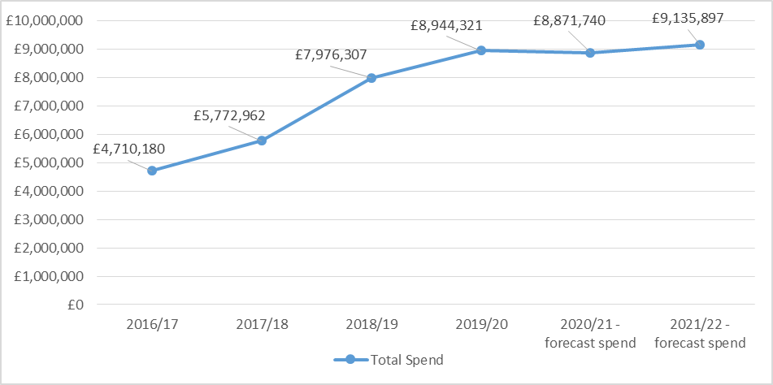

Homelessness is a priority area for the council, but we are in a difficult financial position due to impacts due to Covid. As stated above, we rely heavily on grant funding from government to delivery our services and to commission services to tackle rough sleeping. Following the government’s 1 years spending review in 2020, there is currently no long term certainty from the government in relation to these grants. However, with the government’s aim to end rough sleeping by 2024 as stated in the national rough sleeping strategy, we do not anticipate a significant drop in grant funding for these purposes. We expect to know more about future funding if a longer term spending review is published in autumn as expected.

### 12.3 - Funding for housing and affordable development

As a local authority that owns and manages social housing the council also has a housing revenue account (HRA) separate to its general fund finances, which it uses to fund the services and investments needed to maintain and manage the social housing stock it owns. It is also the housing revenue account that invests in purchasing and developing new homes to join the council’s social housing stock. The council can also borrow money through the housing revenue account, secured against the assets held in it, in order to fund investment in the current stock and to buy new social housing.

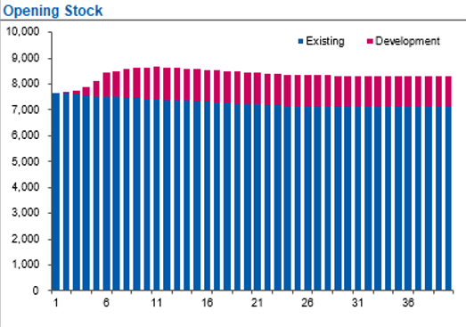

Current HRA stock modelling. Horizontal axis indicates years, with year one starting in 2020/21

Current modelling on the number of homes held in HRA stock presumes a gradual loss of existing homes due to ongoing sales through the Right to Buy. However, despite the losses through Right to Buy, the number of dwellings within the HRA is expected to significantly increase over the next 10 years. This is due to the significant house building plans of Oxford City Housing Ltd, currently factored in for the next 10 years, many of which will be affordable homes purchased into the HRA, alongside the wider programme of purchases planned to be made using the HRA. 1,125 homes are forecast be added in the next 10 years with the HRA spending an anticipated £323 million (depending on available grant amounts). This would be the first significant increase in the number of council homes for many decades.

The forecasting within the HRA presumes gradual rent increases in line with the governments national rent policy, which is CPI +1%. Rental income is projected to increase over the forecasted period, both because of the gradual rent increase, and due to the new rents collected from additional housing stock being added.

Significant costs charged to the HRA include responsive repairs and planned maintenance. Approximately £45m has been allocated for responsive repairs over the next decade, and £87m on planned maintenance. This planned maintenance budget has been increased, due to increasing investment needs including additional spending for health and safety following Grenfell and the current building safety legislation going through Parliament. The HRA business plan does not currently make any allowance for additional investment that may be required following a Government review of the ‘Decent Homes’ standard that is currently underway as a part of the changes proposed under the Social Housing White Paper

In addition to the financial provision for new housing supply the business plan also makes a £50m provision over the next 10 years for investment in carbon reduction measures for the existing housing stock. Although a significant figure, it is unlikely to be sufficient in light of the pressing need to decarbonise the housing stock. The level of additional investment that will be required to be accommodated within the business plan will also be dependent upon the level of Government support from the ‘social housing decarbonisation fund’

The HRA is currently accessing borrowing to fund its ambitious investment programme, in particular the investment into developing new affordable housing stock. Currently peak debt is forecast to be reached in year 10 of the HRA business plan (year 2031-32) at an amount of £566m, and then after 6 years at the level to drop, until being cleared in 2054/55.

The new housing strategy will need to consider the balance of different priorities for investment within the financial context of the housing revenue account, and assess what levels of future investment are required for different areas such as development of new affordable homes, regeneration of our estates, and our move to decarbonise our housing stock, alongside considering the amounts of future borrowing the HRA can maintain. This prioritisation will form a key part of the strategy development process over the next year.

## **13.0 - Conclusion and draft priorities**

This review and evidence base includes comprehensive data and information on the housing and homelessness situation in Oxford and how it has developed over recent years. A combination of wealth disparity, a strong labour market and undersupply of housing – and in particular affordable housing – has over the last decade resulted in Oxford having one of the least affordable housing markets in the country.

This has had an impact on homelessness in the City through the last decade, that we have had success in tackling through good homelessness prevention activities across the council, as well as good partnership with other agencies. The number of households that we need to place in temporary accommodation to relieve homelessness had reduced, whilst trends in many local authorities across the country have seen an increase to the number of households in such accommodation. After an increase to the number of people experiencing rough sleeping in the city from 2011 to 2017, numbers have declined over the last three years, much due to the council successfully bidding for funds from the government to increase the provision of services for single homeless people and those experiencing rough sleeping. We are relying heavily on the private rented sector when working with households to prevent and relieve their homelessness, and whilst we are achieving good outcomes here, the increasingly high levels of rent presents future challenges.

The development of social and affordable housing has not kept pace with demand over the last decade and we are therefore presented with challenges to assist households that need affordable accommodation. We are not able to offer social housing to all those who need it in the city and we need to look carefully at how we decide who can be offered such properties in the future. Our development programme increased in the last few years and plans are in place to accelerate development even further in coming years. To help meet Oxford’s acute need for housing, our neighbouring District authorities have also agreed to help meet this need.

The council declared a climate emergency in 2019, and we have committed to make new domestic developments as close to net carbon zero as possible. The council’s existing stock needs significant investment to become more energy efficient.

Across all work areas, the council has faced and continue to face challenges due to the effects of the pandemic. The council faces significant financial pressures. We do not yet know the full effects of the pandemic, or what future trends will look like.

The council is committed to continue to do what it takes to prevent and relieve all forms of homelessness in the city, and through creating this review and evidence base, will help us make important decisions on how and where we put interventions and services in place to do so. Based on what the information contained in this document tells us, and the key findings, we have drafted a vision and emerging priorities for the new strategy.

Our draft vision is – ‘**By 2030, meeting Oxford’s need for more affordable housing, improving the standard of housing in the city while lowering its carbon impact, with services and partnerships that are focused on preventing people losing their homes, rapidly rehouse those who become homeless, and ending rough sleeping. ’**

The 5 emerging priorities, and the areas of work that are likely to fall under these are:

* + **Building more, affordable homes**
    - Increasing the rate of affordable homes delivered in the city, in order to tackle the unaffordability local people face in the Oxford housing market.
    - The delivery of the council’s ambitious house building programme through its company Oxford City Housing Ltd, in building nearly 1,900 new homes in the next 10 years, many of which will be charged at a lower “social rent”, and deliver the ‘Oxford Needs Homes’ campaign.
    - Building on our existing good relationships with housing associations to encourage their investment in the city, in order to scale up the delivery of affordable homes.
    - Working with our neighbouring districts to secure the homes outside the city to meet the unmet housing need of the people of Oxford.
  + **Great homes for all**
    - Greater empowerment of council tenants, giving them more say on their homes and neighbourhoods, and greater ability to scrutinise and challenge the council as a landlord.
    - The implementation of a new locality based service delivery model, firmly rooted in the community, more responsive and assessable to the needs of clients.
    - Improving the private rented sector by engaging with landlords and tenants, and implementing a comprehensive licencing scheme.
  + **Housing for a zero carbon future**
    - Rollout of an ambitious investment programme in the council’s housing stock, retrofitting and in some cases rebuilding our homes to ensure they meet the standards required to meet the climate crisis.
    - Ensure high standards of energy efficiency and build quality for new developments, in particular those delivered by OCHL.
    - Working to improve energy ratings in the private rented sector.
  + **Preventing homelessness and adopting a rapid rehousing response**
    - Putting the prevention of homelessness at the heart of all Council services, including the reconfiguration of the City Council’s housing services to support more people to stay in their homes. Ensuring every opportunity is taken across the organisation to prevent homelessness.
    - Delivering services and building partnerships that tackle the trauma of homelessness, repeat homelessness and avoiding the need to be rehoused, through earlier and pre-emptive interventions. Supporting people in both the social and private sector to sustain their tenancies, using data and networks to identify those in greatest need, with the ability to deliver suitable, effective support.
    - A rapid rehousing/ housing-led response to all forms of homelessness, so that homeless people can move to a stable and suitable home quickly, including minimising the use of temporary accommodation, and enabling effective access for homeless households to affordable social housing and the private rented sector.
  + **Ending rough sleeping**
    - Seek to end the need for anyone to sleep rough on the streets of Oxford by 2024 (in line with national objectives).
    - Establish a new countywide approach to preventing and relieving rough sleeping, with new jointly commissioned arrangements across local government, voluntary sector partners and health in Oxfordshire.
    - Enable a housing-led approach to rough sleeping, rapidly moving people on from the street to a new settled home, with more use of flexible support and less use of interim accommodation.

**What happens next?**

We are launching a visioning consultation, where we will ask members of the public, stakeholders and partners to tell us if the review and evidence base includes all the necessary information we need in order to start develop the draft strategy and action plan. We are also asking if we have arrived at the right conclusions based on the evidence and if the emerging vision and emerging priorities reflect what we need to do in order to address homelessness and the housing crisis in Oxford. Views and feedback are important to ensure that we formulate the right vision and priorities for the new strategy.

We will use the feedback received to finalise the review and evidence base and start to develop the new strategy, accompanied by an action plan. The draft strategy will be consulted upon, updated based on feedback and then finalised and implemented in early 2022.

1. [Adopted Oxford Local Plan 2016-2036](https://www.oxford.gov.uk/downloads/download/1176/oxford_local_plan_2016-2036), paras. 3.18-3.19
2. ONS Claimant count by sex and age, March 2021 (Nomis)
3. https://www.ons.gov.uk/employmentandlabourmarket/peopleinwork/employmentandemployeetypes/articles/labourmarketeconomicanalysisquarterly/september2020#coronavirus-and-young-people-in-the-labour-market
4. [Oxfordshire JSNA 2021](https://insight.oxfordshire.gov.uk/cms/joint-strategic-needs-assessment). (Due to the coronavirus (COVID-19) pandemic all summer 2020 exams were cancelled.)
5. https://www.ons.gov.uk/peoplepopulationandcommunity/housing/datasets/ratioofhousepricetoresidencebasedearningslowerquartileandmedian
6. https://www.centreforcities.org/city/oxford/
7. https://commonslibrary.parliament.uk/research-briefings/cbp-8395/
8. https://www.oxford.gov.uk/news/article/1220/city_council_calls_on_short-let_landlords_of_entire_homes_in_oxford_to_apply_for_planning_permission
9. https://commonslibrary.parliament.uk/research-briefings/cbp-8395/
10. <https://www.gov.uk/government/publications/rough-sleeping-strategy-delivery-plan>
11. <https://www.crisis.org.uk/ending-homelessness/homelessness-knowledge-hub/housing-models-and-access/oxfordshire-feasibility-study/>
12. <https://www.gov.uk/government/consultations/use-of-receipts-from-right-to-buy-sales>
13. <https://www.gov.uk/government/publications/the-charter-for-social-housing-residents-social-housing-white-paper/the-charter-for-social-housing-residents-social-housing-white-paper>
14. <https://www.gov.uk/government/consultations/planning-for-the-future>
15. <https://www.gov.uk/government/consultations/changes-to-the-current-planning-system>
16. <https://homeofficemedia.blog.gov.uk/2021/04/29/domesticabuseactfactsheet/>
17. <https://assets.ctfassets.net/6sxvmndnpn0s/1QzOPPJc0PD2R5OzhUNJUo/cbe3cc028eaed31d333645d892006b3c/This_is_England_A_picture_of_homelessness_in_2019.pdf>
18. MHCLG Live tables on homelessness, Detailed local authority level tables: financial year 2019/20, <https://www.gov.uk/government/statistical-data-sets/live-tables-on-homelessness>
19. Household number as published in MHCLG Detailed local authority level tables: October to December 2019
20. Street counts are one of two methods local authorities are advised to use in order to arrive at and report rough sleeping numbers to government on an annual basis. Street counts are carried out on one night in November of every year, where people seen bedded down are counter. To carry out an estimate of those rough sleeping is the second method, and that used to our neighbouring Districts to report the number of rough sleepers. This is an intelligence and multi-agency based exercise, where all those believed to be rough sleeping on a set night in November are included.
21. Oxford, Cambridge and Bristol carried out street counts in 2019 and 2020. Cherwell, South Oxfordshire, Vale of White Horse, West Oxfordshire, Milton Keynes and Reading carried out estimates.
22. Household number as published in MHCLG Detailed local authority level tables: financial year 2019/20
23. Household number as published in MHCLG Detailed local authority level tables: July to September 2020 (revised)
24. https://assets.publishing.service.gov.uk/government/uploads/system/uploads/attachment_data/file/886421/Statutory_homelessness_release_Oct-Dec_2019.pdf
25. https://www.crisis.org.uk/media/236816/the_hidden_truth_about_homelessness_es.pdf
26. <https://www.ons.gov.uk/peoplepopulationandcommunity/birthsdeathsandmarriages/families/datasets/youngadultslivingwiththeirparents>
27. MHCLG states in the Detailed local authority level tables: financial year 2019-20, that ‘no fixed abode’ has been reported to have been overused by some authorities who are aware that living with friends and family was a more appropriate field. We have therefore chosen to include this category here.
28. https://mycouncil.oxford.gov.uk/documents/s56948/Appendix%201%20-%20Hidden%20Homelessness.pdf
29. https://www.resolutionfoundation.org/app/uploads/2021/02/Getting-ahead-on-falling-behind.pdf
30. https://www.crisis.org.uk/media/244285/the_impact_of_covid19_on_people_facing_homelessness_and_service_provision_across_gb_2020.pdf
31. We have discounted those cases – a total of 132 – where ethnicity was recorded as ‘not known’
32. <https://assets.publishing.service.gov.uk/government/uploads/system/uploads/attachment_data/file/793471/Homelessness_-_REA.pdf>
33. 262 new rough sleepers where seen bedded down in the city in 2019/20. Information about last settled base was collected from 90 (34%) of them. 154 new rough sleepers where seen bedded down in the city in 2020/21 (up until 31st Jan 2021). Information about last settled base was collected from 74 (48%) of them.
34. 262 number of new rough sleepers where seen bedded down in the city in 2019/20. Information about reasons for leaving last settled base was collected for 79 (30%) of them. 154 number of new rough sleepers where seen bedded down in the city in 2020/21 (up until 31st Jan 2021). Information about reasons for leaving last settled base was collected for 66 (43%) of them.
35. <https://www.local.gov.uk/sites/default/files/documents/22.7%20HEALTH%20AND%20HOMELESSNESS_v08_WEB_0.PDF>; <https://england.shelter.org.uk/__data/assets/pdf_file/0009/48465/Research_report_Sick_and_Tired_Dec_2004.pdf>; <https://www.qni.org.uk/wp-content/uploads/2016/09/homelessness_babies_families.pdf>; https://www.health.org.uk/blogs/bad-housing-leads-to-bad-health-%E2%80%93-time-for-a-joined-up-approach-in-greater-manchester
36. <https://www.crisis.org.uk/ending-homelessness/homelessness-knowledge-hub/housing-models-and-access/oxfordshire-feasibility-study/>
37. <https://www.oxfordshiregrowthboard.org/>
38. <https://www.blackbirdleys.co.uk/>
39. https://www.oxfordshire.gov.uk/sites/default/files/file/adult-social-and-health-care/OxfordshireMPS2019-22.pdf
40. https://www.gov.uk/government/statistics/family-resources-survey-financial-year-201819
41. https://mycouncil.oxford.gov.uk/documents/b19498/Budget%2020212022%20Wednesday%2009-Dec-2020%2018.00%20Cabinet.pdf?T=9
42. Funds received in this bid for projects delivered through neighbouring District Councils have been deducted from the total amount received. This figure shows funds received for projects/services commissioned by the City Council.